Duxbury Braille Translator
Producer’s Manual

,duxbury ,brl ,translator
,produc]'s ,manual

For the production of Unified English Braille
in Australia and New Zealand.
2011


Round Table on Information Access
for People with Print Disabilities
Duxbury Braille Translator Producer's Manual
Copyright © 2011 Round Table on Information Access for People with Print Disabilities
This work is licenced under the Creative Commons
Attribution-NonCommercial-NoDerivs 3.0 Unported License.
To view a copy of this licence, visit http://creativecommons.org/licenses/by-nc-nd/3.0/ or send a letter to Creative Commons, 171 Second Street, Suite 300, San Francisco, California 94105, USA.
Published by Round Table on Information Access for People with Print Disabilities Inc.
PO Box 229
Lindisfarne, Tasmania 7015
Australia
Email: admin@printdisability.org
Web address: http://www.printdisability.org

National Library of Australia Cataloguing-in-Publication entry
Title: Duxbury Braille Translator Producer's Manual : For the production of Unified English Braille in Australia and New Zealand / Round Table on Information Access for People with Print Disabilities.
ISBN: 9780980706444 (pbk.)
Subjects: Braille--Handbooks, manuals, etc.
Braille--Australia--Standardization.
Braille--New Zealand--Standardization.
Blind--Printing and writing systems--Handbooks, manuals, etc.
Other Authors/Contributors:
Round Table on Information Access for People with Print Disabilities
Dewey Number: 411

About this manual
This manual is published by the Round Table on Information Access for People with Print Disabilities Inc. The Round Table is an umbrella organisation which brings together producers, distributors and consumers of information in alternative formats to print; blindness agencies, tertiary institutions and government departments in Australia and New Zealand.
This manual is available from Round Table in accessible formats.

Acknowledgements
Compiled and edited by Leona Holloway (Vision Australia) following the initial drafting work of Robyn Carey (New South Wales Department of Education and Training), Maria Elford (Statewide Vision Resource Centre), Kate Randall (Vision Australia), Kathy Riessen (South Australia School for Vision Impaired), Christine Simpson (Information Alternatives) and Nicholas Wood (Royal New Zealand Foundation of the Blind).
The members of the working group wish to thank their Employer Organisations as well as the following for their support and assistance in the production of this manual:
- Joe Sullivan, President of Duxbury Systems, for his carefully considered and detailed advice, and for making every endeavour to adjust DBT to suit the particular needs of UEB producers in Australia and New Zealand.
- George Bell, Managing Director of Techno-Vision Systems Ltd. and author of the DBT Help files, for his expertise and advice regarding the new features of DBT 11.
- Nadine Riches and Carmela Carey, for careful proofreading and editing.
- Josie Howse, for excerpts from the Unified English Braille Primer.
- BLENNZ (Blind and Low Vision Education Network New Zealand), for excerpts from the UEB Hitchhikers' Guide.
- The Round Table on Information Access for People with Print Disabilities Inc., for funding the working group's teleconferences and face-to-face meeting.
- The Australian Braille Authority for sponsoring and supporting the project.
- Moria Clunie, for her assistance in the final editing stages.

Table of Contents
Introduction 5
About DBT 5
Further resources 5
PART 1: Getting Started 5
1.1 Installation and Customisation 5
1.1.1 Installing DBT 5
1.1.2 Installing a Template 5
1.1.3 Template Customisation 5
1.1.4 Translation Tables 5
1.2 Quick Start Guide 5
1.2.1 Prepare the Word file 5
1.2.2 Open/Import the Word document in DBT 5
1.2.3 Edit Duxbury Print Document 5
1.2.4 Translate to Braille and Emboss 5
PART 2: The Menus 5
2.1 File Menu (Alt-F) 5
2.1.1 New 5
2.1.2 Open 5
2.1.3 Close 5
2.1.4 Save 5
2.1.5 Save As 5
2.1.6 Translate 5
2.1.7 Print 5
2.1.8 Emboss 5
2.1.9 Exit 5
2.2 Edit Menu (Alt-E) 5
2.2.1 Undo 5
2.2.2 Redo 5
2.2.3 Cut 5
2.2.4 Copy 5
2.2.5 Paste 5
2.2.6 Clear 5
2.2.7 Select All 5
2.2.8 Highlight 5
2.2.9 Change Case 5
2.2.10 Insert File 5
2.2.11 Goto 5
2.2.12 Find 5
2.2.13 Find Again 5
2.2.14 Replace 5
2.2.15 Spell Check 5
2.2.16 Find Misspelling 5
2.3 View Menu (Alt-V) 5
2.3.1 Full Page 5
2.3.2 Fonts 5
2.3.3 Six-Key Entry 5
2.3.4 Codes 5
2.3.5 Translated Line 5
2.3.6 Cycle Through Open Documents 5
2.4 Layout Menu (Alt-L) 5
2.4.1 Apply Style 5
2.4.2 Apply Last Style 5
2.4.3 Style Level + 5
2.4.4 Style Level − 5
2.4.5 Join Styles 5
2.4.6 Join Lines 5
2.4.7 Translation Codes 5
2.4.8 Character Codes 5
2.4.9 Line Codes 5
2.4.10 Left Margin 5
2.4.11 Right Margin 5
2.4.12 Runover Offset 5
2.4.13 Math Codes 5
2.4.14 Page Codes 5
2.4.15 Set Page Number 5
2.4.16 Header 5
2.4.17 Footer 5
2.4.18 Generate Table of Contents 5
2.4.19 Picture 5
2.4.20 Code List 5
2.5 Table Menu (Alt-T) 5
2.5.1 Create 5
2.5.2 Table Properties 5
2.6 Document Menu (Alt-D) 5
2.6.1 Embosser Setup 5
2.6.2 Printer Setup 5
2.6.3 Page Numbering 5
2.6.4 Translation Tables 5
2.6.5 Hyphen Table 5
2.6.6 Add Style 5
2.6.7 Modify Style 5
2.6.8 Delete Style 5
2.6.9 Create Template 5
2.6.10 Delete Template 5
2.7 Global Menu (Alt-G) 5
2.7.1 Embosser/Printer Set-Up 5
2.7.2 Autosave Options 5
2.7.3 Default Views 5
2.7.4 Internationalization 5
2.7.5 Fonts 5
2.7.6 View Preferences 5
2.7.7 Shortcut Preferences 5
2.7.8 WordPerfect Importer 5
2.7.9 Word Importer 5
2.7.10 Formatted Braille Importer 5
2.7.11 Hyperlinks 5
2.8 Help Menu (Alt-H) 5
2.8.1 Help Topics 5
PART 3: Advanced Techniques 5
3.1 Codes 5
3.1.1 What are Codes? 5
3.1.2 Adding Codes 5
3.1.3 Editing Codes 5
3.2 Styles 5
3.2.1 What are Styles? 5
3.2.2 Using Existing Styles 5
3.2.3 Creating and Modifying Styles 5
3.3 Transcriber Intervention 5
3.3.1 Controlling Braille Contraction & Translation 5
3.3.2 ASCII Entry 5
3.3.3 Electronic Addresses 5
3.3.4 Numbers, Basic Mathematics and Technical Materials 5
3.3.5 Typeform Indicators 5
3.3.6 Capitalisation 5
3.3.7 Punctuation 5
3.3.8 Grouping 5
3.4 Specialised Layouts and Formatting 5
3.4.1 Page Breaks and Numbering 5
3.4.2 Lists 5
3.4.3 Boxes 5
3.4.4 Tables 5
3.4.5 Double-Page Spreads 5
3.5 SWIFT 5
3.5.1 What is SWIFT? 5
3.5.2 Installation 5
3.5.3 Using SWIFT 5
3.6 Word Mapping Files 5
3.6.1 What are .mws files? 5
3.6.2 Installation 5
3.6.3 Modification 5
Part 4: APPENDICES 5
APPENDIX 1: ASCII Braille Equivalents 5
APPENDIX 2: Order of Braille Signs 5
APPENDIX 3: UEB Contractions, Shortforms and Mode Indicators 5
UEB Contractions and Shortforms 5
UEB Mode Indicators 5
APPENDIX 4: UEB Symbols and Keyboard Entry for Symbols and Accented Letters 5
APPENDIX 5: DBT Codes 5
Translation modes 5
Direct entry 5
Typeforms & capitalisation 5
Page numbering 5
Page formatting 5
Paragraph formatting 5
Line formatting 5
Tabulation 5
Grouping 5
Mathematics or technical notation 5
Miscellaneous 5
APPENDIX 6: Styles in the English (Unified) - Australian Formatting Template 5
APPENDIX 7: Styles in the RNZFB Template 5
APPENDIX 8: Glossary of Terms Appearing in this Manual 5
APPENDIX 9: Proofreading Checklist 5
Checking Scanned Material 5
Checking Word Files 5
Checking a .dxp File that has been Imported from Word 5
Checking a Translated .dxb File 5
APPENDIX 10: DBT Shortcut Keys 5
Menu Access 5
Perform Function 5
Insert Codes and Styles 5

Introduction
This manual is intended as an accompaniment to the Duxbury Braille Translator (DBT) software application, a braille translation software produced by Duxbury Systems Inc. DBT is designed to suit the needs of braille publishers worldwide and as such supports a wide variety of languages, translation codes and formatting requirements. This manual has been written specifically for use in Australia and New Zealand, for the production of Unified English Braille.
This manual has been compiled using the advice of advanced users of DBT across Australia and New Zealand. DBT often provides several methods of achieving the same effect; in such cases this manual attempts to explain the main methods and make recommendations about those which are easiest or most appropriate for our use.
This manual has been written with specific reference to DBT versions 10.6, 10.7 and 11.1. Most features of DBT are consistent across all versions, however we have tried to indicate where a difference occurs. Much of the content of this manual will also be applicable to earlier versions of DBT.
Unified English Braille was adopted as the standard braille code for use in Australia in 2005, and shortly after in New Zealand. It should be noted that DBT contains some features that are not relevant for translation to Unified English Braille. Such features have not been described in this manual.

About DBT
DBT uses two propriety file types with the extensions .dxp and .dxb. Both contain text (print for .dxp and braille for .dxb), codes and styles, and one can be converted to the other using the translate (Ctrl-T) command.
DBT has been designed to be fully accessible for people with a vision impairment. Menu and direct keyboard shortcuts have been given throughout the manual and are also listed in Appendix 10: DBT Shortcut Keys. The only diagrams used are screen shots for the aid of sighted transcribers, with all relevant information described in the text below. It should be noted that some features of DBT, such as the spell checker, do not work well with a screen reader.
This manual may be revised or updated in the future, when major upgrades to DBT are released. The Chair of the Australian Braille Authority welcomes feedback on the manual, and can be contacted via email through the ozbrl list cited below.

Further resources
DBT is accompanied by a comprehensive Help System, as described in 2.8 Help Menu. The Help System is highly recommended for assistance on topics not covered in this manual and additional advice on those areas that are.
Several resources exist as references and teaching aids for Unified English Braille, including:
- The Rules of Unified English Braille (2010), available through the ICEB website at http://www.iceb.org/ueb.html
- Unified English Braille Guidelines for Technical Material (2008), available through the ICEB website at http://www.iceb.org/ueb.html
- Unified English Braille Primer, Australian Edition (2008), available through the ABA website at http://www.printdisability.org/aba/ueb.php
- Unified English Braille Manual: New Zealand Edition (2010), available from the RNZFB Braille Awareness Consultant at braille@rnzfb.org.nz.
Braille materials produced in New Zealand should follow the BANA guidelines for formatting:
- Braille Formats: Principles of Print to Braille Transcription (1997), available at http://www.brl.org/formats/
The following resources are recommended to keep up to date with changes to DBT, UEB, and national formatting guidelines:
- Ozbrl Email List - to subscribe, send a blank email to
ozbrl-subscribe@yahoogroups.com
- Australian Braille Authority (ABA) http://www.printdisability.org /aba/
- Braille Authority of New Zealand Aotearoa Trust (BANZAT). Email braille@rnzfb.org.nz for current BANZAT contact details.
- Royal New Zealand Foundation of the Blind http://www.rnzfb.org.nz/learn/accessible-information/braille
- Duxbury Systems http://www.duxburysystems.com/
- DuxNews Announcements List: To subscribe, send a blank email to
duxnews-request@freelists.org with "subscribe" in the subject line.

PART 1:
Getting Started

1.1 Installation and Customisation

1.1.1 Installing DBT
To install DBT, it may be necessary to first log on as an administrator.
When launching the new software for the first time, a choice of three installation options will be given:
- Simple Installation is nearly automatic, and is sufficient for the needs of most users.
- Custom Installation allows a greater degree of control over the installation, but in practice should seldom be needed.
- Network Installation allows network support personnel to easily install and maintain multiple DBT installations through a network.
The first time that DBT is opened following installation, a prompt will be given to activate the software licence using the alpha-numeric license number that was provided with the software.

1.1.2 Installing a Template
Since the introduction of DBT 10.6, document templates contain a great deal of useful information. Not only do they include desired settings for a default printer and embosser, but they also specify such information as the braille translation table in use, a list of styles, and page formatting protocols. Templates can also contain text such as a letter head, a signature, a production notice, or any other text which is used regularly. Using template supplied by a national Braille Authority allows the recommended formatting for page layout and styles to be most easily achieved.
The English (Unified) - Australian Formatting template should be used in Australia. The template and its associated .mws file are available for download from the Australian Braille Authority's website at
http://www.printdisability.org/aba/ueb.php
The RNZFB template should be used in New Zealand.
To install the template .dxt file and its associated .mws file, copy the files into the Duxbury Templates folder, for example
C:\Program Files\Duxbury\DBT 10.7\Templates.

Updates
The English (Unified) - Australian Formatting template may be revised or new translation tables will become available on occasion. When this occurs, the files and installation instructions will be made available on the ABA website and advertised through the ozbrl list.

1.1.3 Template Customisation
After installing DBT and an appropriate template, it is next necessary to customise the template to individual requirements and preferences. Such settings are discussed in detail in 2.7 Global Menu. In particular, the following settings should be specified:
- Global embosser setup
- Default views
- Fonts
- Formatted braille importer
- Hyperlinks
Templates contain global printer and embosser settings so these should be specified before saving the template. It may be helpful to create more than one template in order to allow for different paper settings or for different situations that are regularly used.
Refer to 2.6.9 Create Template for instructions on how to save changes to a template and mark it as the default template for use with all new documents.

1.1.4 Translation Tables
Translation tables control the way print and braille are translated. These tables are updated from time to time by Duxbury to improve translation.
The UEB translation table files are called:
- enuncb.btb (braille table)
- enuncp.btb (print table)
To take effect, any new files must be copied to the Duxbury folder, for example C:\Program Files\Duxbury\10.7. The new files will overwrite any existing files. Note that update files are usually accompanied by instructions on how, and to where, they should be copied.
To check the date of the most recent UEB translation tables, contact the ABA Secretary or Chair, using the contact details given on the ABA website or by contacting the RNZFB Braille Awareness Consultant at braille@rnzfb.org.nz.

1.2 Quick Start Guide
This section provides an overview of the process involved in producing a braille document from a Word file. For a more detailed explanation of any of the processes mentioned here, refer to further sections of this manual or check DBT’s online help.
There are three key stages in producing a braille document using Microsoft Word and DBT:
- Prepare the Word file
- Import to DBT and edit
- Translate and emboss

1.2.1 Prepare the Word file
Much of the required formatting, layout and editing work can be done in the Word source file, before importing to DBT. A properly structured Word document with mark-up for various components of the text will result in a better layout when the document is opened in DBT.
Refer to 3.5 SWIFT and Appendix 9: Proofreading Checklist for additional techniques and tips on how to prepare a Microsoft Word document in readiness for translation and embossing.

Codes
It is possible to insert DBT codes directly into a Word file to maximise the amount of editing that is applied at this stage of the braille production process. Simply type the DBT code inside double square brackets and asterisks, for example [[*lea*]], wherever it is needed. For more information on DBT codes, refer to 3.1 Codes.

Styles
A style is a set of formatting characteristics that can be applied to text to quickly change its appearance. Many styles that are applied to text in a Word document will be retained when the file is opened in DBT.
In particular, styles should be applied to:
- Headings: The English (Unified) - Australian Formatting template supports up to four levels of heading while the RNZFB template supports only two. Heading structure may need to be adjusted from the printed document as any headings smaller than level 4 (or 2) will be imported as <h4.> (or <h2.>).
- Lists: Numbered or bulleted lists that are automatically formatted by Word will be imported into DBT as paragraphs. To retain the desired indented formatting, apply one of the <List.> styles from the style drop-down menu.
The simplest way to apply styles is to use the style drop-down menu on the formatting toolbar. Place the cursor on the relevant line then select the desired style from the menu.

Page Numbers and Breaks
Indicating print page numbers is usually an important part of braille transcription. Print page numbers are indicated in DBT with a preceding [lea] code. If desired, this code can be inserted in Word by entering [[*lea*]] before every page number - this will convert in DBT as the correct [lea] code.
Note: Many Transcribers also prefer to add an [l] code after each print page number. This adds clarity for viewing in .dxp files but is not strictly necessary as long as each page number is followed immediately by a space.
Ensure that print page numbers are located at the beginning of each new print page, not at the end (as in many print books).
Page breaks in Word will also carry over to DBT as [pg] codes.

Paragraphs
To ensure that paragraphs are retained when the document is imported to DBT, two hard returns must be used in Word. Hard returns are entered using the Enter key, and will appear in Word as ¶ if show/hide formatting indicators has been activated.
Soft returns will translate as line breaks [l] rather than new paragraphs. Soft returns are entered using Shift-Enter and will appear as small right-angled arrows in Word if show/hide formatting indicators has been activated.

Bold, Italic or Underlined Fonts
Ensure that any required typeforms are included in the Word document, as they will be retained in the DBT file.
Check that any surrounding punctuation is included in or excluded from the typeform style as appropriate. Also ensure that leading or trailing spaces have been excluded and are not part of the typeform style, because DBT will place the braille typeform indicators exactly where the style begins and ends in the Word document.
Sometimes it will be necessary to remove the typeform indicators completely because they serve as nothing more than ornamentation and will add clutter to the translated text braille.

Tables
A table that is formatted correctly in Word will be imported to DBT using the <Outline.> style with hierarchical levels, resulting in a "stair-step" layout. Information in Word tables must be presented horizontally (not vertically) for the table to convert successfully.
For more information about stair-step tables and other table layouts for braille, refer to 2.5 Table Menu and 3.4.4 Tables.

Images
Include captions and/or image descriptions for diagrams and other important images as appropriate. It is also possible to embed the code for transcriber’s note brackets, i.e. [[*tns*]] and [[*tne*]].

Numbers
Use Ctrl-Shift-Space to insert a non-breaking space wherever a visual space appears in a continuous number in print, for example in numbers over 999, phone numbers and ISBNs. This will be imported into .dxp as a hard space ['] to give a numeric space character " in .dxb. Refer to 3.3.4 Numbers, Basic Mathematics and Technical Materials for more information about the presentation of numbers in braille.

1.2.2 Open/Import the Word document in DBT
When the Word document has been formatted, either:
- select "Duxbury" on the SWIFT toolbar (refer to 3.5 SWIFT) or
- save and close the Word file then open it in DBT

1.2.3 Edit Duxbury Print Document
Open the Word file in DBT using the UEB Australian Formatting or RNZFB template as appropriate (2.1.2 Open). Check the formatting of the .dxp file to ensure that it is correct. Use the Alt-F3 command to switch code view on or off if needed (2.3.4 Codes), and Ctrl-T to check the braille output (2.3.5 Translated Line).
Depending on the purpose of the document, some braille-specific transcription or formatting may need to be performed, including the following. When the transcription is complete, the .dxp file(s) should be saved (2.1.4 Save).

Divide into volumes
The ideal number of pages per volume will depend on the binding method. Most books will need to be split into several braille volumes. Any such splits should be made at a natural break, such as a new part or chapter.

Title page
Each organisation is likely to have its own custom title page, which will normally include information about the publication, transcription and braille volumes.
Use the <CentredText> style to centre all text on the title page, which should occupy the first page of each volume.

Preliminary pages
Braille transcriptions of published books should include preliminary pages with information in the print that is additional to the text. These are placed between the title page and contents page, and should be numbered using roman page numbers.

Table of contents
An overall contents of the book appears in volume one. It should begin on a new braille page, close to the front of the volume. The contents for the book should indicate which chapters or parts are in each volume, and the right column should be labelled "volume" using the [fr] (flush right) command. Use the <ListRm6.> style to ensure that the right column is reserved for volume numbers only, and use the Alt-F7 shortcut to position the contents number flush right with leader dots.
Note: As a default, the Alt-F7 shortcut will insert the code [fr;p~".], which creates dot 5 " leader dots but the shortcut can be customised to create other leader dots as described in 2.7.7 Shortcut Preferences.
Example:
.dxp:
[pg]
<H1.>Contents for the Book</H1.>
[fr]Volume
<ListRm6.>Chapters 1-3[fr;p~".]1
Chapters 4-7[fr;p~".]2
Chapters 8-10[fr;p~".]3</ListRm6.>
<CentredLine></CentredLine>
[pg]
.dxb:
,3t5ts = ! ,book
,volume
,*apt]s #a-#c """""""""""""""" #a
,*apt]s #d-#g """""""""""""""" #b
,*apt]s #h-#aj """"""""""""""" #c
"33333333333

All volumes, including the first, should include a contents for the volume. The right column should be labelled "page" and the numbers given should refer to braille page numbers.
Example:
.dxp:
[pg]
<H1.>Contents for volume 3</H1.>
[fr]Volume
<ListRm6.>Chapter 8: Navel gazing [fr;p~".]1
Chapters 9: Star gazing [fr;p~".]47
Chapter 10: Back to earth[fr;p~".]95</ListRm6.>
<CentredLine></CentredLine>
[pg]

Running title(s)
The top of each braille page should be reserved for a running title. This title should give information that enables the reader to find sections quickly.
To create a running title, use the F8 shortcut to apply the <RunningTitle.> style from the English (Unified) - Australian Formatting template or insert the [tls] [tle] codes through the Layout menu (2.4.16 Header).

Breaks
Use the <CentredAsterisks> style to indicate minor breaks with 3 centred asterisks and the <CentredLine> style to indicate major breaks with a centred horizontal line.
A customised break indicator may also be created to mimic the appearance of the print.
Example:
.dxp: <CentredText> • • •</CentredText>
.dxb: _4 _4 _4

Page turnovers and numbering
It is usually important for a new print page to be indicated to the braille reader for reference purposes. To begin a new print page, use the [lea] code (Alt-Enter).
Each new section or chapter should begin on a new braille page. Use the [pg] command (Ctrl-Enter) to create a page break.
Sometimes, as when starting the first page of the main text, it is desirable to ensure that the document text begins on the right-hand leaf of a double-sided document. To most easily achieve this, manually insert the code [sd1] using the code parameters dialogue box (F9 or Ctrl-[).
Preliminary pages should be numbered using roman page numbers. This can be achieved in the English (Unified) - Australian Formatting template using the <PageRoman> style. The <PageArabic> style should then be inserted at the end of the preliminary pages to start Arabic page numbering at page 1 where the body of the text begins.
There are times when it may be necessary to manually control the braille page numbers, for example when creating an interfacing table with page numbers prefixed a and b. Refer to 3.4.1 Page Breaks and Numbering for guidance.

Text positioning
The position of text on the braille page is essential to conveying its meaning in the absence of visual cues such as font size.
If headings have been formatted correctly as styles in Word, they will be imported into DBT with the appropriate heading styles. If not, the styles should be adjusted or inserted at this stage. The English (Unified) - Australian Formatting template provides four levels of heading, whereas the RNZFB templates provides two. To apply a heading style, position the cursor on the line of text and use the F8 shortcut to select the appropriate heading level.
Example:
.dxp:
<H2.>Where the wind blew</H2.>
Paragraphs imported from Word should automatically be tagged with the <Para.> style, which will correctly position text on the next braille line, starting in cell 3 with runover to cell 1. If inputting text directly in DBT, either use the F8 shortcut to select the hierarchical <Para.> style or use the Ctrl-M shortcut to insert a [p] paragraph code.
Lists of items and poetry should be presented in braille with new lines beginning on the margin and runover indented. Use the F8 shortcut to apply a <List.> style. For more information on lists, refer to 3.4.2 Numbered Lists.
Indentation of blocks of text such as paragraphs and list items can be indicated in braille using hierarchical levels and the Alt-right and Alt-left shortcuts, as described in 2.4.3 Style Level + and 2.4.4 Style Level -.
Example:
.dxp: <List.>• Back pack[l]
• Clothes: [l]
[hl2]- shirts[l]
- pants[l]
- underwear</List.>
.dxb: "9 ,back pack
"9 ,clo!es3
- %irts
- pants
- "uwe>
Refer to 3.4 Specialised Layouts and Formatting for guidance on more complicated formatting such as tables and boxes.

Transcriber's notes
A transcriber's note is used whenever any wording is added to the print text, such as:
- An explanation of some special braille format or usage
- A description of an illustration or visual layout
Use the F8 shortcut to insert the <TNote> (Australian) or <Trans.note> (New Zealand) style around all transcriber’s notes.
Example:
.dxp:
[p]<TNote>Photograph of a Japanese Macaque bathing in a hot spring surrounded by snow.<TNote>[l]
.dxb:
@.<,photograph ( a ,japanese ,macaque ba?+ 9 a hot spr+ surr.d$ by sn[4@.>

Reference notes and indicators
When footnotes or endnotes appear in the print, use the same reference symbols (for example superscripted number or daggers) in the braille.
Notes should generally be placed at the position where they occur or at the end of the paragraph. They must be marked off clearly from surrounding text, for example by means of indentation or placement in transcriber’s note brackets as applied using the <TNote> style.
If the notes are deemed unimportant to an understanding of the text and unlikely to read, they may be gathered at the end of a chapter or volume. In this case, reference numbering should be added by the transcriber if it is not used in the print.

Braille translation
Refer to 3.3 Transcriber Intervention for guidance on identifying and controlling known translation issues such as contractions, typeforms, capitals, numbers and electronic addresses.

1.2.4 Translate to Braille and Emboss
When the .dxp file is complete, translate it to braille (2.1.6 Translate). Check the .dxb file, paying particular attention to:
- Running title
- Page breaks
- Headings
- Block capitals and typeform indicators, especially near punctuation and line breaks
- Blank lines
It is strongly recommended that any corrections required at this stage are made in the original .dxp file, not the .dxb. To return to the original file, use Ctrl-Tab or close the new file (Ctrl-F4).
Warning: Never back-translate (i.e. re-translate a file that is the product of translation) as this will introduce errors where ambiguities exist in the braille code.
If a hard copy of the braille is required for proofreading or distribution, select an embosser and specify page size and interpoint options (2.6.1 Embosser Setup) then emboss (2.1.8 Emboss).
If the braille will be distributed or used as electronic braille, save it in .brf format. Refer to 2.1.5 Save As for instructions and other file type options.

PART 2:
The Menus

2.1 File Menu
(Alt-F)

2.1.1 New
File Menu shortcut: N
Direct shortcut: Ctrl-N
Create a blank document. The New File dialogue box will appear.
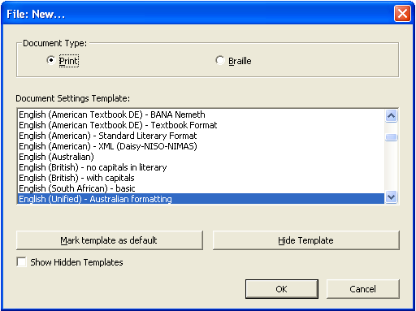
- Document Type: Print (P) for .dxp (the default) or Braille (B) for .dxb
- Document Settings Template: A list of available templates is given, with the default template highlighted. To select a different template, use the mouse or type the first letter of the template name and use the up and down arrows. For an explanation of templates, refer to 2.6.9 Create Template.
- Mark template as default: (M) Select this option when the most frequently used template is highlighted, so that it appears as the default each time a new file is created or opened.
- Hide Template: (H) Select this option when an unneeded template is highlighted, so that it no longer appears in the list of available templates when a new file is created or opened.
- Show Hidden Templates: Check to reveal any templates previously marked as hidden.

2.1.2 Open
File Menu shortcut: O
Direct shortcut: Ctrl-O
Import or Open an existing file. Some file formats that can be opened in DBT include:
- Microsoft Word .doc (refer to 2.7.9 Word Importer for recommended settings when importing these files)
- Duxbury .dxp or .dxb
- Braille-Ready Format .brf (refer to 2.7.10 Formatted Braille Importer for recommended settings)
- Text format .txt
- Microsoft Excel .xls (DBT 11 only)
- Word Perfect .wpd (refer to 2.7.8 WordPerfect Importer for recommended settings)
- XML, including DAISY
- HTML
Rich text files (.rtf) cannot be opened in DBT and must first be converted to one of the above formats.
After selecting a file to open, the Import File dialogue box will open, with the default DBT template highlighted.
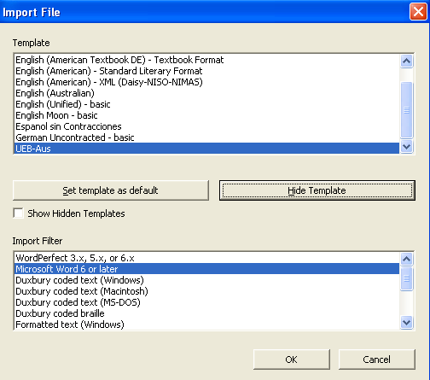
In most cases, the default template and import filter will be correct. Press OK (Enter) to continue.
"Set template as default" and "Hide Template" are also available for customisation of DBT, as described in 2.1.1 New.

2.1.3 Close
File Menu shortcut: C
Direct shortcut: Ctrl-F4
Close the current document without exiting DBT.

2.1.4 Save
File Menu shortcut: S
Direct shortcut: Ctrl-S
Save the current document. For new documents, the Save As dialogue box (as described in 2.1.5 Save As) will be opened.

2.1.5 Save As
File Menu shortcut: A
Direct shortcut: F3
Save the current document in a different location and/or with a different file name.
The file format may also be selected from the following:
Print Documents:
- DBT print (*.dxp): This is the standard format in which to save a Duxbury print file. It is a working Duxbury file containing the print text, code and styles, and it can only be opened within DBT.
- Formatted text (*.prf): Use this format if you wish to create a print file that contains formatted text and can be opened using programs other than DBT. Warning: A .prf file cannot be reopened in DBT as a working file for further editing.
- SGML/ICADD/HTML (*.sgm): Use this format to create a print file that shows the text, code and styles, and can be opened using programs other than DBT. Warning: A .sgm file cannot be reopened in DBT as a working file for further editing.
Braille Documents:
- DBT Braille (*.dxb): This is the standard format in which to save a Duxbury braille file. It is a working Duxbury file containing the braille text, code and styles, and can only be opened within DBT.
- Formatted braille (*.brf): This option creates an embosser-ready file that can be opened using programs other than DBT. It is also appropriate for use with a refreshable braille display. US encoding is advised. This format should only be used for completed documents, as editing is likely to adversely affect page alignment and is not advised.
- Duxbury coded braille (*.bru): This format is an old format originally used as an intermediary format before final production of the .brf. There is no longer any reason to use .bru files.
- Refreshable braille (*.lbf): This format is only available in DBT 11. Linear braille format is a braille file marked with indicators for VersaBrailles and other linear braille devices.

2.1.6 Translate
File Menu shortcut: T
Direct shortcut: Ctrl-T
Translate from print to braille or braille to print. When a .dxp file is translated to .dxb, the original file will remain open, and the translated version will be displayed in a new document with the cursor in the same position in the text.
To return to the original file, use Ctrl-Tab or close the new file (Ctrl-F4). Warning: Never back-translate (i.e. re-translate a file that is the product of translation) as this will introduce errors where ambiguities exist in the braille code.

2.1.7 Print
File Menu shortcut: P
Direct shortcut: Ctrl-P
Produce an ink-print copy of the print or braille document. Do not confuse the print command with embossing!
Before using the print command, ensure that the desired printer has been specified (refer to 2.6.2 Printer Setup).

Printing a .dxp file
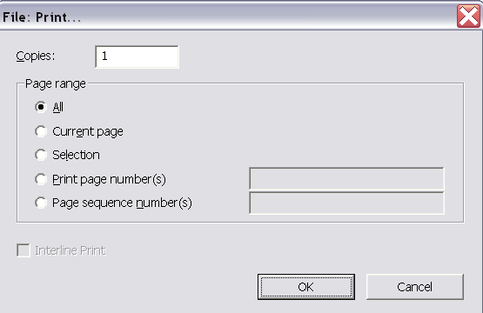
- Copies (Alt-C): The number of copies required.
- Page range:
  - All (Alt-A)
  - Current page (Alt-E): Only print the page that the cursor is on
  - Selection (Alt-L): Print only the text that is selected or highlighted in the document
  - Print page number(s) (Alt-P): This refers to the page numbers as they appear on the pages of the document
  - Page sequence number(s) (Alt-N): This refers to the pages as if the document starts at page 1 and continues with page 2, 3, etc. The page numbers displayed on each page may need to be ignored. Refer instead to the status line when the cursor is on each page required.

Printing a .dxb file
In addition to the above options, when printing a .dxb file the option to print interline print will be given, whereby a print translation will be printed above the braille.
Example:
"Interline" printed version
8,9t]l9e0 pr9t$ v].n
of a braille document.
( a brl docu;t4

2.1.8 Emboss
File Menu shortcut: E
Direct shortcut: Ctrl-E
The Emboss option is only available when working within a braille (.dxb) file.
Before using the Emboss command, ensure that the required embosser has been specified (refer to 2.6.1 Embosser Setup).
A number of options are available for printing multiple copies or only part of the document.
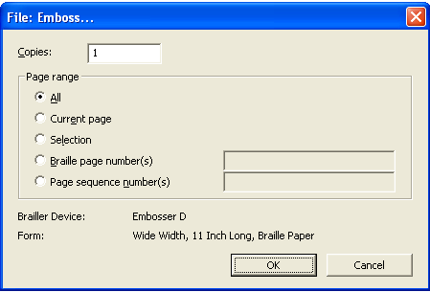
- Copies (Alt-C): The number of copies required.
- Page range:
  - All (Alt-A)
  - Current page (Alt-E): Only print the page that the cursor is on
  - Selection (Alt-L): Print only the text that is selected or highlighted in the document
  - Braille page number(s) (Alt-B): This refers to the page numbers as they appear on the pages of the document
  - Page sequence number(s) (Alt-N): This refers to the pages as if the document starts at page 1 and continues with page 2, 3, etc. The page numbers displayed on each page may need to be ignored. Refer instead to the status line when the cursor is on each page required.

2.1.9 Exit
File Menu shortcut: X
Direct shortcut: Alt-F4
Close all documents and exit DBT. A prompt will be given to save any unsaved documents.

2.2 Edit Menu
(Alt-E)

2.2.1 Undo
Direct shortcut: Ctrl-Z
Undo the last operation. This command can be repeated up to 100 times.

2.2.2 Redo
Direct shortcut: Ctrl-Y
Redo an operation that has just been undone as described in 2.2.1 Undo.
Unlike the Redo function in MS Word, Redo cannot be used in DBT to re-apply the last command - it only works for reversing Undo.

2.2.3 Cut
Edit Menu shortcut: T
Direct shortcut: Ctrl-X
Remove any highlighted text and place it on the clipboard so that it can be moved to another location (in the current file, another DBT file, or another application).
Warning: The Cut function may be used for text, code or styles, but beware that style tags are automatically paired. If one style tag is cut, for example <Para.>, the associated </Para.> tag will also be removed.

2.2.4 Copy
Edit Menu shortcut: C
Direct shortcut: Ctrl-C
Copy any highlighted text and place it on the clipboard so that it can be duplicated in another location (in the current file, another DBT file, or another application).

2.2.5 Paste
Edit Menu shortcut: P
Direct shortcut: Ctrl-V
Paste text from the clipboard to the current location of the cursor. This option is only available after text has been cut or copied from a DBT file that is open in the same session of DBT, or another application.
If a section of text is highlighted when the paste command is used, it will be overwritten with the clipboard text.

2.2.6 Clear
Edit Menu shortcut: L
Direct shortcut: Del
Delete any highlighted text (or text immediately following the cursor location) without placing it on the clipboard.
Warning: The Clear function may be used for text, code or styles, but beware that style tags are paired. If one style is cut, for example <Para.>, the associated </Para.> tag will also be removed.

2.2.7 Select All
Edit Menu shortcut: A
Direct shortcut: Ctrl-A
Highlight the entire document, including all text and codes.

2.2.8 Highlight
Edit Menu shortcut: H
Direct shortcut: Ctrl-H
The Highlight command turns the Arrow/Cursor Keys, Home, End, Page Up and Page Down keys into a highlighter while editing. It has the same effect as holding down the Shift key while using these keys.

2.2.9 Change Case
Direct shortcut: Shift-F3
Toggle between ALL CAPS, no caps, and Initial Caps on highlighted text or within the current word. This function is only available when working in .dxp files, not in braille files.
This function is particularly useful for the removal of block capitals that serve only a decorative purpose, as is often the case with headings or the first few words in a chapter.

2.2.10 Insert File
This function will insert the entire contents of a selected file at the cursor location (or in place of any highlighted text) in the current DBT file.
Files that can be inserted directly into a DBT file include:
- Other DBT files (*.dxp, *.dxb): Note that when inserting another DBT file, its template will also be imported and override the existing template (refer to 2.6.9 Create Template for more information on templates). It may be safer to copy and paste the text from one DBT file to the other, unless it known that the same template has been used for both documents.
- Braille graphics files (*.brg, *.sig, *.vim)
- Music files (*.lim, *.mid, *.mus): Note that music files can only be imported if GOODFEEL version 3 or later is installed on the system.
- Microsoft Word (*.doc, *.docx) and Word Perfect (*.wp, *.wpd, *.wps, *.wp6) files

2.2.11 Goto
Edit Menu shortcut: G
Direct shortcut: Ctrl-G
While working with a .dxb file, quickly relocate the cursor to a different position by specifying either the document page number or reference page number, and the line and cell numbers. (Reference page numbers are also known as "print page numbers", and are defined by the [lea] code.)

2.2.12 Find
Edit Menu shortcut: F
Direct shortcut: Ctrl-F
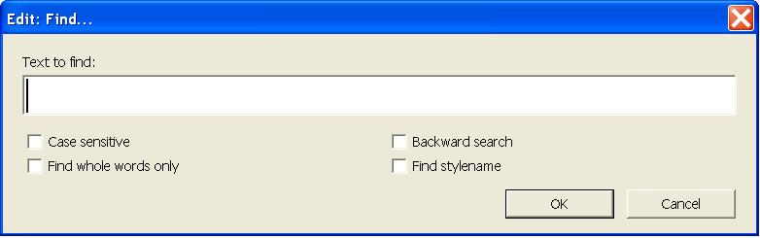
The Find function will search the document for any text entered into the "Text to find" field, by searching from the cursor location to the end of the document.
Note: When working in a .dxp file, only print text can be searched for. When working in a .dxb file, only braille text may be searched for. Braille text can be entered using 6-key entry or as ASCII text.
The Find, or Find and Replace, function can also be applied to a highlighted block of text. Once the highlighted section has been searched, a dialogue box will ask if whether the remainder of the document should also be searched.
The search criteria can be refined using the check boxes for "Case sensitive", "Backward search", "Find whole words only", or "Find stylename".

Find Codes
When code view is toggled on (Alt-F3), the Find function can be used to search for codes or a combination of codes and text.
To type a DBT code into the "Text to find" field, press F9 or Ctrl-[ to open the code brackets, and type the code text within them. Alternatively, use the F5 shortcut to bring up the codes menu, and then insert symbols or codes from the list.

Find Styles
The "Find stylename" checkbox enables a search for style tags. Be sure to enter the name of the style exactly as DBT defines it, including a period (full stop) at the end of the style name, if appropriate.
As with codes, styles can only be found using the Find function when code view (Alt-F3) is toggled on.

2.2.13 Find Again
Edit Menu shortcut: N
Direct shortcut: Ctrl-I
After using the Find function, look for the next occurrence of the same text.

2.2.14 Replace
Edit Menu shortcut: R
Direct shortcut: F6
The Replace dialogue offers the same options as the Find dialogue (2.2.12 Find), but with the additional function of a replacement text string. It is possible to find and replace text, codes, style names or a combination of these.
When working in a .dxp file, it is only possible to search for and replace print text. When working in a .dxb file, only braille text may be searched for and replaced.
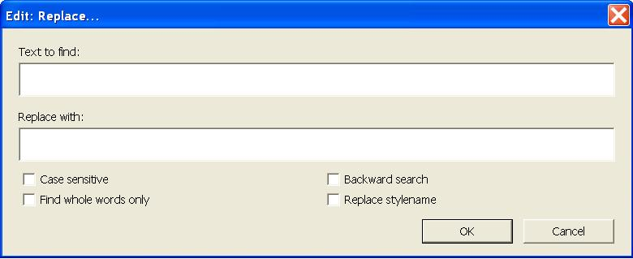
If the search string is found, a prompt will ask whether it should be replaced. The possible answers are Yes (Y), No (N), All (A) or Stop (S).

2.2.15 Spell Check
Edit Menu shortcut: S
Direct shortcut: Shift-F11
A Spell Check can be carried out on a section of highlighted text, or if no text is highlighted, from the cursor location to the end of the document. To check spelling in an entire document, position cursor at the beginning of the document (Ctrl-Home) before starting the Spell Check.
Note: Spell Check options are not available in .dxb documents – only when working in .dxp files.
Note: The Spell Check cannot be easily used in conjunction with a screen reader. It may be easier in such situations to conduct a spell check in Word prior to opening the file in DBT or to use the Find Misspelling feature in DBT (2.2.16 Find Misspelling).
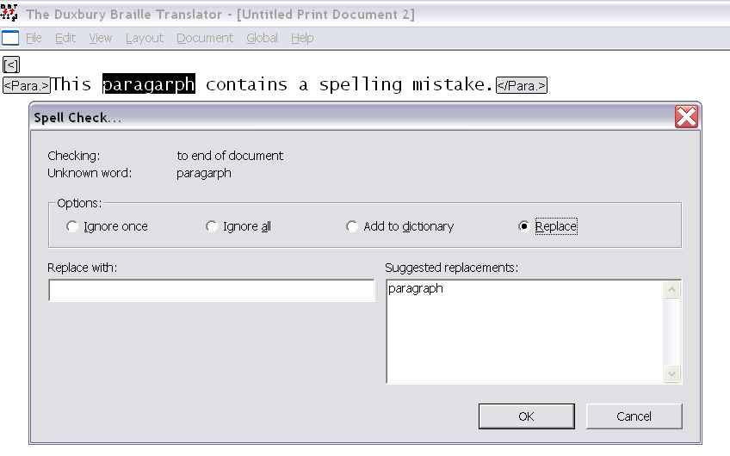
The Spell Check dialogue offers the following options for misspelled words:
- Ignore once (I)
- Ignore all (A)
- Add to dictionary (D): The word will not be detected as a misspelling in future
- Replace (R): Select from the list of suggestions provided, or specify a different correction in the "Replace with" field.

2.2.16 Find Misspelling
Edit Menu shortcut: M
Direct shortcut: F11
This is an alternative method of checking and correcting spelling. It moves the cursor to the next misspelled word and highlights it. The text can then be edited directly in the document without having to use the Spell Check dialogue box.

2.3 View Menu
(Alt-V)

2.3.1 Full Page
View Menu shortcut: F
When Full Page is checked, one full print or braille page is displayed on the screen. To enable this, the size of the text displayed is significantly reduced.
When unchecked, the amount of text displayed on the screen is determined by the display fonts selected, as described in 2.7.5 Fonts.
The default for this setting is unchecked.

2.3.2 Fonts
DBT offers a choice of three fonts for use when working in .dxp and .dxb documents:

Print Font
View Menu shortcut: P
Direct shortcut: Ctrl-F5
This is the standard setting for working in a .dxp file.
If print font is selected while working in a .dxb file, the screen will show the ASCII equivalents for the braille symbols, rather than a true print translation.
Example:
.dxp: number 1
.dxb: numb] #a

Braille Font
View Menu shortcut: B
Direct shortcut: Ctrl-F6
Use this command when working in a .dxb file to view the text in braille font.
This font is not recommended when working in a .dxp file, as the braille that would be shown is not actually translated. Rather, each print character is substituted with its ASCII braille equivalent.
Example:
.dxp: number 1
.dxb: numb] #a

SimBraille Font
View Menu shortcut: S
Direct shortcut: Ctrl-F7
SimBraille font is similar to braille font but the empty dots in each cell are shown as tiny dots known as "shadow dots". SimBraille is usually the preferred font for sighted braille producers working with a braille file.
Example:
.dxp: number 1
.dxb: numb] #a

2.3.3 Six-Key Entry
View Menu shortcut: K
Direct shortcut: F2 (toggle on/off)
This function allows the user to enter braille directly into a .dxb document, using designated keys on the keyboard. This can be very useful for the transcription of mathematics, when .dxb is often the preferred format in which to work.
The default keys for six-key entry are S D F and J K L, giving the user a similar feel to brailling on a Perkins or BrailleNote. If different keys are desired, they can be set under the Global menu (refer to 2.7.6 View Preferences).
It is also possible to use six-key entry in a .dxp document, but it must be applied only within the <Brlinline> style or Grade 0 mode [cz]. When six-key entry is used in .dxp, the ASCII symbol equivalent for braille contractions will be displayed.
Example:
Print: The equation xª = 1¾ …
.dxp: The equation <Brlinline>;;x9a"7#a#c/d</Brlinline> …
.dxb: ,! equa;n ;;x9a"7#a#c/d 444
If six-key entry is used in a .dxp document without the <Brlinline> style or Grade 0 mode [cz], the subsequent braille translation will be literal, and most likely incorrect.
Example:
.dxp: The equation ;;x9a"7#a#c/d …
.dxb: ,! equa;n 22x#i;a^8#g_?a_?c_/d 444
Refer to Appendix 1: ASCII Braille Equivalents for a full list of ASCII symbols and the corresponding braille signs.

2.3.4 Codes
View Menu shortcut: C
Direct shortcut: Alt-F3
The appearance of formatting codes and style tags can be toggled on or off.
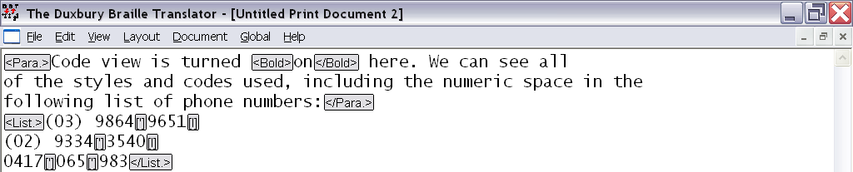
When code view is toggled off, the effect of any formatting codes that are present will be reflected in the layout of the print, for example a paragraph will begin in cell 3, just as it would in the braille translation.
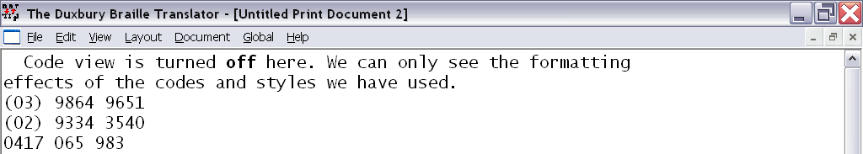
Refer to 3.1 Codes and 3.2 Styles for more information on codes and styles.
Note: The default code view can be specified in the default template, as described in 2.6.9 Create Template.

2.3.5 Translated Line
View Menu shortcut: T
Direct shortcut: Ctrl-F8
When Translated Line is activated, a yellow strip along the bottom of the screen shows the translation of the line on which the cursor is located. This function is available in both print and braille files.
Note: Take care when working in .dxp and checking braille in the translated line, as a small number of symbols are known to translate incorrectly here, in spite of the fact that they will be correct when the whole document is translated to braille. If you notice an error in the translated line, translate to .dxb to be sure before modifying the .dxp.

2.3.6 Cycle Through Open Documents
View Menu shortcut: Type a number based on the order in which documents were opened, i.e. the most recently opened document will be 1, the second will be 2, etc.
The names of all open documents are shown in the sequence in which they were opened. If more than 9 documents are open at one time, select "More Windows" (menu shortcut M) to open the Select Window dialogue box with a full list.

2.4 Layout Menu
(Alt-L)
The Layout menu contains numerous functions that manage all aspects of translation and formatting of text within the document. This menu gives access the many styles, translation codes, and format codes that make DBT so flexible.

2.4.1 Apply Style
Layout Menu shortcut: S
Direct shortcut: F8
For information and advice on using Styles, refer to 3.2 Styles. A list of the styles that are available for use in the Australian and New Zealand DBT formatting templates are given in Appendix 6: Styles in the English (Unified) - Australian Formatting Template and Appendix 7: Styles in the RNZFB Template.
The Apply Style dialogue box has only one control. Type the first letter(s) of a style name and/or use the arrow keys to choose a style from the list of all styles in the template. Select OK (Enter) to apply the style in the document.
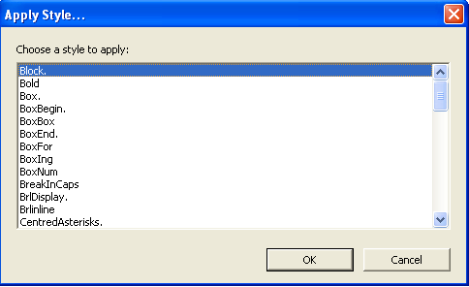
The manner in which a style is applied depends on whether it is a paragraph or character style, as described below.

Paragraph and Character Styles
Paragraph (or linear) styles have a full stop at the end of their name. They apply to whole paragraphs of text and can contain other codes and styles.
Character (or nestable) styles do not have a full stop at the end of their name, and apply to discrete sections of text of any size.
For more detailed information Paragraph and Character styles and their differences, refer to 3.2.1 What are Styles?

2.4.2 Apply Last Style
Direct shortcut: Shift-F8
Apply the paragraph style from the preceding paragraph to the one in which the cursor is located.

2.4.3 Style Level +
Direct shortcut: Alt-Right arrow
Increase the current hierarchical paragraph style level by one increment.
Hierarchical styles are styles that can be manually increased or decreased by one standard level or increment. (Increments are usually 2 cells, but can be set as needed.) The hierarchical styles available in the Australian and RNZFB templates are:
- <Block.>
- <Contents.>
- <H1.> through to <H4.>
- <List.>
- <ListDeep.>
- <ListRm6.>
- <MarginNote.>
- <Note.>
- <Outline.>
- <Para.>
The level of a hierarchical style is indicated by the [hlX] code, where X is the level number.
An increase can be applied to whole blocks by placing the cursor anywhere in the first line of the block.
An increase can be applied to individual or selected items within in a block by adding a hard return immediately before the relevant item, and then pressing Alt-Right arrow.
Note: To apply any subsequent style level adjustments, the cursor must always be positioned after the first hierarchical level indicator.

2.4.4 Style Level −
Direct shortcut: Alt-Left Arrow
Decrease the current hierarchical paragraph style level by one increment, in the same manner described in 2.4.3 Style Level +.

2.4.5 Join Styles
Layout Menu shortcut: J
Combine all paragraphs selected or partially selected into a single paragraph style, with only a hard return code [<] between each paragraph. This command can only be used on a selection of text that contains more than one paragraph, or at least one hard line break.
This feature can be helpful for quickly cleaning up the formatting of text, for example when converting a series of paragraphs into a list:
- Apply the <List.> style to the first paragraph
- Select at least part of this paragraph and those paragraphs following that also need conversion to list items
- Use the Join Styles command (Alt-L, J)

2.4.6 Join Lines
Layout Menu shortcut: O
Replace all line-breaking codes in a selection with spaces. Essentially, this command can be used to re-wrap a paragraph when lines are forcibly broken at the wrong places. Line-breaking codes that can be removed include a hard return [<] line [l] or paragraph [p].
Sometimes source document files contain hard carriage returns at the end of every line - this is common with some PDF files that have been converted to Word, and Plain Text (.txt) files. When imported to DBT, these unwanted line breaks appear as new lines or paragraphs. Toggle code view on (Alt-F3) to see the additional line codes:
Example:
This text was [l]
typed in a word [l]
processor and [l]
then saved as a [l]
plain text file. [l]
Note: Take care to highlight and Join Lines on only one paragraph at a time, otherwise paragraphs will be merged.

2.4.7 Translation Codes
Layout Menu shortcut: T
This sub-menu contains codes for setting, changing and manipulating the braille translation.
Note: Take care when inserting translation codes in the midst of a document. If the braille grade is being changed for only part of a document, remember to change back to the required braille grade at the appropriate point. The effect of a translation code can only be terminated with another translation code.
Example:
.dxp: [cz]grade 0, [tx][g1]grade one, [tx][g2]and grade 2 contracted braille.
.dxb: grade 0, grade one1 & grade #b 3tract$ brl4

Grade 0
Direct shortcut: Alt-0 (Zero)
Insert the [cz] code to render all text following in grade 0 braille.
Grade 0 braille is a direct and literal translation of print ASCII characters to their braille equivalents.
The effect of the [cz] code is terminated by a [tx] code.

Grade 1
Direct shortcut: Alt-1
Insert the [tx][g1] codes to render all text following in grade 1 braille.
Grade 1 braille may also be referred to as "uncontracted braille", because no contractions or shortforms are used. Grade 1 braille is generally used by young children and limited users of braille.

Grade 2
Direct shortcut: Alt-2
Insert the [tx][g2] codes to render all text following in grade 2 braille.
Grade 2 braille has also been known as "contracted braille". It is the most commonly used form of braille, and should be used by default unless otherwise specified for a particular document.

CBC
"Computer Braille Code" is not used in UEB.

Spanish Text
Direct shortcut: Alt-4
Use this option when embedding Spanish text in an English context. The command will insert the [g1][fl-span] codes, which force grade 1 mode and translate any accented letters with the correct native Spanish symbols.

LIFG
Direct shortcut: Alt-5
Use this option when embedding Latin, Italian, French or German in an English context. The command will insert the [g1][fl-lifg] codes to force grade 1 mode and translate any accented letters in the correct native Latin, Italian, French, or German symbols.

2.4.8 Character Codes
Layout Menu shortcut: C
This sub-menu contains codes for some of the more commonly-used braille characters.

Letter Sign
Layout Menu shortcut: L
Warning: Do not use this option when producing UEB, as it will cause the braille to translate incorrectly.

Termination Sign
Layout Menu shortcut: T
Warning: Do not use this option when producing UEB, as it will cause the braille to translate incorrectly.

Hard Space
Direct shortcut: Alt-F2
Insert the ['] code, which acts like a non-space but translates as a space that cannot break across a line.
When a hard space is inserted between two numbers in UEB, a continuation indicator/numeric space " will be inserted. A numeric space is required whenever a space is used in long numbers such as numbers with more than three digits, phone numbers or ISBNs.
Example:
.dxp: 9864[']9326
.dxb: #ihfd"icbf

Group
Layout Menu shortcut: Ctrl-B
Insert the codes [:] and [;] to group (or keep together) a block of text. The codes serve to treat a few words as one, for example to set two or three words as flush right.
Note: The same effect of grouping can also be achieved by inserting a hard space between each word in the block.
Warning: Be careful to group only small blocks – even though the text may easily fit on one line in the .dxp file, it may require two or more lines in braille.

2.4.9 Line Codes
Layout Menu shortcut: L
This sub-menu contains a range of codes for formatting lines:
- New Line: (Ctrl-L) [l] Go to cell 1 of a new line if not already in cell 1 on the current line.
- Skip Line: (Ctrl-K) [sk1] Insert one blank line.
- Suppress Skipped Line: (Alt-K) [skn] Suppress one blank line produced as an effect of the preceding or following commands. For example, <H2.>[skn] will remove the blank line before the heading. This command may be useful where two blank lines would otherwise be created.
- Centering: (Shift-F6) [hds] … [hde] Align all text in the centre of the braille page.
- Flush Right: (Shift-F7) [fr] Align the next word on the right of the braille page. Note that a space will force any following text onto a new line. To align more than one word or symbol on the right, they must be grouped together (refer to "Group" in 2.4.8 Character Codes).
- Flush Right w/Leader: (Alt-F7) [fr;p~".] Insert a line of dot 5s " and align the next word on the right of the braille page. Note that the code associated with this shortcut can be changed, as described in 2.7.7 Shortcut Preferences.
- Tab to Runover Point: (sub-menu shortcut R) [l][run] Go to a new line, with text starting in the runover position. This is the equivalent of a soft carriage return in Word.
- Single Spacing: (sub-menu shortcut S) [svsbl0] single line spacing. This is the default setting.
- Double Spacing: (Shift-F2) [svsbl1] Double line spacing.
- New Paragraph: (Ctrl-M) [p]

2.4.10 Left Margin
Layout Menu shortcut: E
This sub-menu contains the options 1, 2, 3 (F4), 4, 5, 7, 9, 11 and 13.
This command will insert an [indN] code, where N specifies the number of cells by which the left margin will be indented. Remember to reset the left margin to cell 1 at the end of the indented section, using one of the codes [ind] [ind0] or [ind1] (all are equivalent).
Note: This feature is intended only to make temporary changes to the left margin. Do not use this feature as a way of reformatting the document for a new paper size – instead, use the "Embosser Setup" dialogue under the Document Menu to specify a form (refer to 2.6.1 Embosser Setup).

2.4.11 Right Margin
Layout Menu shortcut: I
This sub-menu contains the options 0, 1, 2, 4 and 6 (Shift-F4).
This command will insert a [rmN] code, where N specifies the number of cells by which the right margin will be indented. Remember to reset the right margin to 0 at the end of the indented section, using [rm] or [rm0].
This feature is useful for ensuring that the right margin contains only reference numbers and no text, for example when creating a contents page or inserting line numbers for plays or poetry.
Note: This feature is intended only to make temporary changes to the right margin. Do not use this feature as a way of reformatting the document for a new paper size – instead, use the "Embosser Setup" dialogue under the Document Menu to specify a form (refer to 2.6.1 Embosser Setup).

2.4.12 Runover Offset
Layout Menu shortcut: R
This sub-menu contains the options 0, 1, 2 (Ctrl-R), 3, 4, 6, 8, and 10.
This command will insert a [ptysN] code, whereby text begins on the margin and N specifies the number of cells by which any runover will be indented. Remember to reset the runover offset to 0 at the appropriate location by inserting a [ptys0] or [ptye] code.
Note: The poetry runover code overrides the runover setting in a [hi] code (refer to 2.4.3 Style Level +). If a suitable hierarchical style is available, the [hl] code is preferable because the same layout can be achieved with the additional advantage of incremental indentation through the hierarchy function. Refer to Appendix 5: DBT Codes for more information.

2.4.13 Math Codes
Layout Menu shortcut: M
This sub-menu contains many codes related to formatting and translation in Nemeth Mathematics notation. Only those codes that are relevant when translating to UEB mathematics have been described here and all others should be ignored.
For a more general discussion of transcription techniques for mathematical and technical materials, refer to 3.3.4 Numbers, Basic Mathematics and Technical Materials.

Base (subscript)
Insert the [bs] and [be] codes to add a subscript symbol in the braille. A grade 1 indicator is also inserted automatically if the text is not already in a grade 1 context.
Example:
Print: point P₁
.dxp: point P[bs]1[be]
.dxb: po9t ,p;5#a

Power (superscript)
Insert the [ps] and [pe] codes to add a superscript symbol in the braille. A grade 1 indicator is automatically added in the braille translation if the text is not already in a grade 1 context.
Examples:
Print: 10²
.dxp: 10[ps]2[pe]
.dxb: #aj9#b
Print: footnote¹
.dxp: footnote[ps]1[pe]
.dxb: footnote;9#a

Subscript (directly under)
Insert the [us] and [ue] codes to indicate text that is written directly under an "item". The beginning of the item is marked with the code [e].
Example:
Print: 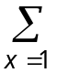
.dxp: [e] {D+e253}[us]x=1[ue]
.dxb: ,.s.5<x"7#a>

Superscript (directly over)
Insert the [os] and [oe] codes to indicate text that is written directly above an "item". The beginning of the item is marked with the code [e].
Example:
Print:
heat and light
.dxp: [e][q~;\o][os]heat and light[oe]
.dxb: ;\o.9<h1t & li<t>

Fraction
Insert the [fs] [fl] [fe] codes to add fraction symbols in the braille. [fs] designates the fraction start, [fl] designates the fraction line, and [fe] designates the fraction end.
Examples:
Print: 3½
.dxp: 3[fs]1[fl]2[fe]
.dxb: #c#a/b
Print: 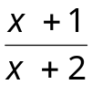
.dxp: [fs]x+1[fl]x+2[fe]
.dxb: ;(x"6#a./x"6#b)

Square roots and other radicals
Insert the [sqrts] and [sqrte] codes to indicate the start and end of a square root in the braille. A grade 1 indicator is automatically added to the braille if the text is not already in a grade 1 context.
Examples:
Print: 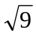
.dxp: [sqrts]9[sqrte]
.dxb: ;%#i+
Print: 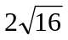
.dxp: 2[sqrts]16[sqrte]
.dxb: #b%#af+
Insert the [ixrts] [ixrtd] [ixrte] codes to indicate an indexed radical. [ixrts] designates the start of the expression, [ixrtd] designates the delimiter between the index and the root, and [ixrte] designates the end of the root.
Example:
Print: 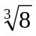
.dxp: [ixrts]3[ixrtd]8[ixrte]
.dxb: ;%9#c#h+

Grade 1
Insert the [i] code to translate the next expression in grade 1 braille. Its effect lasts only until the next space. Use this code to uncontract a single word such as an acronym.
Example:
.dxp: [i]STD call
.dxb: ,,std call

Grade 1 with Letter Sign
Insert the [ii] code to translate the next expression in grade one and insert a grade one indicator. Its effect lasts only until the next space.
Example:
.dxp: [ii]y-a-c-h-t
.dxb: ;;y-a-c-h-t

Bold Verbal Passage
Insert the [fts~b] [fte~b] codes to add the appropriate bold indicator(s) in the braille.
Examples:
Print: wise
.dxp: wi[fts~b]s[fte~b]e
.dxb: wi~2se
Print: fairy
.dxp: [fts~b]fairy[fte~b]
.dxb: ~1fairy
Print: Take it easy!
.dxp: [fts~b]Take it easy! [fte~b]
.dxb: ~7,take x easy6~'

Italic Verbal Passage
Insert the [fts~i] [fte~i] codes to insert the appropriate italic indicator(s) in the braille.
Examples:
Print: wise
.dxp: wi[fts~i]s[fte~i]e
.dxb: wi.2se
Print: fairy
.dxp: [fts~i]fairy[fte~i]
.dxb: .1fairy
Print: Take it easy!
.dxp: [fts~i]Take it easy![fte~i]
.dxb: .7,take x easy6.'

2.4.14 Page Codes
Layout Menu shortcut: G
This sub-menu contains codes for setting, changing and manipulating pagination:
- New Page: (Ctrl-Enter) [pg]
- New Reference Page: (Alt-Enter) [lea]
- Block Protect: (sub-menu shortcut B) When applied to a text selection, the [kps] … [kpe] codes keep the selection together on the same braille page
- Vertical Centring: (sub-menu shortcut V) Centres a block of text vertically on the page. The [vcs] code should begin the vertically centred page, and [vce] must be placed immediately after the [pg] code that ends the vertical centring.

2.4.15 Set Page Number
Layout Menu shortcut: N
In the Set Page Number dialogue, enter the desired page number, and if desired, use the radio buttons to choose between Roman and Arabic numbering. The default is Arabic.
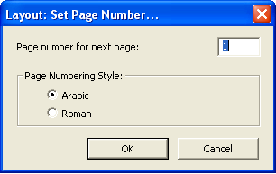
The [pvN][pntX] codes will be inserted, where N indicates the number of the page, and X indicates the numbering style – "a" for Arabic, and "r" for Roman.
Note: Page numbering codes must be the very first thing on the braille page; otherwise they will not take effect until the following page.
For more complicated page numbering, refer to Appendix 5: DBT Codes.

2.4.16 Header
Layout Menu shortcut: H
Create or change a running header. A running header, also known as a running title, contains information about the current chapter, part, or section name, and runs along the top of each braille page to help the reader easily identify their position in the book.
Text is designated as a running header using the [tls] … [tle] codes.
A running header can be discontinued by inserting the [tld] code.
For a running header to take effect on the current braille page, it must be placed at the very beginning of that page, immediately after a [pg] code if present. If other text or codes precede the [tls] … [tle] codes, the running header will not appear until the following braille page.
Note: A running header is quite different from – and not to be confused with – a heading.
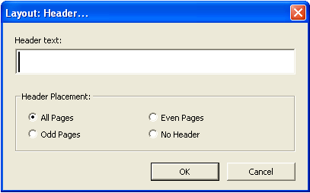

Header Text
Enter the text of the running header into the "Header text" field. This text should be in print for a .dxp document, or braille for a .dxb.
The template in use will determine how many cells are allowed for a running header. The default minimum number of cells between the running header and the margins is 4 for the Australian template and 8 for the New Zealand template. Check any running headers in the braille translation to ensure that they fit on one line and that there is some space between the running title and page numbers. If not, shorten the running title or (in New Zealand only) reduce the running-header side room using the code [svrhsM:N] where M sets the fixed amount of space reserved on the left for the largest page number expected, and N for a similar amount on the right. The values of M and N must be equal.

Header Placement
Specify where the header will appear:
- All Pages
- Odd Pages
- Even Pages
- No Header - select this option to discontinue an earlier header.
Running Header placement can also be controlled manually using the [svrhpN] code. N is 1 for usage on odd pages only, 2 for even only, 3 for usage on both, 0 on neither. The default value is 3, i.e. usage on both.

2.4.17 Footer
Layout Menu shortcut: F
Create or change a running footer. The Footer functions in the same way as the Header (see above) and it is indicated by the codes [rfs] … [rfe].
In New Zealand a running footer is used for dictionaries as described in the BANA formatting guidelines.
Current Australian formatting guidelines do not endorse the use of a braille footer, however it may be useful in special circumstances.

2.4.18 Generate Table of Contents
Layout Menu shortcut: B
Automatically generate a table of contents within a braille document, using either braille page numbers or print page numbers.
For many transcribers, this is one of the most labour-saving of DBT's options – however, in order to take advantage of this feature, it is vital that the document contains appropriate heading styles.
To automatically generate a table of contents, follow these steps:
- Ensure that all headings within the document are formatted using styles
- Translate to braille if not already in a .dxb file
- Place the cursor where the table of contents should be inserted. This will usually be on a blank page near the top of the document between two [pg] codes
- Select "Layout" (Alt-L), "Generate Table of Contents" (B)
- A dialogue box will appear, containing the default settings as specified in the template being used. For the English (Unified) - Australian Formatting template, the settings will be as follows. These settings can be changed if desired:
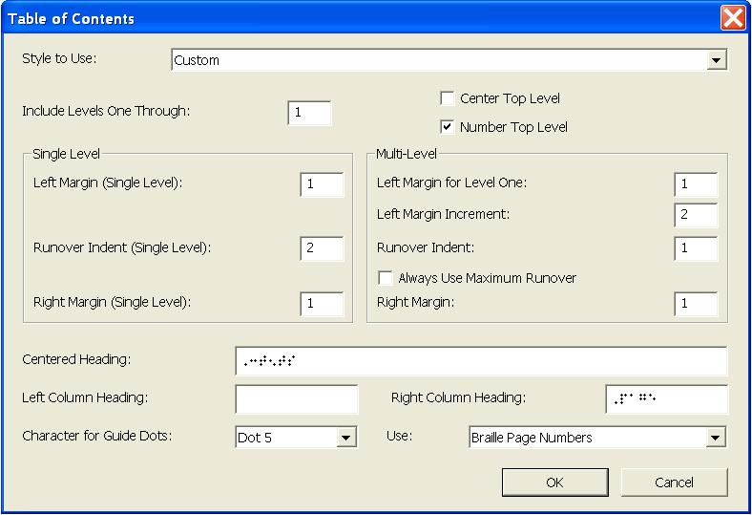
  - Style to Use: Custom. This allows all other settings to be adjusted.
  - Include Levels One Through: 1. Change this to 2, 3 or 4 to make sub-headings appear on the contents page. One or two levels will generally suffice for most documents.
  - Center Top Level: Unchecked
  - Number Top Level: Checked
  - Single Level: Adjust these settings if only level 1 headings are being listed on the contents page.
    - Left Margin: 1
    - Runover Indent: 2
    - Right margin: 1
  - Multi-Level: Adjust these settings if subheadings (more than one level of heading) are being listed on the contents page.
    - Left Margin for Level 1: 1
    - Left Margin Increment: 2
    - Runover Indent: 1
    - Always use Maximum Runover: Unchecked
    - Right Margin: 1
  - Centered Heading: ,3t5ts
  - Left Column Heading: Blank. This may be changed to ,*apt}
  - Right Column Heading: ,page
  - Character for Guide Dots: Dot 5. Other choices are dot 3, dot 6, or dots 3-6.
  - Use: Braille Page Numbers. This may be changed to "Print Page Numbers".
- Select "OK" to insert the table of contents.
To continue working in a print (.dxp) file, insert the automatically generated table of contents into the .dxp file:
- Back-translate (Ctrl-T) the braille to print
- Ensure that view codes is switched on (Alt-F3 if necessary)
- Select the table of contents, i.e. all text and codes from <toc:marker> to [top]
- Copy (Ctrl-C)
- Exit the print (.dxp) document without saving
- Exit the braille (.dxb) document without saving
- Paste (Ctrl-V) the table of contents in the correct location in the .dxp file

2.4.19 Picture
Layout Menu shortcut: P
Insert or realign tactile graphics images that have been produced using other software such as QuickTac or Picture Braille. Accepted image file formats are .brg .sig and .vim.
Select "Add" to insert a picture file at the current cursor position in the document. The picture will be centred on the page. When the cursor is resting on a picture, use Align Left, Align Center or Align Right to change the alignment.
Hint: It is helpful to have code view (Alt-F3) toggled on to check that the cursor is resting on a picture. The picture will appear as a [gd] code.
Use the backspace or delete keys to remove the picture from the document.

Resolution
The picture will be produced using closely embossed dots. Resolution controls how closely together the dots are placed.
Note: Not all braille embossers can produce pictures, so please check that the embosser being used supports this function. Contact the embosser supplier or manufacturer for further information.
Warning: If using an interpoint (double-sided) embosser, braille cannot be embossed on the reverse side of any page containing a picture. Add a blank braille page either before or after the page with the picture on it and check to ensure the document has embossed correctly.

2.4.20 Code List
Layout Menu shortcut: D
Direct shortcut: F5
The Code List provides access to the complete menu of DBT codes. It also offers some characters that cannot normally be entered directly using the keyboard.
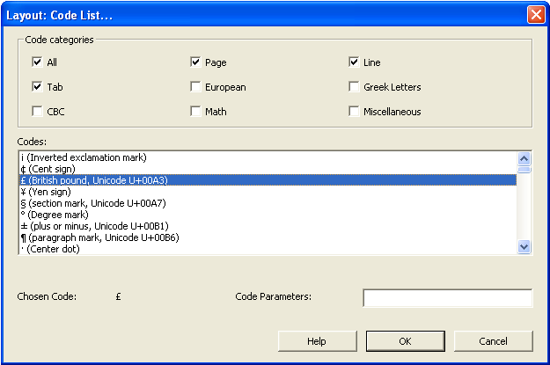
- Code categories: Check "All" to see all categories of codes or only selected categories to restrict the codes list.
- Codes: Type the first letter and use the arrow keys to highlight a selected code or character from the list.
- Code Parameters: Type in any parameters necessary, for example for the code [hi] type the hierarchy level number.
Note: Some of the codes in the F5 menu are outdated, obsolete, or not relevant for UEB translation, so the effect of any unfamiliar codes should be checked thoroughly.

2.5 Table Menu
(Alt-T)
The Table Menu is a new feature in DBT 11.1 and is not available in earlier versions. For advice on creating tables in earlier versions of DBT, refer to 3.4.4 Tables.
The easiest way to format a table in DBT 11.1 is to create the table in Word then import it into DBT, which will automatically apply all necessary codes to the table data and select a table type. To change the table type, position the cursor inside the table then open the Table Properties dialogue box as described in 2.5.2 Table Properties.

2.5.1 Create
Open the Table Properties dialogue box and insert all of the codes required to create a new blank table, i.e.
- [htbs] table start. This code includes information about the table type, as described below.
- [htbe] table end
- [>] column separator
- [<] row separator
Note: The Create option is enabled only when the cursor is placed outside of any existing tables in the document.
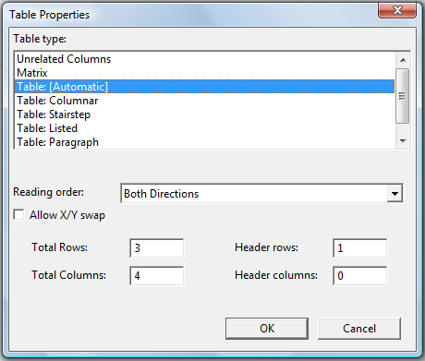

Table Type
Table Type gives a list of different table layouts which DBT can implement. The choice of format should be determined by the type, quantity and layout of data in the original print table and how it is to be used by the braille reader. Choices include:
- Unrelated columns (u): Material is formatted in columns but there are no "leader" or "filler" dots between the columns. Use this option for a list of items that do not really form a table but will fit more compactly on the page in multiple columns, such as a vocabulary list.
Example:
Print:
duck | jack | clock
back | hack | black

.dxp: [htbs;u:0:0:b:n:a]duck[>]jack[>]clock[<]
back[>]hack[>]black[htbe]
.dxb: duck jack clock
back hack black

- Matrix (m): As with unrelated columns, material is formatted in columns but there are no "leader" or "filler" dots between the columns. Use this option for a mathematical matrix. Note that the mathematical brackets will need to be added.
Example:
Print:
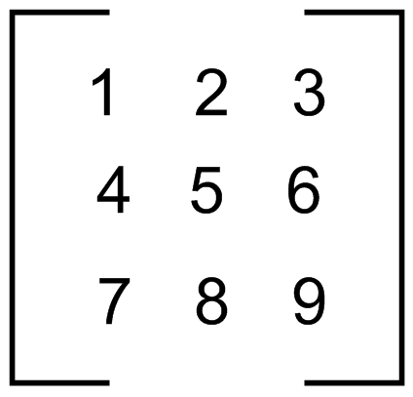
.dxp: [htbs;m:0:0:b:n:a][q~,.<]1[>]2[>]3[q~,.>][<]
[q~,.<]4[>]5[>]6[q~,.>][<]
[q~,.<]7[>]8[>]9[q~,.>][htbe]
.dxb: ,.<#a #b #c,.>
,.<#d #e #f,.>
,.<#g #h #i,.>

- Table: [Automatic]: This is the default choice, and is the setting for all tables in a newly-imported document. DBT uses its own discretion in choosing the most appropriate layout.
- Table: Columnar (r;c): Material is formatted in columns with "leader" or "filler" dots when the data for a cell falls short of the full column width. DBT automatically determines all column widths. Use this option as the first choice when the items in all rows can easily fit across one braille line.
Example:
Print:
travel | 2000 | 2010
motor vehicle | 50% | 49%
public transport | 40% | 38%
bicycle | 9% | 11%
walk | 1% | 2%

.dxp: [htbs;r:1:0:b:n:c]travel[>]2000[>]2010[<]
motor vehicle[>]50%[>]49%[<]
public transport[>]40%[>]38%[<]
bicycle[>]9%[>]11%[<]
walk[>]1%[>]2%[htbe]
.dxb:
travel #bjjj #bjaj
"333333333333333 "3333 "3333
motor vehicle #ej.0 #di.0
public transport #dj.0 #ch.0
bicycle """""""" #i.0 #aa.0
walk """"""""""" #a.0 #b.0
- Table: Two-page (r;2): is like Table: Columnar, but the formatted result is wider and will be placed on facing pages. Use this option for tables that need to be read in both directions but will not fit across a single page. If embossing single sided, the first page must be flipped over so that the two pages are facing. If embossing double sided, insert the codes [pg][sd0] to ensure that the table starts on a left leaf.
- Table: Stairstep (r;s): Material is formatted like an outline, with each new row starting a new line on cell one. The second column of each row starts on a new line on cell three. The third column starts on cell five, and so forth. Use this option for tables with only a few columns (as column headings must be remembered by the reader) and a large amount of text in each cell (i.e. tables which cannot be presented as columnar).
Example:
Print:
Name | Age | Address | Phone
Albert Benson | 57 | 12 Crescent st VERMONT 3156 | (03) 978 6533
Janice Little | 34 | 33/120 Nicholson st EAST BRUNSWICK 3057 | 0419 888 777
Andrea Simpson | 42 | 38 Hillside way IVANHOE 3073 | (03) 9334 8721
.dxp: [htbs;r:1:0:b:n:s]Name[>]Age[>]Address[>]Phone[<]
Albert Benson[>]57[>]12 Crescent st VERMONT 3156[>]
(03) 978[']6533[<]
Janice Little[>]34[>]33/120 Nicholson st EAST BRUNSWICK 3057[>]0419[']888[']777[<]
Andrea Simpson[>]42[>]38 Hillside way IVANHOE 3073[>](03) 9334[']8721[htbe]
.dxb:
,"n
,age
,address
,ph"o
,alb]t ,b5son
#eg
#ab ,cresc5t st ,,v]mont
#caef
"<#jc"> #igh"fecc
,janice ,ll
#cd
#cc_/#abj ,ni*olson st ,,ea/
,,brunswick #cjeg
#jdai"hhh"ggg
,&rea ,simpson
#db
#ch ,hillside way ,,ivanhoe
#cjgc
"<#jc"> #iccd"hgba

- Table: Paragraph (r:p): Each table row is formatted as a single "paragraph", with a distinct text delimiter inserted between the text for adjacent rows and another to indicate the end of a row. A distinct text item is used in place of an empty table cell. This option is suitable only for tables that will be read in a linear fashion across each row.
Example:
Print:
Name | Age | Address | Phone
Albert Benson | 57 | 12 Crescent st VERMONT 3156 | (03) 978 6533
Janice Little | 34 | 33/120 Nicholson st EAST BRUNSWICK 3057 | 0419 888 777
Andrea Simpson | 42 | 38 Hillside way IVANHOE 3073 | (03) 9334 8721

.dxp: [htbs;r:1:0:b:n:p] Name[>]Age[>]Address[>]Phone[<]
Albert Benson[>]57[>]12 Crescent st VERMONT 3156[>]
(03) 978[']6533[<]
Janice Little[>]34[>]33/120 Nicholson st EAST BRUNSWICK 3057[>]0419[']888[']777[<]
Andrea Simpson[>]42[>]38 Hillside way IVANHOE 3073[>](03) 9334[']8721[htbe]
.dxb:
,"n; ,age; ,address; ,ph"o4
,alb]t ,b5son; #eg; #ab ,cresc5t
st ,,v]mont #caef; "<#jc">
#igh"fecc4
,janice ,ll; #cd; #cc_/#abj
,ni*olson st ,,ea/ ,,brunswick
#cjeg; #jdai"hhh"ggg4
,&rea ,simpson; #db; #ch ,hillside
way ,,ivanhoe #cjgc; "<#jc">
#iccd"hgba

- Table: Listed (r:l): Material is formatted as a list with the column header repeated at the start of each new cell. Use this option for large tables that cannot easily be formatted in a columnar layout, especially when the data makes it hard to tell one column for another in isolation. The table must include one row of headers at the top of the table and one column of headers.

Example:
Print:
City | Jan | Feb | Mar | Apr | May | Jun | Jul | Aug | Sep | Oct | Nov | Dec
Melbourne | 26 | 26 | 24 | 20 | 17 | 14 | 13 | 15 | 17 | 20 | 22 | 24
Sydney | 26 | 26 | 25 | 22 | 19 | 17 | 16 | 18 | 20 | 22 | 24 | 25
Brisbane | 30 | 29 | 28 | 26 | 23 | 21 | 20 | 22 | 24 | 26 | 28 | 29

.dxp: [htbs;r:1:1:b:n:l]City[>]Jan[>]Feb[>]Mar[>]Apr[>]May[>]Jun[>]Jul
[>]Aug[>]Sep[>]Oct[>]Nov[>]Dec[<]
Melbourne[>]26[>]26[>]24[>]20[>]17[>]14[>]13[>]15[>]17[>]20[>]22[>]24
[<]
Sydney[>]26[>]26[>]25[>]22[>]19[>]17[>]16[>]18[>]20[>]22[>]24[>]25[<]
Brisbane[>]30[>]29[>]28[>]26[>]23[>]21[>]20[>]22[>]24[>]26[>]28[>]29[<]
[htbe]
dxb:
,c;y
,melb\rne
,jan3 #bf
,feb3 #bf
,m>3 #bd
,apr3 #bj
,may3 #ag
,jun3 #ad
,jul3 #ac
,aug3 #ae
,sep3 #ag
,oct3 #bj
,nov3 #bb
,dec3 #bd

,c;y
,sydney
,jan3 #bf
,feb3 #bf
etc.

Reading order
The "Reading order" control is used to indicate whether the table will most often be read across rows or down columns. This influences DBT’s choice of table format.
Check "Allow X/Y swap" if it is acceptable for the axes of the table to be inverted to assist in allowing the table to fit across the braille page.

Rows, columns and headers
When creating a new table, fill in the "Total rows" and "Total columns" controls so that DBT will automatically insert the correct number of codes to delimit cells [>] and rows [<]. Type the data for one cell between each of these codes.
Warning: Do not adjust the "Total rows" and "Total columns" controls when modifying an existing table as the results may be unpredictable.
The "Header rows" and "Header columns" controls tell DBT how many rows and columns hold header labels instead of data. This is useful to ensure a proper formatting result.

2.5.2 Table Properties
Open the Table Properties dialogue box (as described above) to control the layout of an already-existing table.
Note: The "Table Properties" item is enabled only when the cursor is within an existing table.

2.6 Document Menu
(Alt-D)
The Document Menu contains settings that are stored with an individual document file. DBT stores "sticky document information", including embosser setup, with each document. This enables transcribers to work easily with a range of documents intended for different paper sizes, for example.
The document menu is initially set by the template selected when a file is first created. If any settings are changed in the document menu, the template will not be affected and neither will other documents created from the same template.
The Document Menu also contains commands that manage templates so that the menu settings and styles can be preserved for later use.
Note: If working with a .dxp document, be sure to make all document menu changes to the .dxp file rather than the translated .dxb.

2.6.1 Embosser Setup
Document Menu shortcut: E
Direct shortcut: Ctrl-F11
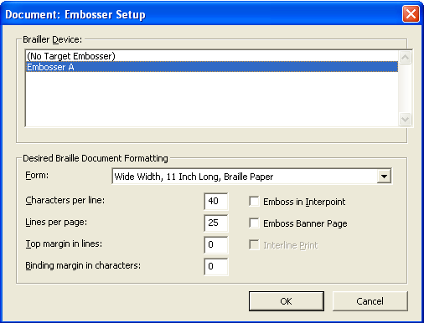

The Document Embosser Setup dialogue specifies embosser settings only for the current document. If the document is a print document, the settings will be applied only when the document is translated to braille. The settings will also be stored as sticky document information when the document is saved.
- Brailler Device (Alt-D): A list of installed embossers. Use the arrow keys to highlight the desired embosser. Note: If the required embosser does not appear in the document embosser menu, it must be added through the Global Embosser menu (refer to 2.7.1 Embosser/Printer Set-Up).
- Desired Braille Formatting:
  - Form: (Alt-F) A drop-down menu shows the forms (paper sizes) supported by the selected embosser.
  - Characters per line: (Alt-C) A default value is given based on the embosser and form chosen, however the value can be changed.
  - Lines per page: (Alt-L) A default value is given based on the embosser and form chosen, however the value can be changed.
  - Top margin in lines: (Alt-T) Lines left blank at the top of each page in addition to the top margin.
  - Binding margin in characters: (Alt-B) Characters left blank at the side of the page in addition to the binding margin.
  - Emboss in Interpoint: (Alt-I) Check for double sided embossing.
  - Emboss Banner Page: Check to emboss a banner page at the start of the document with basic identification information such as file name and date.
  - Interline Print: (Alt-P) This option is only available for embossers that can also print, such as Tiger embossers. If checking this option reduces the number of lines that the embosser can fit on one page, DBT will make the necessary adjustments.
The "OK" control (Enter) accepts all settings in the dialogue and applies them to the current document only. Upon closing the dialogue, a warning will be given if the document format will change as a result of any settings that have been applied – this is important because the table of contents may need to be regenerated.

2.6.2 Printer Setup
Document Menu shortcut: P
Direct shortcut: Ctrl-F12
There are two probable situations where a document may need to be printed (as opposed to embossed). The first is to obtain a copy of the text (.dxp) document, and the second to obtain a print copy of the braille (.dxb) document. In the latter case (most often used by sighted braille proof readers), special care needs to be taken in setting up the formatted page size.
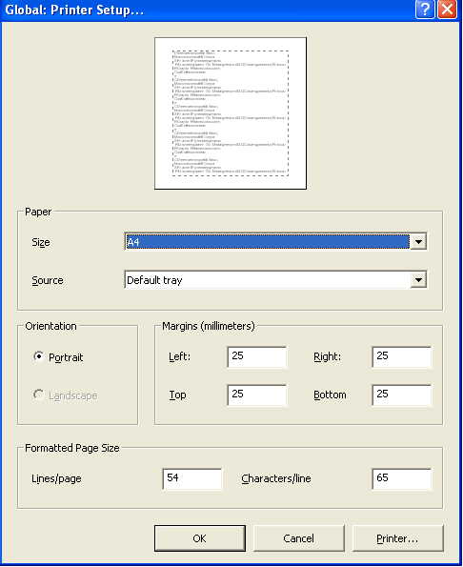

Printer
Direct shortcut: Alt-P
Select an ink printer before making appropriate changes to the main dialogue.
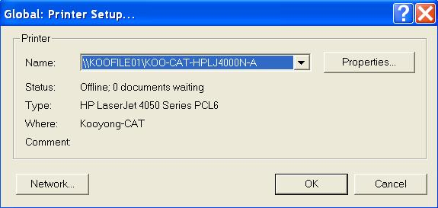
- Name: Select the printer from the drop-down list.
- Properties: (Alt-P) Open another dialogue that is appropriate to the properties available for the printer selected.
- Network: (Alt-W) If the printer is on a Network, this will bring up the standard Windows Network Printer dialogue appropriate to the operating system. Once the printer is selected, press OK to return to the main Printer Setup dialogue.

Paper
- Size: (Alt-Z) Select the size of paper to be used for printed output. The list of sizes available is determined by the make and model of printer selected.
- Source: (Alt-S) Options given (for example, paper feed method or printer tray) are dependent on the make and model of printer selected.

Orientation
- Portrait: (Alt-O) Vertical page alignment.
- Landscape: (Alt-A) Horizontal page alignment.

Margins (millimetres)
- Left: (Alt-L)
- Right: (Alt-R)
- Top: (Alt-T)
- Bottom: (Alt-B)

Formatted Page Size
- Lines per page: (Alt-I)
- Characters per line: (Alt-C).
Note: DBT prints using the font and point size specified in "Fonts" under the Global Menu (2.7.5 Fonts). Some experimentation may be required to ensure that the output fits the selected paper size. For example, with 22 point Braille or SimBraille font, only the first 25-26 lines per page, and 30-32 characters per line will be printed.
These settings will be ignored if "Auto-determine point size for printed output" has been checked in the "Fonts" submenu. (For more information refer to 2.7.5 Fonts.)

2.6.3 Page Numbering
Document Menu shortcut: N
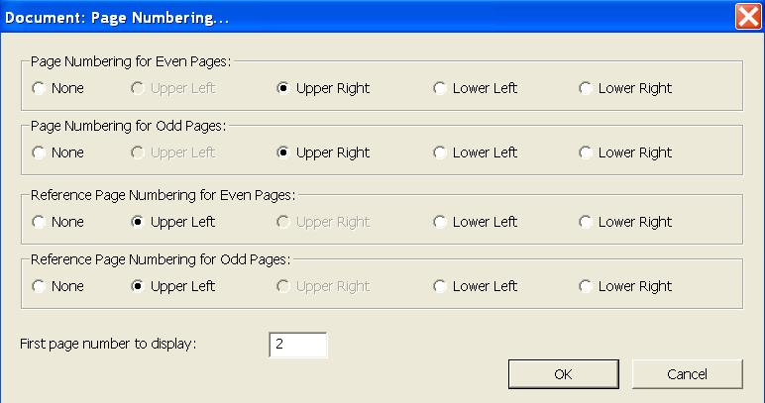

The Page Numbering dialogue sets the location of page numbers throughout the document. The first four controls specify the positioning of braille page numbers and reference page numbers on odd and even pages. Choices available are:
- None
- Upper Left
- Upper Right
- Lower Left
- Lower Right
Note: Both types of page numbers cannot be placed in the same corner. For example, if lower right is selected for the reference page number on odd pages, lower right is not available for page numbering on odd pages.
Australian formatting standards specify that the braille page number is placed in the top right corner and the print reference page number is in the top left corner. These settings are stored in the English (Unified) - Australian Formatting template.
New Zealand formatting standards specify that the braille page number is placed in the bottom right corner and the print reference page number is in the top right corner. These settings are stored in the RNZFB template.
The fifth and final control is a text box that defines the braille page on which the page numbering should begin.

2.6.4 Translation Tables
Document Menu shortcut: T
The translation tables determine the substitution rules used by DBT. Only one table can be selected for each document. For UEB translation, the correct translation table is English/Unified, as specified in the Australian and RNZFB templates.
The only time that the translation table may need to be changed is when producing a whole document in a foreign braille code.

2.6.5 Hyphen Table
Document Menu shortcut: H
This sub-menu offers a number of options for controlling how braille breaks over lines where hyphens and/or dashes occur in the text. Only one of the available hyphen tables can be selected for any given document.
- None: (N) Braille words will not be broken across lines, regardless of the presence of a hyphen or dash.
- Dashes: (D) Allow braille words to break across lines only where dashes occur.
- Dashes and Hyphens: (H) Allow braille words to break at an explicit hyphen or a dash in the text. This is the default option.
- French: (F) Actively hyphenate French braille words at the ends of lines. This option may only be used in conjunction with the French translation table.

2.6.6 Add Style
Document Menu shortcut: A
Open the Add Style dialogue box to create a new style. Styles are explained in 3.2 Styles.
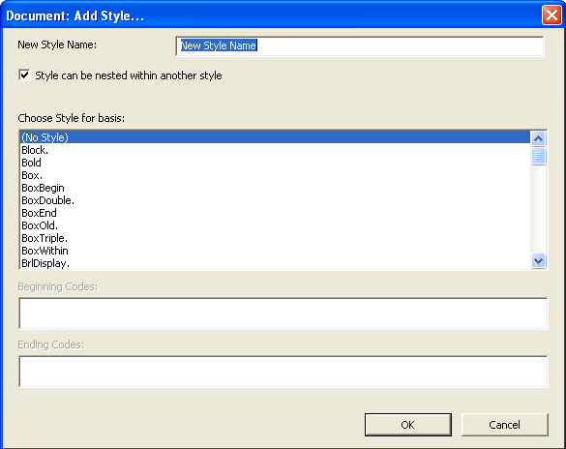
- New Style Name: Enter a meaningful name for the new style. No spaces are permitted in the name. It is not necessary to insert a full stop after paragraph styles as this will be done automatically.
- Style can be nested within another style: Check to create a character style; uncheck to create a paragraph style. For information on the difference between these style types, refer to 3.2.1 What are Styles?.
- Choose style name for basis: Select an existing style from the list to create a similar style. The codes of the existing style will be provided for modification.
Select "OK" (Enter) to open the Edit Styles dialogue box.
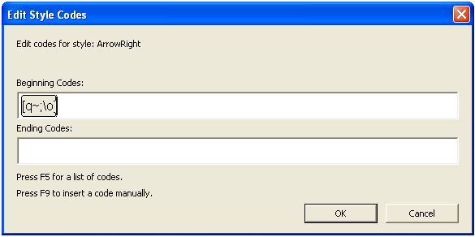
Enter or modify the beginning and ending codes. Note that each separate code should be enclosed in square brackets, which can be added using the F9 shortcut. The F5 shortcut can also be used to access the list of codes.

2.6.7 Modify Style
Document Menu shortcut: M
The Modify Style dialogue box is used to modify any styles that already exist in the current template.
Note: Changes made in this way will affect only the current document, and any templates subsequently created from the current document. It will not affect the template from which the current document was created unless it is overwritten, as described in 2.6.9 Create Template.
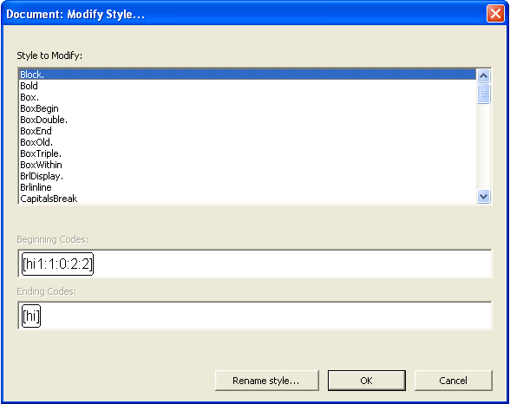
Select a style to modify from the list, then select OK (Enter) to proceed to the Edit Style Codes dialogue box.
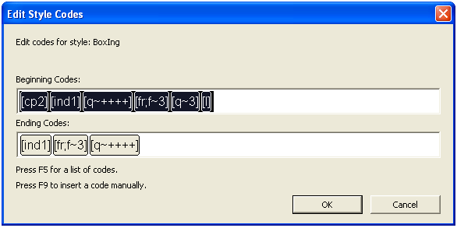
Change the codes wherever necessary, being careful to delete the whole of any unneeded codes and to place new codes in code brackets by selecting from the F5 code list or using the F9 shortcut for manual entry.
When "OK" is selected, a prompt will be given. To discard the changes, select "No" (Escape).
To change the name of an existing style rather than its codes, choose the style from the list and then select "Rename style" instead of "OK". A prompt will then be given to type a new name for that style.
Note: "Rename style" is an easy way to change a character style into a paragraph style (or the reverse) by simply changing the full stop at the end of the style name.

2.6.8 Delete Style
Document Menu shortcut: D
The Delete Style dialogue box is used to remove an existing style from the list of those available within the current document.
Be careful not to remove any styles that have been applied in the current document, as the formatting effects will be lost.
Note: Using the Delete Style function will delete the style from the current document only. The style will remain available for use in any other documents where it is already defined, and in the template from which the current document was created.

2.6.9 Create Template
Document Menu shortcut: C

What is a template?
A template is a document that is used as a basis upon which other documents can be created. DBT templates are simply .dxt files that store codes, settings and other information that is then automatically presented in all new documents created from that template.
Templates can contain things like:
- Embosser and printer settings
- Styles
- Translation tables and codes
- Any required text (such as a customized title page)
- Table of Contents settings
- View settings
… and more.
The template may also be associated with a Word to DBT mapping file (.mws), as described in 3.6 Word Mapping Files.

Default templates
It is recommended that the most frequently used template be marked as the default template, so that it is automatically suggested each time a new document is created. To do this:
- File Menu (Alt-F)
- New (N)
- Highlight the desired template
- Select "Mark template as default"
Use of the English (Unified) - Australian Formatting and RNZFB UEB templates is strongly encouraged as they already contain many of the recommended settings, including translation table, styles and page layout. The English (Unified) - Australian Formatting template is supplied with DBT 11.1. A copy of the template for use with earlier versions of DBT is available for download from http://www.printdisability.org/aba/ueb.php.
The Australian and New Zealand templates will need to be customised for individual use, for example embosser and printer defaults. It may also be useful to include text in a template, for example the production organisation's letterhead, standard title page, copyright statement or production notes. Instructions on modifying a template are given below.

Selecting a template
Select a template for use when creating a new document, as specified in 2.1.1 New.
Note: Once a new document has been created from a certain template, it is not possible to change to a different template. When an existing DBT document is opened, it will be based on the template from which it was originally created. If a different template is required, either copy the text from the document and paste into a new document with the preferred template or import a blank file with the preferred template. Be aware that any styles used that are not found in the new template will no longer work.

Creating or modifying a template
A new DBT template can be created from any .dxp (or .dxb) file. The resulting template will include any settings and styles that are present in the original document. If desired, it is also possible to save the text and codes within the document as part of the template.
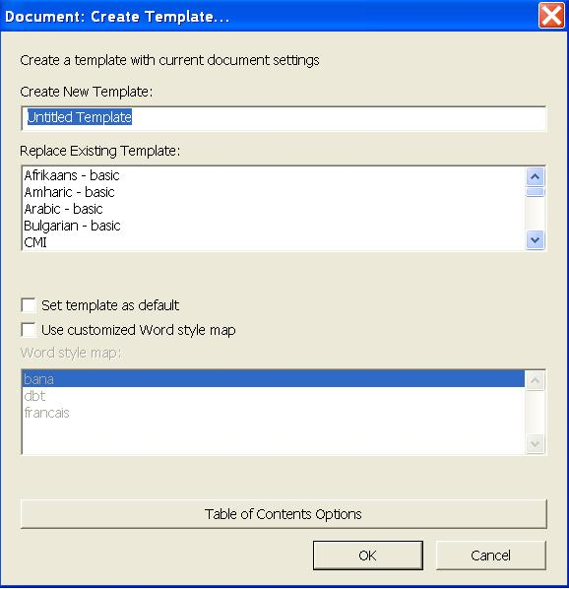
- Create New Template: A text field where the name of a new template can be typed. To replace an existing template, tab to the next field without entering any text.
- Replace Existing Template: A list of all existing templates, displayed in alphabetical order. To replace a template created previously, highlight the template name in the list and select "OK" (Enter). Note: It is not possible to replace most of the standard templates supplied with DBT. To modify the English (Unified) - Australian Formatting template, it must be saved with a new name.
- Use Customized Word Style Map: Check this box only if a customized .mws file has been created. If this box is checked, a list of available files will appear. Refer to 3.6 Word Mapping Files for more information.
- Table of Contents Options: Opens a dialogue box to customise settings for the creation of a Table of Contents in the new template.
After selecting "OK" (Enter), a dialogue will ask whether the document’s text should be included as part of the template. This can be a most useful feature if many of the documents include pro forma text such as a title page or copyright statement. If text is not required in the document, select "Cancel" (Escape).
Note: A warning will be given if a new template is given the same name as an existing template. It is only possible to replace the existing if it was not one of DBT's default templates.

2.6.10 Delete Template
Document Menu shortcut: L
Permanently remove a custom template from the list of templates available when importing or creating a new document. A prompt will be given to confirm the choice.
Note: DBT's own standard templates cannot be removed. They can, however, be hidden, as described in Select a Template under 2.6.9 Create Template.

2.7 Global Menu
(Alt-G)
The purpose of the Global Menu is to apply settings that will take effect in all future documents. The Global Menu is a generic set-up for DBT, and generally used only when DBT is being set up and customised after installation, or when new printers or embossers are installed. The parameters for each new document must be set under the Document Menu.
As detailed settings such as embosser names, models, and braille page sizes will vary, this section is intended as a general guide only.

2.7.1 Embosser/Printer Set-Up
Global Menu shortcut: E (emboss) or P (print)
Note: To apply printer and embosser settings to specific jobs, use the Document Menu (refer to 2.6.1 Embosser Setup and 2.6.2 Printer Setup).
The options and settings available in this dialogue are the same as those in the "Embosser/Printer Setup" dialogue under the Document Menu, with the addition of three controls: "New", "Modify Embosser", and "Remove".
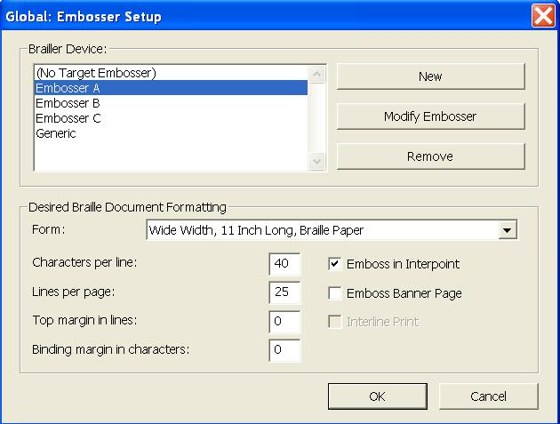

New/Modify Embosser
The dialogue boxes to set up a new embosser or modify an existing embosser look the same. They have three tabs.
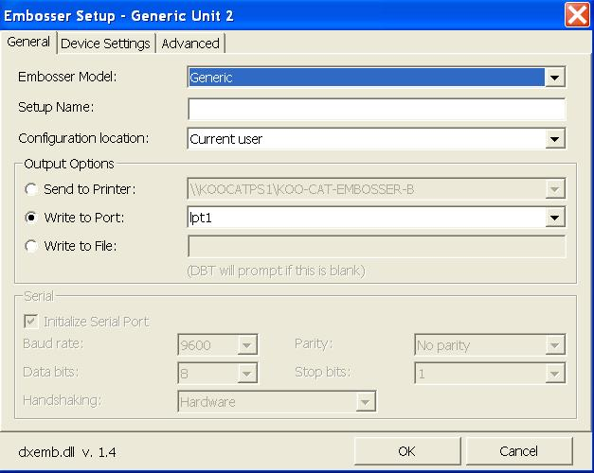

General
- Embosser Model: Select the appropriate embosser model from the drop-down list.
- Setup Name: Choose a memorable or meaningful name for the embosser.
- Send to Printer: For networked embossers, find the embosser within the drop-down list.
- Write to Port: For embossers connected directly to the PC, select from the drop-down list.
- Select "OK".

Device Settings/Advanced
It is strongly advised that DBT users do not change any options within the "Device Settings" or "Advanced" tabs. Refer all embosser problems to an embosser dealer or technician.

Desired Braille Document Formatting
Specify the characters per line and lines per page on the main dialogue box, using the maximum settings that will ever be required. The settings for each document will be specified using the "Document" menu (refer to 2.6.1 Embosser Setup) and, if desired, saved in the template.

2.7.2 Autosave Options
Menu shortcut: A
Define the settings for DBT’s autosave function, which provides back-up in the event that the system fails while DBT is in use.
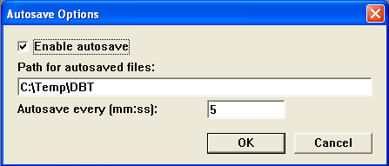
- Enable autosave: Default is checked
- Path for autosaved files: Use the default path or type in a new path
- Autosave every (mm:ss): Default is 5 minutes
Note: To safeguard against all scenarios, manually save the document regularly while using DBT (2.1.4 Save).

2.7.3 Default Views
Global Menu shortcut: D
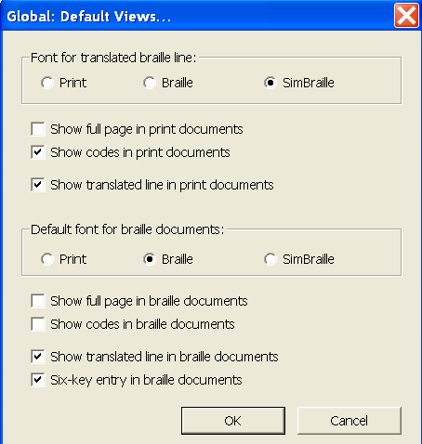
Recommended default views are as follows:
- Font for translated braille line: Braille or SimBraille
- Show codes in print documents: Check
- Show translated line in print documents: Check
- Default font for braille documents: Braille or SimBraille
- Show full page in braille documents: Uncheck
- Show codes in braille documents: Uncheck
- Show translated line in braille documents: Check
- Six-key entry in braille documents: Check
Note: To adjust default views, the individual user must be logged in (not an administrator).

2.7.4 Internationalization
Menu shortcut: I
The default settings should be satisfactory:
- Language for menus and dialogs: English
- Local/National Braille Encoding for Input and Display: North American English
- Use Local/National Encoding for Braille Displays: Selected

2.7.5 Fonts
Global Menu shortcut: F
Specify the point size of the print and braille fonts as displayed on screen.
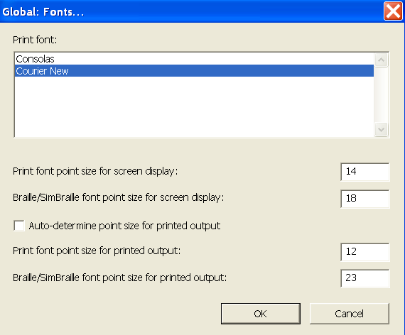
Recommended default fonts are as follows:
- Print font: Courier new
- Print font for screen display: 12 or larger
- Braille font for screen display: 16 or larger
- Auto-determine point size for printed output: Unchecked
- Print font point size for printed output: 12
- Braille font for printed output: 23
Note: To adjust the default fonts, the individual user must be logged in (not an administrator).

2.7.6 View Preferences
Global Menu shortcut: V
The default View Preferences should be satisfactory.
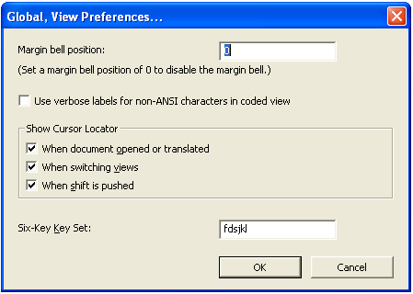
- Margin bell position: 0 Type a numeric value in this field to turn on the margin bell if you are typing direct braille and require strict formatting, for example mathematic expressions or tables. The bell will sound when the cursor reaches the specified number of cells before right margin; i.e. for a value of 5, the bell will sound at cell 36 of 40.
- Use verbose labels for non-ANSI characters in coded view: Unchecked. Check this option if working with special print characters that are similar in appearance to other characters, such as some Greek letters. When in coded view (Alt-F3), special symbols will be described within curly braces, for example Ε is displayed as {Epsilon}. Note that in some cases, a numeric DUSCI value will be given instead.
- Show Cursor Locator: The cursor position can be highlighted as a closing circle in any or all of these instances.
  - When document opened or translated: (Alt-O) Check.
  - When switching views: (Alt-V) Check.
  - When shift is pushed: (Alt-S) Check.
- Six-Key Key Set: (Alt-K) fdsjkl. This determines the set of keys used for direct braille entry, which may be changed for ergonomic reasons.

2.7.7 Shortcut Preferences
Global Menu shortcut: S
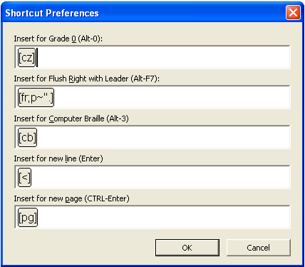
This dialogue box allows the transcriber to change the code that is inserted when some of DBT's special keyboard shortcuts are used. The default settings are:
- Grade 0 braille (Alt-0): (Alt-0) [cz]
- Flush right with leader dots (Alt-F7): (Alt-R) [fr;p~".] The default code gives dot 5 for leader dots. To modify, replace the quotation mark " with the appropriate ASCII code for the desired braille symbol (refer to Appendix 1: ASCII Braille Equivalents).
- Insert for Computer Braille (Alt-3): (Alt-C) [cb] Note that the computer braille code is not used in UEB, therefore it is possible to assign a new code and function to this shortcut key if you wish (refer to Appendix 5: DBT Codes for a list of useful codes).
- Insert for new line (Enter): (Alt-L) [<] It may be useful to change this to [l], which has the same function in forcing text to a new line but only does so when the cursor is not already located on a blank line, and is better recognised when using styles.
- Insert for new page (Ctrl-Enter): (Alt-P) [pg] It may be useful to change this to [top], which has the same effect as [pg] unless it happens to fall at the top of a new braille page, when it has no effect.

2.7.8 WordPerfect Importer
Global Menu shortcut: W
Use this dialogue box to specify how DBT should interpret files that are imported from WordPerfect.
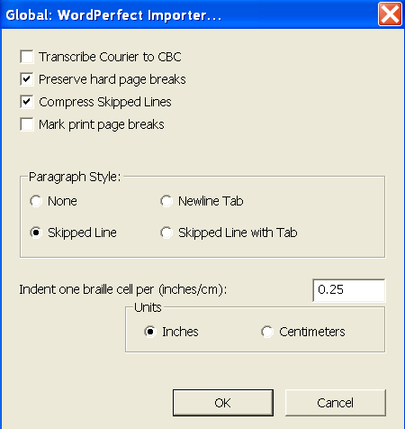
- Transcribe Courier to CBC: All material shown in courier font in the original WordPerfect file will be marked as computer code in the braille document. This is not necessary if transcribing in UEB.
- Preserve hard page breaks: Hard page breaks in the WordPerfect file will be imported as [pg] code, forcing text onto the braille page.
- Compress Skipped Lines: A series of blank lines in the WordPerfect document is reduced to a single blank line in the DBT document.
- Mark print page breaks: Insert print page references [lea] where a page turnover appears in the WordPerfect document.
- Paragraph Style: Defines the appearance of a paragraph in the original WordPerfect document. Select from "None"; "Skipped Line"; "New line with Tab"; or "Skipped Line with Tab".
- Indent one braille cell per (inches/cm): Specify the distance that should be interpreted as an indent within the original WordPerfect document.

2.7.9 Word Importer
Menu shortcut: R
Specify how DBT will interpret files that are imported from Word.
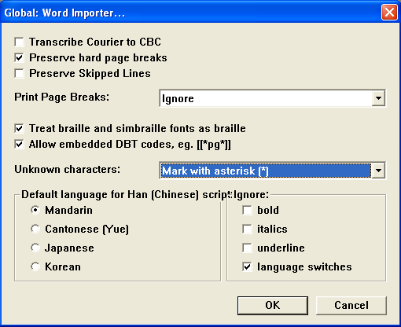
- Transcribe Courier to CBC: All material shown in courier font in the original Word file will be marked as computer code in the braille document. This is not necessary if transcribing in UEB.
- Preserve hard page breaks: Recommended. Hard page breaks in the Word file will be imported as [pg] code, forcing text onto the braille page.
- Preserve Skipped Lines: Not recommended. Blank lines in the Word file will be imported as the codes [l][<] to create a blank line in the braille.
- Print Page Breaks: Select from "Ignore" (recommended); "Mark from Word document"; "Treat hard page breaks as print page breaks"; or "Use publishers' <ipp no=#> reference page tags"
- Treat braille and simbraille fonts as braille: Recommended. Check to automatically treat text written in braille in the Word document as ASCII braille in the DBT document.
- Allow embedded DBT codes, e.g. [[*pg*]]: Recommended. Check to allow DBT codes to be typed directly in the original Word document.
- Unknown characters: Select from Mark with asterisk * (recommended); Ignore; or Output Unicode Value
- Default language for Han (Chinese) script: This setting (available only in DBT 11.1 and above) may need to be adjusted whenever transcribing a document containing Chinese script. Select from "Mandarin" (default); "Cantonese (Yue)"; "Japanese"; or "Korean".
- Ignore: Check to ignore any of "bold"; "italics"; "underline"; "language switches". As a default, it is recommended that typeform indicators not be ignored; however it may be useful to change this setting (available only in DBT 11 and above) for particular documents containing spurious changes in typeform. Regardless of this setting, typeforms in heading styles will be ignored.

2.7.10 Formatted Braille Importer
Global Menu shortcut: B
The option "Read imported braille without interpretation" is strongly recommended so that formatted .brf files can be opened without lines or page turnovers changing. Note that when opened in this manner, the .brf file may not fit the usual embosser settings.
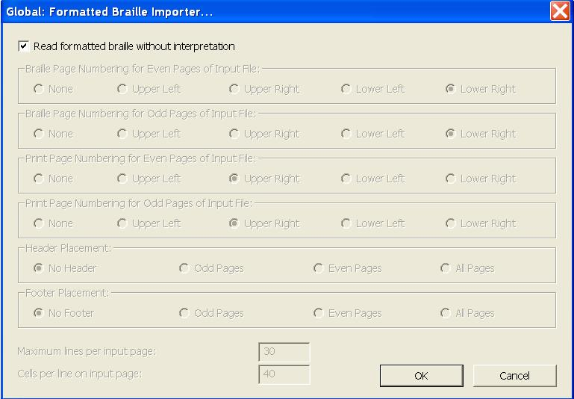

2.7.11 Hyperlinks
Menu shortcut: H
This setting is only available in DBT 11.1 and above. For earlier versions of DBT, all hyperlinks will be imported as text only without the associated electronic reference.
A hyperlink is an element in an electronic document that links to another electronic address. It consists of text, which usually appears as blue and underlined, and an unseen reference to an electronic address, often a URL.
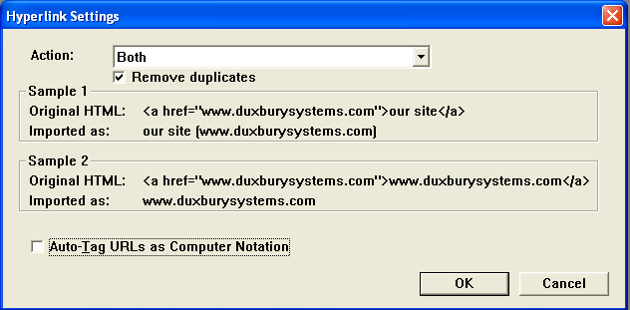
- Action: Choose from "URLs"; "Text" and "Both" (default)
- Remove duplicates: If "Both" has been selected and the text and URL are the same, only one will be included in the DBT file (default).
- Sample 1 & Sample 2: Illustrate the treatment of samples according to the Action selected above.
- Auto-Tag URLs as Computer Notation: Uncheck for UEB. The default is checked.

2.8 Help Menu
(Alt-H)
The Help menu in DBT can be extremely useful and is highly recommended for use alongside this manual.

2.8.1 Help Topics
The Help system consists of five tabs, which can be navigated using Ctrl-Tab. It is possible to print information in a particular topic or group of topics: Open the Options menu (Alt-O) then select Print (P).

Contents (Alt-C)
Topics are grouped by subject in the left pane. Use the arrow keys to scroll down or up the list, then press "Enter" on a particular topic to view the information in the right-hand pane.
Of particular use is the DBT Codes Quick References, located under "Codes Styles and Templates", "Codes".

Index (Alt-N)
An alphabetical list of topics that can be searched by keyword (Alt-W). Highlight the most relevant topic the press Display (Alt-D).

Search (Alt-S)
Type a keyword (Alt-W) to bring up a list of related Topics (Alt-T). Highlight the most relevant topic then press Display (Alt-D).

Favorites (Alt-I)
Bookmark useful topics so they can be found again quickly in future. Navigate to the topic first then go to the Favourites Tab (Alt-I) and select Add (Alt-A).

Glossary
Provides short definitions for terms used in the Help Menu. The glossary is only available in DBT 10.7 and lower.

PART 3:
Advanced Techniques

3.1 Codes
Refer to Appendix 5: DBT Codes for a list of commonly used DBT codes and their functions.

3.1.1 What are Codes?
A code is a special character inserted amongst the text which acts as a command to control things such as braille translation, text position and page layout. Codes can be seen on screen as grey text enclosed in [square brackets] but only their effects will appear in the output document; not the codes themselves.
To toggle code view on and off, use the shortcut Alt-F3 (refer to 2.3.4 Codes).
Some of the advantages of codes are:
- Codes allow advanced transcribers more direct control to create custom layouts and translations
- Codes may be easier than styles for vision impaired transcribers to apply and delete because they are not paired

3.1.2 Adding Codes
Codes can be added to a document using four different methods:
- Manual Entry: Press Ctrl-[ or F9. This will open an edit box into which the code can be typed. Press Enter to close the edit box and insert the new code at the cursor location.
- Select from the Code List: Press F5 or go to Layout (Alt-L), Code List (D) to bring up the complete list of codes (2.4.20 Code List). To simplify the list, use the check-boxes to show or hide the various categories of codes. Please note that some of the codes in the F5 menu are outdated, obsolete, or not relevant for UEB translation, so the effect of any unfamiliar codes should be checked thoroughly.
- Layout Menu: Select the desired effect from the Layout Menu, which will automatically insert the correct code(s). Refer to 2.4 Layout Menu for more information.
- Shortcut Keys: Some of the most commonly used codes have been assigned direct-entry shortcut keys. Refer to Appendix 10: DBT Shortcut Keys for a list of standard shortcuts and 2.7.7 Shortcut Preferences for guidance on how to adjust some of these shortcuts.

3.1.3 Editing Codes
To edit a code that has already been inserted into the text, highlight the code (Ctrl-shift-arrow) and then press F9 or type Ctrl-[ to open the code for editing.

3.2 Styles
Refer to Appendix 6: Styles in the English (Unified) - Australian Formatting Template and Appendix 7: Styles in the RNZFB Template for the styles available in the Australian and New Zealand templates, along with the functions of these styles.

3.2.1 What are Styles?
A style is a group of codes which have been combined to achieve common and consistent formatting or translation outcomes. Using styles saves having to enter a number of individual codes into a document each time to get the same effect. As with codes, the effects of the style will appear in the braille translation but the style itself will not.
Styles are presented as grey paired tags enclosed in <angle brackets>, and each style comprises an opening tag and a closing tag. A closing style tag has a forward slash (oblique stroke) at the start of its name.
Example:
<style> opening tag
</style> closing tag
Some of the advantages of styles are:
- Styles can be applied automatically when importing from Word
- A single style can apply a number of codes at once
- Styles reduce the need for transcribers to be familiar with a large number of codes
- End tags are applied automatically
- Styles can make the appearance and layout of a .dxp file clearer for a sighted transcriber

Paragraph Styles (also known as "Linear Styles")
The presence of a full stop at the end of the style name indicates that a style is paragraph. Some examples of paragraph styles include:
<Para.> … </Para.>
<Box.> … </Box.>
<List.> … </List.>
A paragraph style applies to an entire paragraph. Paragraph styles are comparable to block elements in HTML or XML.
Provided that the cursor is positioned immediately after an end paragraph style or line code [l], the start tag of any new paragraph style will automatically position itself on a new line, and the end tag will automatically force any following text onto a new line.
Text does not need to be highlighted in order to have a paragraph style applied to it –simply place the cursor anywhere in the relevant paragraph and apply the style. If text is highlighted, each paragraph within the selection – including paragraphs that are only partially selected – will be given its own pair of start and end tags.
Note: A paragraph style cannot be nested inside any other styles, for example a <Para.> style cannot be contained inside a <Box.> style.
After applying a hierarchical paragraph style, the style level can be adjusted (refer to 2.4.3 Style Level + and 2.4.4 Style Level −).

Character Styles (also known as "Nestable Styles")
A character style can be applied to any text without forcing a new line. A character style can begin and/or end within a paragraph, sentence or even in the middle of a word. Character styles are comparable to inline elements in HTML or XML.
If text is highlighted, the beginning tag is inserted immediately before the highlight and the ending tag is inserted just after. If no text is highlighted, applying a character style will result in the cursor resting between the start and end tags.

3.2.2 Using Existing Styles

Inserting a Style from the menu
Styles are automatically applied when importing text from a Word Processor. They can also be applied from a menu:
- Press F8 to bring up the menu
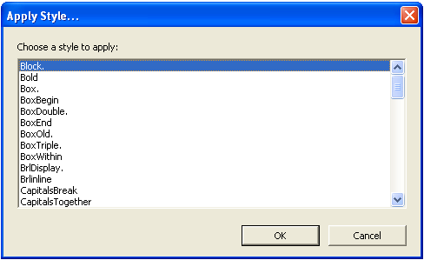
- Type the first letter of the style name to jump to that letter
- Select the required style using the arrow keys or mouse pointer
- Press Enter or OK
Paragraph styles can be applied by placing the cursor anywhere within the paragraph and will be applied around the whole block of text in which the cursor is located. Character styles can only be applied to selected text.

Inserting a Style manually
On occasion, it may be necessary to insert the opening and closing tags manually.
Note: When inserting a style manually, its name must be written exactly as it appears in the F8 menu. Be sure to insert the corresponding closing style tag (beginning with a forward slash) at the required location.
There are two methods that can be used to enter styles manually.
A. Using the styles edit box:
- Position the cursor in the position where the style starts.
- Ctrl-Shift-< to open the styles edit box. Note: The < symbol is found on the same key as the comma, so this is the same shortcut as Ctrl-Shift-comma.
- Type the style name, for example Para.
- Press Enter to insert the new code.
- Repeat for the closing style tag, remembering to add a forward slash at the start.
B. Entering the style as a code:
- Position the cursor in the position where the style starts.
- F9 or Ctrl-[ to open the codes edit box.
- Type es~ followed by the style name, for example es~Para.
- Press Enter to insert the new code, which will appear as a style, for example <Para.>
- Repeat for the closing style tag, instead typing ee~ before the style name.

Trouble Shooting when Working with Styles

Disappearing start/end tags
Because styles are paired tags, cutting or deleting one end (e.g. <Para.>) will automatically remove the corresponding tag at the other end (e.g. </Para.>). This ensures that no unmatched style tags exist in the document, but also means that when editing text, the whole style needs to be re-inserted. Alternatively, move the text instead of the style.

Unexpected effects
Sometimes applying a style to a block of text can adversely affect individual codes that are contained within that text. This is because the codes contained within the style may override the individual codes within the document text. This can be prevented by inserting any individual codes into the document text after the style has been applied to the block.
To see which codes are contained in a style either:
- refer to Appendix 6: Styles in the English (Unified) - Australian Formatting Template or Appendix 7: Styles in the RNZFB Template; or
- open the Modify Styles dialogue box as explained in 2.6.7 Modify Style.

3.2.3 Creating and Modifying Styles
The most commonly used styles in Australia are included in the English (Unified) - Australian Formatting template. In New Zealand, the most commonly used styles are included in the RNZFB template.
If desired, these styles can be modified or new styles can be created, as described in 2.6.6 Add Style and 2.6.7 Modify Style.

3.3 Transcriber Intervention
Some aspects of translation from print to braille are not easily automated or require human judgment. In these cases, the transcriber must manipulate the .dxp or .dxb file to achieve the desired outcome. This section explores some of the common scenarios that may require transcriber intervention, and provides some handy tips for manipulating translation.

3.3.1 Controlling Braille Contraction & Translation

Switching between Grade 2 and Grade 1
Changing between contraction modes can be achieved through the use of either codes or styles.

Codes
A range of codes can be used to manipulate contraction modes.
The [tx][g1] (Alt-1) and [tx][g2] (Alt-2) codes will set braille translation as uncontracted or contracted respectively. Remember to change back again at the end of the passage.
Example:
.dxp: [p]Fill in the blanks:[l]
[List.] ● [tx][g1]en--gh
● th--tre[l]
● can--en[tx][g2][/List.]
The [i] code can be used to translate the following word in grade 1 without a grade 1 indicator.
Example:
.dxp: [i]ch-ch-chilly
.dxb: ch-ch-chilly
The [ii] code can be used to translate the word immediately following it in grade 1, and add the grade 1 word indicator ;;.
Example:
.dxp: [ii]c-h-i-l-l-y
.dxb: ;;c-h-i-l-l-y
The [ui] code can be used to translate the character immediately following it in grade 1, and add the grade 1 symbol indicator ;.

Styles
A range of styles can also be used for manipulating contraction modes:
- <Uncontract> will translate the selection uncontracted without adding any grade 1 indicators.
- <G1Passage> will translate the selection in grade 1 and add the grade 1 passage indicator and terminator
- <G1TextBegin> will insert the grade 1 passage indicator on a line of its own. All following text will be translated in grade 1.
- <G1TextEnd> will insert the grade 1 terminator on a line of its own. All following text will revert back to the original translation mode.
- <G1Word> will translate the word immediately following (or enclosed) in grade 1 and will also add the grade 1 word indicator. The same result can be achieved by simply using the [ii] code before the word.

Forcing no contraction
A particular contraction can be manually prevented by inserting the code [u] or [/] at the appropriate location. While these two codes both serve to uncontract without adding a grade 1 indicator, they are subtly different in that:
- the [/] code will only prevent a contraction at the place it is inserted
- the [u] code will prevent a contraction at the place it is inserted because it treats the letter immediately following it as a grade 1 symbol
Examples:
Print: in the US (United States)
.dxp: in the U[/]S
.dxb: 9 ! ,,us
.dxp: in the U[u]S
.dxb: 9 ! ,u,s
The [/] code is particularly useful for preventing words from bridging in unusual compound words or in email and web addresses.
Examples:
Print: hathair
.dxp: hat[/]hair
.dxb: hathair
Print: www.freedolly.org
.dxp: www.free[/]dolly.org
.dxb: www4freedolly4org

Languages
When transcribing an English-language text, foreign words should be transcribed using UEB accent symbols and grade 1 braille, as described above. Foreign words are usually distinguished by use of typography, such as italics, bold or quotation marks.
Example:
Print: pirouette and battement développé
.dxp: pirouette and <Uncontract><Italics>battement développé</Italics>
</Uncontract>
.dxb: pir\ette & .1battement .1d^/evelopp^/e
When transcribing a foreign language text for native English readers, as in the case of a language textbook, the native braille symbols should be used for accented letters with grade 1 braille.
Use the [lng~X] code to start grade 1 transcription in another language, where X can take the values of:
de = German
en = English
es = Spanish
fi = Finnish
fr = French
it = Italian
la = Latin
mi = Māori
nl = Dutch
pt = Portuguese
sv = Swedish
sw = Swahili
Alternatively, use one of the language codes available through the Layout menu for Spanish, Latin, Italian, French or German (2.4.7 Translation Codes).
Use the [lng] code to resume transcription in the original language (usually UEB English).
Example:
Print: Je t'aime à la folie … I'm crazy in love with you
.dxp: [lng~fr]Je t'aime à la folie … [lng]I'm crazy in love with you
.dxb: ,je t'aime ( la folie 444 ,i'm crazy 9 love ) y

3.3.2 ASCII Entry
ASCII stands for "American Standard Code for Information Interchange". ASCII is a character encoding standard for the English language, which enables correct representation and interchange of text on computers and other electronic devices that work with text.
In DBT, ASCII entry is used to bypass the translation process, as it enables the transcriber to enter braille symbols directly into a print document. There is a unique equivalent ASCII character for every braille symbol. Refer to Appendix 1: ASCII Braille Equivalents for a full list of ASCII braille symbols.
There are three ways to enter ASCII in a Duxbury file:

1. Grade 0 mode
The [cz] code begins ASCII entry within a print document. Use the shortcut Alt-0 to enter this code.
To end grade 0 mode, insert either the grade 1 [tx][g1] or 2 [tx][g2] codes as appropriate (using the Alt-1 or Alt-2 shortcuts respectively).
Example:
Print: Øeresund
.dxp: [cz],@*o[tx][g2]eresund
.dxb: ,@*oeresund

2. <Brlinline> Style
The <Brlinline> style can be used to enter larger sections of braille into a .dxp file, using either 6 key entry or ASCII entry. Simply insert the <Brlinline> style at the cursor location, and then type the required ASCII symbols, or press F2 to use 6 key entry within the <Brlinline> style.

3. [q~W] and [d~W] Codes
Another way of entering ASCII braille symbols is by using [q~W] codes or [d~W] codes. These codes can be entered by pressing F9 or Ctrl-[ to open the code parameter edit box, and then typing the code in manually.
Example:
Print: Øeresund
.dxp: [q~,@*o]eresund
.dxb: ,@*oeresund
The only difference between q and d codes is that [d~W] codes will automatically insert a following space, but [q~W] codes will not.
Note: The [d~W] code is useful when creating a new style which includes text with spaces, as no spaces can be included within a style.
Example:
Print: * * *
.dxp: [hds][d~"9][d~"9][d~"9][hde]
.dxb: "9 "9 "9
These codes are useful when only a short string of ASCII symbols is required, for example, adding a brief maths equation to a literary text. If a longer passage is needed, it is recommended that the grade 0 mode or <Brlinline> style be used.

3.3.3 Electronic Addresses
In UEB, internet and email addresses should generally be presented in grade 2 braille. However, where there could be some ambiguity or bridging of two words in the braille, grade 1 braille may be used for clarity.
To prevent two words from bridging incorrectly – that is, from forming a contraction where two words run together – insert the [/] code between the two letters that form the contraction.
Example:
Print: www.tafensw.edu.au
.dxp: www.tafe[/]nsw.edu.au
.dxb: www4tafensw4$u4au
If an internet or email address breaks on to a new line in UEB, a continuation indicator (dot 5) is required at the end of the first line. To achieve this, insert the <continuation></continuation> style at an appropriate location in the address (i.e. not in the middle of a word). This style will break to a new line and add the dot 5 continuation indicator. The new line will begin at the current runover position.
Example:
Print: joe.blow@joesgarage.com.au
.dxp: joe.blow@joesgarage.<continuation></continuation>com.au
.dxb: joe4bl[@ajoesg>age4"
Com4au

3.3.4 Numbers, Basic Mathematics and Technical Materials
When transcribing basic mathematical symbols within a literary context, a few simple rules should be followed.
2.4.13 Maths Codes contains further guidance on the translation of mathematical material in DBT. For guidance on the correct braille representation of mathematics texts, long mathematical passages and other complex maths or technical documents, refer to the Unified English Braille Guidelines for Technical Materials.

Numbers
When transcribing numbers, the print punctuation can be followed exactly.
Examples:
.dxp: 7/11/59
.dxb: #g_/#aa_/#ei
.dxp: 7-11-59
.dxb: #g-#aa-#ei
.dxp: 7.11.59
.dxb: #g4aa4ei
UEB uses a numeric space " (dot 5) to indicate spaces in long numbers if no other punctuation is used. This applies to numbers with more than 3 digits, ISBNs, and phone numbers.
When preparing material in Word, it is possible to insert a hard space using the shortcut Ctrl-Shift-Space. When working in a .dxp file, a hard space can be inserted using the shortcut Alt-F2. Both these methods will result in a numeric space in braille.
Examples:
Print: 1 000
.dxp: 1[']000
.dxb: #a"jjj
Print: 0.999 999
.dxp: 0.999[']999
.dxb: #a4iii"iii
Print: ISBN 978 0 12 345678 9
.dxp: ISBN 978[']0[']12[']345678[']9
.dxb: ,,isbn #igh"j"ab"cdefgh"i
Print: phone 03 9864 2123
.dxp: phone 03[']9864[']2123
.dxb: ph"o #jc"ihfd"babc

Operation signs

Symbols
Some keyboard equivalents for mathematical symbols – such as the letter x for "multiply" and hyphen for "minus" – will not translate correctly in DBT.
Mathematical symbols should therefore be entered in Word using the "Insert Symbol" menu, or a supported mathematics program such as MathType or Equation Editor. Alternatively, the symbols can be entered using keyboard shortcuts. Refer to Appendix 4: UEB Symbols and Keyboard Entry for Symbols and Accented Letters for a more comprehensive list of shortcuts for symbol insertion.
Symbol | Entry Method
+ plus | keyboard symbol
− minus | Insert Menu > Symbol in Word
× multiplication | Alt-0215
÷ division | Alt-0247
= equals | keyboard symbol

Fractions
Simple and compound fractions are presented in braille using a linear format rather than vertically. The fraction line will usually need to be entered by the transcriber.
The fraction line is a specific symbol in braille, and cannot be entered as a standard oblique stroke (forward slash). There are several methods of inserting a fraction in DBT:

Fraction Symbol Imported from Word
Three of the most common fractions – ½ ¼ and ¾ – have their own symbol in Word that will import and translate correctly in DBT.
Example:
.dxp: ¼
.dxb: #a/d

Fraction Line Codes
For all other fractions, fraction codes are available through the layout menu, as described in 2.4.13 Math Codes.

Direct Braille/ASCII Method
Transcribers who are proficient in braille may prefer to type the fraction using direct braille as described in 3.3.2 ASCII Entry.

3.3.5 Typeform Indicators
UEB enables the use of typeform indicators, however it is important to apply some judgment regarding when and how these should be used. Typeforms do not need to be transcribed in braille if they have been used for a purely decorative effect. Typeforms are generally ignored when applied to headings because the braille layout is sufficient to distinguish the heading from the rest of the text.
Typeform indicators – that is, bold, italics, underline and script – can be applied through the use of either codes or styles. When using typeform indicators it is important to have the codes or styles in the correct order and position within the text.
If typeform styles are being used in conjunction with other styles, it is best to place the pair of typeform indicators inside the other style(s).
Example:
.dxp: <List.><Italics>adagio e cantabile</Italics></List..>
In emphasised passages of more than one paragraph, the first word of each paragraph should be preceded by the typeform passage indicator, but the terminator is not included until after the last word of the final paragraph. This applies even to paragraphs of less than three words – the passage indicator must still be used, not the word indicators. Unfortunately the typeform styles can't detect and apply this convention automatically, so the codes must be inserted manually. Sometimes ASCII entry may be necessary to force a passage indicator.
Example:
Print:
Dear Laura Buxton,
On Thursday 14th of June we found a balloon with a label on it with your name and address. It is very strange because my name is Laura Buxton too.
Yours sincerely,
Laura Buxton
.dxp:
[fts~i]Dear Laura Buxton,
[p][fts~i]On Thursday 14th of June we found a balloon with a label on it with your name and address. It is very strange because my name is Laura Buxton too.[l]
[q~.7]Yours sincerely,[l]
[q~.7]Laura Buxton[q~.']
Or…
<Italics>Dear Laura Buxton,
[p][fts~i]On Thursday 14th of June we found a balloon with a label on it with your name and address. It is very strange because my name is Laura Buxton too.[l]
[q~.7]Yours sincerely,[l]
[q~.7]Laura Buxton</Italics>
.dxb:
.7,de> ,laura ,buxton1
.7,on ,?urs"d #adth ( ,june we f.d a balloon ) a label on x ) yr "n & address4 ,x is v /range 2c my "n is ,laura ,buxton too4
.7,yrs s9c]ely1
.7,laura ,buxton.'

3.3.6 Capitalisation
If a string of capitalised text contains two semantically different items, those items should be capitalised separately. DBT can't detect the difference between the items, so without intervention they are translated as one capitalised passage. Insert the [xcs] code or the <CapitalsBreak> style from the Australian template at the point where the capitals should be terminated.
Examples:
.dxp: I don't read the NEW ZEALAND HERALD.[xcs] I just can't.
.dxb: ,I don't r"d ! ,,,new z1l&
h]ald4,' ,I j c't4
Print: ICCHousing
.dxp: ICC[xcs]Housing
.dxb: ,,icc,h\s+
Print: NaOH
.dxp: NaO<CapitalsBreak></CapitalsBreak>H
.dxb: ,na,o,h
When a passage of capitalised words contains line breaks for formatting purposes (i.e. in a poem or centred block of text), DBT will translate each line as a separate block of capitals. The [ucs] and [uce] codes or the <CapitalsTogether> style from the Australian template will prevent this, and instead force DBT to translate the text as one continuous capitalized passage.
Example:
Print: BEWARE
OF
THE DOG
.dxp: [hds]<CapitalsTogether>BEWARE[l]
OF[l]
THE DOG</CapitalsTogether>[hde]
.dxb:
,,,2w>e
(
! dog,'

3.3.7 Punctuation

Quotation Marks
Understanding how DBT deals with quotation marks (and apostrophes) is critical to achieving an accurate braille translation. UEB offers a range of two-cell braille symbols for each print form of quotation marks, however the one-cell (non-specific) quotation marks 8 and 0 should be used for the predominant quotation marks in the text in the majority of cases.
As a default, DBT will consider the first quotation mark encountered to be the predominant quotation mark. To change the default setting to a chosen quotation mark as the prevailing quotation marks, use the [uoq~X] code with one of the following values:
- [uoq~"] or [uoq~0022] for the ordinary keyboard double-quote " i.e. Unicode 0022.
- [uoq~`] or [uoq~0060] for the grave accent character ` i.e. Unicode 0060
- [uoq~«] or [uoq~00ab] for double-angle (Italian) quotation marks « and ».This code can be useful to force both single and double quotes to translate as their respective compound directional quotes which can be useful when the exact punctuation is of importance to the reader.
- [uoq~»] or [uoq~00bb] for reversed double-angle quotation marks » and «

3.3.8 Grouping

Grouping
"Grouping" means to keep a block of text together or to treat several words as though they were a single word.
Grouping can be achieved applying the Group codes [:] [;] around the block of text or by inserting a hard space ['] between each word in the block (2.4.8 Character Codes).
Grouping should also be used in conjunction with the [ifbrl] and [ifprt] commands as these commands apply only to one word.
Example:
.dxp: [ifbrl][:]Emboss this document at 30 characters wide. If at 40, table of contents will need revision.[;]

Breaking
Conversely, it is sometimes necessary to force breaks in a block of text.
Insert the assisted-hyphenation code [-]in a long word to indicate that the word may be broken at that point to hyphenate at the end of a line.
Note: The assisted-hyphenation code must not be used adjacent to contractions affected by hyphenation.
Example:
Print: She's supercalifragilisticexpialidocious!
.dxp: She's supercalifragilistic[-]expialidocious!
.brf: ,%e's sup]califragili/ic-
expialidoci\s6

3.4 Specialised Layouts and Formatting
Formatting of simple text was explained in 1.2.3 Edit Duxbury Print Document. Some more complex formatting is described here.

3.4.1 Page Breaks and Numbering
The most commonly used way of forcing a new braille page in DBT is to use the [pg] code (Ctrl-Enter), however a number of variations exist which can also be very useful.
[top] has the same effect as [pg] but has no effect if it happens to fall at the top of a new braille page.
[sdN] starts a new page if the current page is not even (N=0) or odd (N=1). For example [pg][sd1] would start a new page, and if necessary add a blank page so that the following text appears on an odd-numbered page (or right-hand leaf). This code can be very useful for easily ensuring that significant new sections begin on the right side of an interpoint (double-sided) volume.
The [pg] code is the simplest form of the general code [pgN~X], where N and X are both optional and can be left blank.
- N sets the braille page number to a chosen value. For example, [pg34] creates a new braille page numbered 34
- X defines a prefix character for the displayed braille page number. For example, [pg1~p] creates a new braille page numbered p1. The prefix is continued until a page code with a blank value for X is given, e.g. [pg~]
Similarly, [pvN~X] defines the number and prefix of the next braille page but does not force a new braille page.

3.4.2 Lists
Lists are usually formatted in print with bullets or numbers on the left margin and text blocked in a new column. Braille transcriptions of lists and poetry should similarly place the bullet or number on the left margin with indented runover.
<List.> styles are provided in the Australian formatting template and <Poem.> styles in the RNZFB template to enable easy formatting of most lists, as described in Appendix 6: Styles in the English (Unified) - Australian Formatting Template and Appendix 7: Styles in the RNZFB template. Simply choose the style with the appropriate runover point from the F8 style menu. For sub-items in a list, adjust the style level using the Alt-Right arrow or Alt-Left arrow shortcuts, as described in 2.4.3 Style Level +.
Example:
Print:
- Animalia
  - vertebrates
  - invertebrates
- Plantae
- Protista
- Fungi
- Monera (three types of bacteria)
.dxp: <List.>• Animalia[l]
[hl2]* vertebrates[l]
* invertebrates[l]
[hl1]• Plantae[l]
• Protista[l]
• Fungi[l]
• Monera (three types of bacteria)</List.>
.dxb:
_4 ,animalia
"9 v]tebrates
"9 9v]tebrates
_4 ,plantae
_4 ,proti/a
_4 ,fungi
_4 ,mon]a "<?ree types (
bact]ia">
There may some cases when the standard <List.> or <Poem.> styles are insufficient. For example, it may be deemed important to block all text clear of numbers in the left margin for student examinations. In these cases, it is possible to create a new style (as described in 2.6.6 Add Style) or manually insert the appropriate codes:
- [ptysN] begin poetry mode with N cells runover
- [ptye] end poetry mode
- [indN] indent left margin by N cells
- [ind] return to the left margin
Example:
Print:
11. In his usual _ manner, he had insured himself against this type of loss.
(a) pensive
(b) providential
(c) indifferent
(d) circumspect
.dxp: [ptys5]11. In his usual _ manner, he had insured himself against this
type of loss.
[ind5][ptys4]a. pensive[l]
b. providential[l]
c. indifferent[l]
d. circumspect[ind][ptye]
.dxb: #aa4 ,9 8 usual .- mann}1 he _h
9sur$ hmf ag/ ? type ( loss4
a4 p5sive
;b4 provid5tial
;c4 9di6]5t
;d4 circumspect

3.4.3 Boxes
Box styles are used to indicate text that is boxed in a print document. Depending on context, it is not always essential to reproduce boxes in the braille, and transcriber discretion should be used.
The standard <Box.> style should be used as a default. Simply place the boxed text between the opening and closing box style tags, without adding a blank line before or after the style.
Example:
Print:
Look for examples of bright colours used as warnings at home.
.dxp: <Box.>[p]Look for examples of bright colours used as warnings at home.<Box.>
.dxb:
"33333333333333333333333333334
,look = examples ( b"r col\rs us$ z w>n+s at home4
"3333333333333333333333333333j
Other box styles can be used to indicate additional boxes, when it is important for the reader to differentiate between their meanings. Refer to Appendix 6: Styles in the English (Unified) - Australian Formatting Template for a range of available box styles.
If using more than one style of box within a document, consistency is important so that the reader can quickly find the box they need within their braille volume. For example, in a school text book the transcriber could use <Box.> style for blue boxes containing "More Info", and a different style such as <BoxDouble.> for pink boxes containing "Homework Activities".
If more than one style of box is used within a braille volume, a transcriber’s note should be added to the beginning of the volume explaining which style of braille box relates to each type of print box.

3.4.4 Tables
The preferred method for presenting tables in braille is to mimic the print, however this is often not possible due to spatial restrictions. As such, a range of presentation methods have been developed. The choice of table format should be determined by the complexity of the table contents and how it is to be used by the braille reader.
Tables can and should be formatted automatically in DBT 11.1 as described in 2.5 Table Menu. Users of earlier versions of DBT will need to format tables manually, as described below.

Columnar Format
The columnar format retains the layout of the original table as closely as possible, with items laid out in rows and columns. It is the preferred method for presenting tables and is particularly important if the reader will need to access the table information both vertically and horizontally.
Sometimes it can be very difficult to make table contents fit within the space available across the braille page. Below are a few ideas that can help to achieve a good fit. Remember to add a transcriber's note to explain any significant changes made to the table.
- Shorten words by omitting capitals and/or punctuation.
- Shorten numbers by omitting commas or numeric spaces
- Move units of measurement to the column headings, e.g. %, grams, years
- Reduce the gap between columns of numbers to one cell if appropriate.
- Insert the numeric passage indicator ## at the beginning of numeric tables so that the numeric indicator # does not need to be repeated for every number. End the table with a numeric passage terminator #'.
- Allow a table to run onto a second braille page, and repeat the column headings on the second page.
- Rotate short wide tables so they are long and thin (Transcriber's note required.)
- If row headings are lengthy, force them to break by using a hard return at the appropriate place, then inserting two hard spaces (Alt-F2) for the indent.
- Key the row or column headings using abbreviations, numbers or single letters with full stops. (Transcriber's note required for the key.)
Here are two commonly used methods of table presentation that work well in DBT:

Tab Method for Columnar Format (.dxp)
The tab method is used to create vertical columns in a braille table while working primarily in .dxp rather than a braille file. Tab stop positions are set using braille cell numbers and braille in each column of the table is then aligned to a tab stop.
Follow these steps, translating to .dxb when necessary to count the number of braille cells:
- Insert the [ctb] code to clear all previous tabs. Note: The [ctb] code is always required before setting tab stops, even if none have been set previously.
- Count the number of braille characters in the longest item in each column.
- Add to this figure a total of 2 blank cells for each gap between columns. Note: This can be reduced to 1 cell if necessary to save space, but only for numeric tables where no spaces occur within cell data.
- Calculate the cell in which each column will begin. Or, if numbers in tables are right-aligned, calculate the cell in which the column will end.
- Use the code [stbS:A:P] to set the tab stops, where
  - S = tabstop number
  - A = alignment type, i.e. left (l), right (r), centred (c) or decimal (d)
  - P = position, i.e. the cell number to which items will be aligned
- If no leader dots are required (i.e. if there are less than 5 spaces between items) use the tab key to insert a tab [>] between each item in the table to align them to the tab stops previously set.
- If leader dots are required (i.e. if there are 5 or more spaces between items) insert the [#S:F~X] code before each column item, where
  - S = tabstop number
  - F = fill type, i.e. p for part fill with one blank cell on either side (recommended) or f for full fill
  - X = ASCII symbol for the fill character. Commonly used characters include the hyphen - for dots 3,6 or the double quote " for dot 5.
- If multiple items appear in the same column (except column 1), insert the grouping codes [:] [;] to treat them as one item for tabbing purposes, for example [>][:]day 2[;]
- To create horizontal table lines, set another tab stop 1 cell beyond the end of the table, with right alignment. For each horizontal line, go to a new line and insert the code [#S:F~X], specifying the last tab stop with full fill and the leader dots of choice. A hard space ['] will also be required to make the leader dots appear.

Example:
Print:
Incidence of homicide | Percentage | Number
New South Wales | 34 | 89
Victoria | 19 | 49
Queensland | 20 | 53
Western Australia | 10 | 27
South Australia | 5 | 12
Tasmania | 3 | 8
Australian Capital Territory | 2 | 4
Northern Territory | 7 | 18
Total | 100 | 220
.dxp:
[ctb][stb1:r:32][stb2:r:37][stb3:r:38]Incidence of homicide[#1:p~"] Percentage[#2]no.[l]
[#3:r:f~7]['][l]
New South Wales[#1:p~"]34[#2]89[l]
Victoria[#1:p~"]19[#2]49[l]
Queensland[#1:p~"]20[#2]53[l]
Western Australia[#1:p~"]10[#2]27[l]
South Australia[#1:p~"]5[#2]12
Tasmania[#1:p~"]3[#2]8
Australian Capital Territory[#1:p~"]2[#2]4
Northern Territory[#1:p~"]7[#2]18[l]
[#3:f~3]['][l]
Total[#1:p~"]100[#2]220[l]
.dxb:
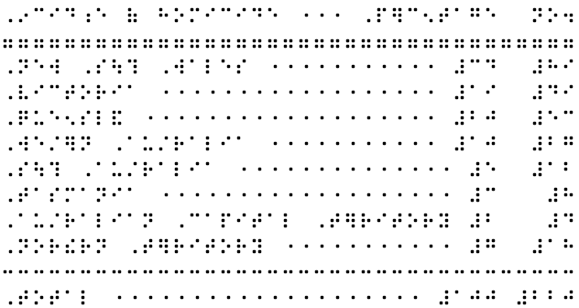

Direct Braille Method for Columnar Format (.dxb)
Entering a table as direct braille makes alignment of items easy if the transcriber must have a good knowledge of braille.
Create the table in a .dxb file, remembering to make all spaces hard spaces (Alt-F2). Leader dots should be inserted between columns wherever there is a space of 5 or more blank cells. If adding leader dots, the minimum number of cells containing leader dots should be 3.
A row of "lower g" 7 cells can be used as a separator after heading row(s) if needed. Also, a row of "lower c" 3 cells can be used as a separator above a "total" row, for example the last row of a financial table.
When the table is complete, it can be copied and pasted into a .dxp file if needed, but it must be enclosed within the <Brlinline> style. The table will appear as ASCII characters in the .dxp file.

Stairstep Format (.dxp)
In stair-step format, progressive indenting is used to indicate the columns of the table. The stair-step method is well-suited to long and/or wordy literary tables. It allows the reader to quickly find the required information but can take up a lot of space. Simple, well-formatted tables in a Word source file will import successfully as stair-step tables in DBT 10 using the <Outline.> style.
The text in the first column of the table is blocked at the margin. The text in the second column of the table is placed on a new line and blocked at cell 3, and so on. Each indent should be 2 cells deeper than the one preceding it. When a new row begins, it must revert back to cell 1 on a new line.
To create a new stairstep table in DBT, apply the <Outline.> style and use increasing paragraph levels (Alt-right arrow) to indent each successive. row.
A transcriber's note should be added before the table to explain the formatting and list the column headings. A blank line can be inserted before and after the table if desired.
Example:
Print:
Dieter | Breakfast | Lunch | Dinner
Alex | bacon and eggs on toast | meat pie and chips | sausages and vegetables with cheese sauce
Michael | wheat bix | pasta | pizza
Mimi | porridge | sushi | grilled fish and salad

.dxp:
[p]<TNote>The following table has been transposed to stairstep format. It consists of 4 columns, each beginning on a new line a further two braille cells from the margin.</TNote>[l]
<Outline.>Dieter
[hl2]Breakfast
[hl3]Lunch
[hl4]Dinner
[hl1]Alex
[hl2]bacon and eggs on toast
[hl3]meat pie and chips
[hl4]sausages and vegetables with cheese sauce
[hl1]Michael
[hl2]wheat bix
[hl3]pasta
[hl4]pizza
[hl1]Mimi
[hl2]porridge
[hl3]sushi
[hl4]grilled fish and salad
.dxb:
,diet]
,br1kfa/
,lun*
,d9n]
,alex
bacon & eggs on toa/
m1t pie & *ips
sausages & vegetables )
*eese sauce
,mi*ael
:1t bix
pa/a
pizza
,mimi
porridge
su%i
grill$ fi% & salad

Linear Format (.dxp)
The linear format for table presentation provides column heading information as a transcriber's note, and then presents the cell data row by row. It is best suited to literary tables with only a few columns and a brief amount of information in each.
Column 1 data should be keyed in followed by a colon. Data from subsequent columns should be presented with a semicolon (or ellipsis) acting as a separator. A transcriber's note should be added before the table, explaining the formatting and listing the column headings.
The <List.> style should be applied to the table text, to indent any runover.
Example:
Print:
Dieter | Breakfast | Lunch | Dinner
Alex | bacon and eggs on toast | meat pie and chips | sausages and vegetables with cheese sauce
Michael | wheat bix | pasta | pizza
Mimi | porridge | sushi | grilled fish and salad
.dxp:
<TNote>The print column format has been omitted. The information in the table is listed below in the following order:[l]
[p]Dieter: Breakfast; Lunch; Dinner.</TNote>[l]
<List.>
Alex: bacon and eggs on toast; meat pie and chips; sausages and vegetables with cheese sauce[l]
Michael: wheat bix; pasta; pizza[l]
Mimi: porridge; sushi; grilled fish and salad</List.>
.dxb:
@.<,! pr9t column =mat has be5 omitt$4 ,! 9=ma;n 9 ! table is li/$ 2l 9 ! foll[+ ord]3
,diet]3 ,br1kfa/2 ,lun*2 ,d9n]4@.>
,alex3 bacon & e7s on toa/2 m1t pie & *ips2 sausages & vegetables ) *eese sauce
,mi*ael3 :1t bix2 pa/a2 pizza
,mimi3 porridge2 su%i2 grill$ fi% & salad

Listed Format (.dxp)
The list format for table presentation provides each row as a list with column headings repeated for each item and a blank line between each row. The list format is best suited to literary tables with too many columns for the headings to be easily remembered by the braille reader.
Example:
Print:
 | Hardiness | Suckering | Height | Productivity | Appreciation
Bluecrop | very good | wear | 2 m | good | Very popular variety but with lower productivity in the north and heavier soils.
Bluetta | very good | medium | 1.4 m | very good | Short, compact plant, early fruiting.
Chippewa | very good | medium | 1.4 m | very good | Variety for trial in cold sites.
.dxp:
[p]<TNote>The table has been presented in list format below.</TNote>
<List.>Bluecrop[l]
Hardiness: very good[l]
Suckering: wear[l]
Height: 2 m[l]
Productivity: good[l]
Appreciation: Very popular variety but with lower productivity in the north and heavier soils.[cp2:1]
Bluetta[l]
Hardiness: very good[l]
Suckering: medium[l]
Height: 1.4 m[l]
Productivity: very good[l]
Appreciation: Short, compact plant, early fruiting.[cp2:1]
Chippewa[l]
Hardiness: very good[l]
Suckering: medium[l]
Height: 1.4 m[l]
Productivity: very good[l]
Appreciation: Variety for trial in cold sites.</List.>
.dxb:
,bluecrop
,h>di;s3 v gd
,suck]+3 we>
,hei<t3 #b ;m
,productiv;y3 gd
,apprecia;n3 ,v popul> v>iety b ) l[] productiv;y 9 ! nor? & h1vi] soils4
,bluetta
,h>di;s3 v gd
,suck]+3 m$ium
,hei<t3 #a4d ;m
,productiv;y3 v gd
,apprecia;n3 ,%ort1 compact plant1 e>ly fruit+4
,*ippewa
,h>di;s3 v gd
,suck]+3 m$ium
,hei<t3 #a4d ;m
,productiv;y3 v gd
,apprecia;n3 ,v>iety = trial 9 cold sites4

3.4.5 Double-Page Spreads
Double-page spreads are used when information across two braille pages needs to be kept together, for example a map and key, or a very wide table that runs across two pages.

Facing (or Interfacing) Pages
Facing pages are a left- and right-leaf braille page which are intended to be read together.
To create interfacing pages in a double-sided volume:
- Insert the codes [pg][sd0][pv~a] to force a new, left-leaf page and prefix the page number with the letter a.
- Insert the code [pgX~b] to force the second part of the material onto a new, right-leaf page and prefix the page number with the letter b. X should be the same value as the left leaf page number.
- Insert the code [pgX~] at the end of the interfacing material to specify the next braille page number, turn off prefixing of page numbers and begin a new braille page.
Example:
.dxp: braille page 22 – preceding text
braille page 23 - blank
[pg][sd0][pv~a]braille page a24 - left leaf of interfacing pages
[pg24~b]braille page b24 – right leaf of interfacing pages
[pg25~]braille page 25 – left leaf of continuing material

Joined Pages
A joined page is an extra page that is manually taped to the right-hand edge of the bound page when compiling a braille volume. The reader then unfolds the joined page to read across two pages.
Joined pages should be used with discretion, and notation about the joined page(s) should be kept to assist with the compilation of future copies of that document.
A prefix - such as "j" for "joined" or "r" for "right" - is inserted before the braille page number on the joined page by using a [pg~j] code.
Note that this code will cause all following pages to be prefixed with a "j", so the code must be turned off at the appropriate location in the file, by inserting the code [pv~].

3.5 SWIFT

3.5.1 What is SWIFT?
SWIFT is a Microsoft Word template that is provided by Duxbury and is designed to serve as a user-friendly interface between Word and braille. It has two main purposes:
- SWIFT allows a Word document to be sent straight to DBT for translation, or directly to an embosser. This facility may be particularly useful for braille readers who wish to emboss their ephemeral Word documents and for casual braille producers who do not have any knowledge of DBT or braille.
- The Style Mapper within SWIFT allows the user to easily specify the way that DBT should treat custom styles that have been created and used in Word, thereby minimising the amount of transcriber intervention required in DBT.
Note: The braille translation obtained from SWIFT is only as good as the data entry in the Microsoft Word file. If styles are not used, or if formatting devices are applied incorrectly in the Word file, they will remain incorrect in the DBT file and result in poorly formatted braille. Refer to 3.5.1 Prepare the Word File for advice on how best to format a Word file in preparation for braille translation.

3.5.2 Installation
DBT’s Setup program will automatically install SWIFT.dot into DBT's installation folder.
If the SWIFT toolbar is not visible in Word, go to the View Menu, Toolbars and select "DBT".

3.5.3 Using SWIFT
Note: A Word document must be saved before the SWIFT facilities can be used. If it has not yet been saved, a prompt will be given.

Duxbury Braille (D)
Send the current Word document to DBT. DBT's import dialogue will appear, prompting the user to select the desired template. The file will then be opened as a .dxp file which can be edited before being saved and/or embossed.

Emboss Direct (E)
Send the current Word document directly to an embosser. No intervention is possible and DBT will be closed automatically. The default DBT template will be used.

Print Braille (P)
Send the current Word document directly to a printer as translated braille in SimBraille. No intervention is required and DBT will be closed automatically. For this command to work properly, the following defaults must be set in DBT:
- In the "Global" menu select "Default Views". "Default font for braille documents" must be set to Braille or SimBraille.
- In the "Global" menu select "Fonts". "Auto-determine point size for printed output" must not be checked. The recommended braille font for printed output is 23 point.

Format Hyperlinks (F)
This command is redundant for translation to UEB as hyperlinks are automatically formatted correctly.

Style Mapper (S)
Specify how DBT will treat the styles that have been used in the current Word document.

Selecting a style map (.mws file)
A "Style Mapper" dialogue box appears, in which the current DBT .mws files are listed.
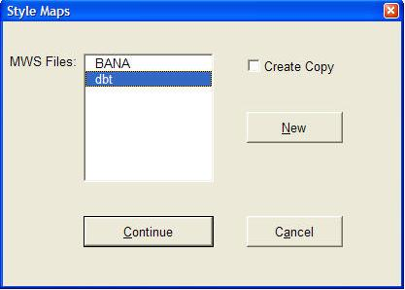
It is possible to create or modify a style map in three different ways:
A. Modify an existing style map. Simply select the file from the list.
B. Create a new, empty, style map. Select "New" (Alt-N) then enter the name of the new file.
C. Create a copy of an existing Style Map. Select an existing file, check the "Create Copy" check box, then select "New" (Alt-N). Enter the name of the new file.

Mapping styles
The Style Mapper will begin at the top of the current Word document and navigate forward. When it detects a style that is not yet mapped, a dialogue is displayed with the name of the new Word style and a list of DBT styles.

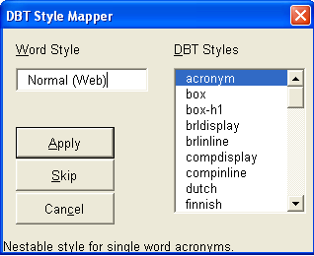
Note: The DBT Styles are not arranged alphabetically but are rather listed in the following order:
- The 33 most common DBT styles
- "User defined": Choose this option to define a non-standard style that exists within the DBT template that will be used
- Any additional DBT styles already in the style map
To map the current Word style to one of the DBT styles, select the DBT style in the list (Alt-D) then select "Apply" (Alt-A or Enter). Other options are "Skip" (Alt-S) to avoid mapping the current style or "Cancel" (Alt-C or Esc) to exit the Style Mapper.
Once all styles in the current Word document have been mapped, a prompt will be given to save the new .mws file and emboss to braille.

Restore Styles (R)
Revert to the previously saved version of the default style map "DBT.mws".

Acronym Tables (T)

What is an Acronym Table?
The rules of UEB require that when letters within an abbreviation or acronym are pronounced separately as letters, contractions should not be used.
Example:
Print: POW (Prisoner of War)
.dxb: ,,pow
In order to implement this rule, DBT's acronym tables contain lists of abbreviations and acronyms that will be translated in uncontracted braille.
The "Global" acronym table is always applied to every document. It is also possible to create new tables and specify one to be used alongside the global table. Separate tables are recommended for use with documents containing acronyms that are unique to a context, such as a business or branch of science. The total number of acronyms in the global table plus one other table should not exceed 1,000.

Managing Acronym Tables
Display the DBT Acronym Tables dialogue box, which enables the acronym tables to be managed.
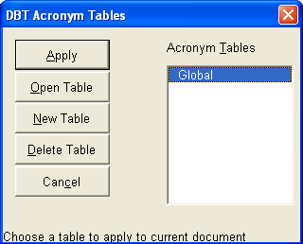
If no acronym tables exist yet, a global table will be created.
Select a table from the list and "Apply" (Alt-A or Enter) to use that table in addition to the global table. The whole document will be checked and if any acronyms in the table(s) are detected their style will be changed to "acronym". This process may take some time, after which a dialogue box will report how many acronyms were detected.
Select "Open Table" (Alt-O) to display a dialogue box where the contents of an existing acronym table can be modified. It is possible to add new acronyms or highlight and remove existing acronyms.
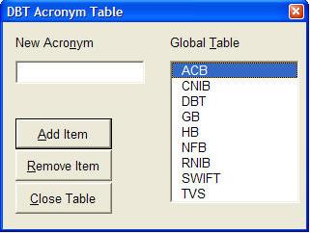
The other available options are "New Table" (Alt-N) to create a new table, "Delete Table" (Alt-D), and "Cancel" (Alt-C) to exit the dialogue box.

Append Acronym (A)
Place the cursor immediately before or within an acronym or abbreviation then select "Append Acronym" to add the word to a chosen acronym table.
Refer to the above section Acronym Tables for more information.

Word Styles Lister (W)
Create a new Word file that will list and describe all of the Word styles available in the current Word document.

3.6 Word Mapping Files

3.6.1 What are .mws files?
DBT comes with several Word to DBT mapping files (.mws). These files determine how a Word file is imported into DBT. Each Word style is associated with a chosen style from the DBT template.

3.6.2 Installation
To install a new .mws file, copy it to the Duxbury\Templates folder (usually located at C:\Program Files\). The new .mws file will then appear as an option when creating a new template and choosing to use a customised Word style map (refer to 2.6.9 Create Template).

3.6.3 Modification
The simplest way to modify a .mws file is to use the DBT Style Mapper in SWIFT (refer to 3.5.3 SWIFT).
It is also possible to open and edit a .mws file directly using a text editor such as Notepad. At the most simple level, the general format of the mapping element is:
<type> "<MSWord style name>"
{
MappedName = "<DBT style name>"
}
<type> may take the value of Built-in, for those styles that come as standard in Word, or User, for those styles that have been created by the user.
<DBT style name> must be enclosed in quotation marks. If the DBT style is a paragraph style, the full stop at the end of its name should be omitted.
Example:
BuiltIn "Endnote Text"
{
MappedName = "Note"
}
To achieve more complex mapping, refer to the DBT Help menu (Contents > Working with Word > Editing the ".mws" file) for more information.

Part 4:
APPENDICES

APPENDIX 1:
ASCII Braille Equivalents
ASCII braille can be entered into a .dxp file using [q~] or [d~] codes, Grade 0 mode, or the <Brlinline> style. For more information, refer to 3.3.2 ASCII Entry.
This list is given in braille order.
A | B | C | D | E | F | G | H | I | J
A | B | C | D | E | F | G | H | I | J
K | L | M | N | O | P | Q | R | S | T
K | L | M | N | O | P | Q | R | S | T
U | V | X | Y | Z | & | = | ( | ! | )
U | V | X | Y | Z | & | = | ( | ! | )
* | < | % | ? | : | $ | ] | \ | [ | W
* | < | % | ? | : | $ | ] | \ | [ | W
1 | 2 | 3 | 4 | 5 | 6 | 7 | 8 | 9 | 0
1 | 2 | 3 | 4 | 5 | 6 | 7 | 8 | 9 | 0
/ | + | # | > | ' | -
/ | + | # | > | ' | -
` | ~ | _ | " | . | ; | ,
` | ~ | _ | " | . | ; | ,

APPENDIX 2:
Order of Braille Signs
When two or more mode indicators, accents or punctuation signs occur together, they are placed in the following order, with the outer signs listed first:
- typeform indicator
- grade 1 mode indicators
- apostrophe
- numeric indicator
- capital indicator or decimal sign
- accent signs

APPENDIX 3:
UEB Contractions, Shortforms and Mode Indicators

UEB Contractions and Shortforms

A | a
about | ab
above | abv
according | ac
across | acr
after | af
afternoon | afn
afterward | afw
again | ag
against | ag/
almost | alm
already | alr
also | al
although | al?
altogether | alt
always | alw
-ance | .e
and | &
ar | >
as | z
B | b
-bb- | 2
be | 2
because | 2c
before | 2f
behind | 2h
below | 2l
beneath | 2n
beside | 2s
between | 2t
beyond | 2y
blind | bl
braille | brl
but | b
C | c
can | c
cannot | _c
-cc- | 3
ch | *
character | "*
child | *
children | *n
con- | 3
conceive | 3cv
conceiving | 3cvg
could | cd
D | d
day | "D
deceive | dcv
deceiving | dcvg
declare | dcl
declaring | dclg
dis- | 4
do | d
E | e
ea | 1
ed | $
either | ei
en | 5
-ence | ;e
enough | 5
er | ]
ever | "E
every | e
F | f
father | "F
-ff- | 6
first | f/
for | =
friend | fr
from | f
-ful | ;L
G | g
-gg- | 7
gh | <
go | g
good | gd
great | grt
H | h
had | _H
have | h
here | "H
herself | h]f
him | hm
himself | hmf
his | 8
I | i
immediate | imm
in | 9
ing | +
it | x
its | xs
itself | xf
-ity | ;y
J | j
just | j
K | k
know | "k
knowledge | k
L | l
-less | .S
letter | lr
like | l
little | ll
lord | "L
M | m
many | _M
-ment | ;T
more | m
mother | "M
much | m*
must | m/
myself | myf
N | n
name | "N
necessary | nec
neither | nei
-ness | ;S
not | n
O | o
of | (
one | "O
oneself | "of
-ong | ;g
ou | \
ought | "\
-ound | .D
-ount | .T
ourselves | \rvs
out | \
ow | [
P | p
paid | pd
part | "P
people | p
perceive | p]cv
perceiving | p]cvg
perhaps | p]h
Q | q
question | "Q
quick | qk
quite | q
R | r
rather | r
receive | rcv
receiving | rcvg
rejoice | rjc
rejoicing | rjcg
right | "R
S | s
said | sd
sh | %
shall | %
should | %d
-sion | .N
so | s
some | "S
spirit | _S
st | /
still | /
such | s*
T | t
th | ?
that | t
the | !
their | _!
themselves | !mvs
there | "!
these | ~!
this | ?
those | ^?
through | "?
thyself | ?yf
time | "T
-tion | ;N
today | td
together | tgr
tomorrow | tm
tonight | tn
U | u
under | "U
upon | ^U
us | u
V | v
very | v
W | w
was | 0
were | 7
wh | :
where | ":
which | :
whose | ^:
will | w
with | )
word | ^W
work | "W
world | _W
would | wd
X | x
Y | y
you | y
young | "Y
your | yr
yourself | yrf
yourselves | yrvs
Z | z

UEB Mode Indicators

boldface
symbol ^2
word ^1
passage ^7
terminator ^'

capitals
sign ,
word ,,
passage ,,,
terminator ,'

grade 1 mode
symbol ;
word ;;
passage ;;;
terminator ;'

italics
symbol .2
word .1
passage .7
terminator .'

numeric mode
numeric indicator #
passage ##
terminator #'

script
symbol `2
word `1
passage `7
terminator `'

underlined
symbol _2
word _1
passage _7
terminator _'

APPENDIX 4:
UEB Symbols and Keyboard Entry for
Symbols and Accented Letters
Many symbols and non-keyboard characters can be entered in Word or a .dxp document using numeric codes. All Windows codes will work in both DBT and Word, however correct UEB translation may not yet be enabled for some symbols which do not appear on this list.
This list includes only those symbols that most commonly appear in literary material and translate correctly to UEB. For a complete list of UEB symbols with Unicode shortcuts, refer to the ICEB's Current UEB Symbols List at http://iceb.org/ueb.html.
The shortcuts in this appendix require that the number-pad (on the right of the keyboard) is used and "Num Lock" is activated.
Symbol | Description | UEB symbol | Windows:  hold down Alt while typing number | Unicode:  number then Alt-X | DUSCI code in DBT:  Ctrl-]
& | ampersand | `& | 0038 | 0026 | 26
* | asterisk | "9 | 0042 | 002a | 2a
\ | back slash | _* | 0092 | 005c | 5c
/ | forward slash | _/ | 0047 | 002f | 2f
: | colon | 3 | 0058 | 003a | 3a
; | semicolon | 2 | 0059 | 003b | 3b
, | comma | 1 | 0044 | 002c | 2c
… | ellipsis | 444 | 0133 | 2026
. | full stop (period) or decimal point | 4 | 0046 | 002e | 2e
! | exclamation | 6 | 0033 | 0021 | 21
? | question mark | 8 | 0063 | 003f | 3f
 | outer quotes | 8 0
‘ ’ | inner quotes (single) | ,8 ,0 | 0145  0146 | 2018  2019 | ec48  ec49
" " | inner quotes (double) | ~8 ~0 | 0147  0148 | 201c  201d | ec4c  ec4d
( ) | round brackets | "< "> | 0040  0041 | 0028  0029 | 28  29
[ ] | square brackets | .< .> | 0091  0093 | 005b  005d | 5b  5d
< > | angle brackets or less-than and greater-than | @< @> | 0060  0062 | 003c  003e | 3c  3e
 | transcriber’s note brackets | `.< `.>
• | bullet | _4 | 0149 | 2022 | ec52
- | hyphen | - | 0045 | 002d | 2d
– | en dash | ,- | 0150 | 2013 | ec43
— | em dash | ,- | 0151 | 2014 | ec44
― | long dash | ",- |  | 2015 | ec45
_ | underscore | .- | 0095 | 005f | 5f
¼ | one quarter | #a/d | 0188 | 00bc
½ | one half | #a/b | 0189 | 00bd
¾ | three quarters | #c/d | 0190 | 00be
÷ | division | "/ | 0247 | 00f7 | f6
× | multiplication | "8 | 0215 | 00d7 | f7
+ | plus | "6 | 0043 | 002b | 2b
± | plus or minus | _6 | 0177 | 00b1 | f531
= | equals | "7 | 0061 | 003d | 3d
≤ | less than or equal to | _@< | 8804 | 2264 | f094
≥ | greater than or equal to | _@> | 8805 | 2265 | f095
° | degrees | ^j | 0176 | 00b0 | f8
% | percent | .0 | 0037 | 0025 | 25
™ | trade mark | ^t | 0153 | 2122
® | registered trade mark | ^r | 0174 | 00ae | f52e
© | copyright | ^c | 0169 | 00a9 | f529
† | dagger | @,? | 0134 | 2020 | ec50
‡ | double dagger | @,] | 0135 | 2021 | ec51
¢ | cent | @c | 0162 | 00a2 | 9b
$ | dollar | @s | 0036 | 0024 | 24
€ | euro | @e | 0128 | 20ac
£ | pounds | @l | 0163 | 00a3 | f523
₣ | franc | `f |  | 20a3 | ed53
¥ | yen | @y | 0165 | 00a5 | 9d
á | a acute | ~/a | 0225 | 00e1 | a0
Á | capital a acute | ,~/a | 0193 | 00c1 | 9ca0
à | a grave | ~*a | 0224 | 00e0 | 85
À | capital a grave | ,~*a | 0192 | 00c0 | 9c85
â | a circumflex | ~%a | 0226 | 00e2 | 83
Â | capital a circumflex | ,~%a | 0194 | 00c2 | 9c83
ä | a umlaut | ~3a | 0228 | 00e4 | 84
Ä | capital a umlaut | ,~3a | 0196 | 00c4 | 8e
ã | a tilde | ~]a | 0227 | 00e3 | f563
Ã | capital a tilde | ,~]a | 0195 | 00c3 | f543
ç | c cedilla | ~&c | 0231 | 00e7 | 87
Ç | capital c cedilla | ,~&c | 0199 | 00c7 | 80
é | e acute | ~/e | 0233 | 00e9 | 82
É | capital e acute | ,~/e | 0201 | 00c9 | 90
è | e grave | ~*e | 0232 | 00e8 | 8a
È | capital e grave | ,~*e | 0200 | 00c8 | 9c8a
ê | a circumflex | ~%e | 0234 | 00ea | 88
Ê | capital e circumflex | ,~%e | 0202 | 00ca | 9c88
ë | e umlaut | ~3e | 0235 | 00eb | 89
Ë | capital e umlaut | ,~3e | 0203 | 00cb | 9c89
í | i acute | ~/i | 0237 | 00ed | a1
Í | capital i acute | ,~/i | 0205 | 00cd | 9ca1
ì | i grave | ~*i | 0236 | 00ec | 8d
Ì | capital i grave | ,~*i | 0204 | 00cc | 9c8d
î | i circumflex | ~%i | 0238 | 00ee | 8c
Î | capital i circumflex | ,~%i | 0206 | 00ce | 9c8c
ï | i umlaut | ~3i | 0239 | 00ef | 8b
Ï | capital i umlaut | ,~3i | 0207 | 00cf | 9c8b
ñ | n tilde | ~]n | 0241 | 00f1 | a4
Ñ | capital n tilde | ,~]n | 0209 | 00d1 | a5
ó | o acute | ~/o | 0243 | 00f3 | a2
Ó | capital o acute | ,~/o | 0211 | 00d3 | 9ca2
ò | o grave | ~*o | 0242 | 00f2 | 95
Ò | capital o grave | ,~*o | 0210 | 00d2 | 9c95
ô | o circumflex | ~%o | 0244 | 00f4 | 93
Ô | capital o circumflex | ,~%o | 0212 | 00d4 | 9c93
ö | o umlaut | ~3o | 0246 | 00f6 | 94
Ö | capital o umlaut | ,~3o | 0214 | 00d6 | 99
õ | o tilde | ~]o | 0245 | 00f5 | f575
Õ | capital o tilde | ,~]o | 0213 | 00d5 | f555
ú | u acute | ~/u | 0250 | 00fa | a3
Ú | capital u acute | ,~/u | 0218 | 00da | 9ca3
ù | u grave | ~*u | 0249 | 00f9 | 97
Ù | capital u grave | ,~*u | 0217 | 00d9 | 9c97
û | u circumflex | ~%u | 0251 | 00fb | 96
Û | capital u circumflex | ,~%u | 0219 | 00db | 9c96
ü | u umlaut | ~3u | 0252 | 00fc | 81
Ü | capital u umlaut | ,~3u | 0220 | 00dc | 9a
ÿ | y umlaut | ~3y | 0255 | 00ff | 98

APPENDIX 5:
DBT Codes
Following is a list of commonly used DBT codes needed for UEB translation, categorised according to their function. A full list of all DBT codes is available under the DBT Help Menu, "DBT Codes Quick Reference", however please note that some of the codes listed there are not appropriate for use with UEB.
Some of the codes listed may have shortcut keys, be part of the menus, or be embedded in the styles which are part of the Australian or New Zealand templates.
When working in DBT, the F5 key will bring up a list of most codes, grouped under different headings from those used here. All DBT codes can also be entered manually using Ctrl-[ or F9, but this may not always be the most efficient method.

Translation modes
code | description | explanation | reference
[/] | break sequence | break a sequence to prevent a contraction | 3.3.1
[g1] | grade 1 mode | do not use contractions | 2.4.7  3.3.1
[g2] | grade 2 mode | use contractions | 2.4.7  3.3.1
[i] | grade 1 word without indicator | translate the following word in grade 1 mode, without a grade 1 indicator | 3.3.1
[ii] | grade 1 word with indicator | translate the following word in grade 1 mode, and insert a grade 1 word indicator ;; | 3.3.1
[u] | grade 1 symbol | treat the letter immediately following as a grade 1 symbol. Use in the middle of a symbols-sequence to prevent a contraction. | 3.3.1
[ui] | grade 1 character with indicator | insert a grade 1 symbol indicator ; | 3.3.1
[ts] … [te] | grade 1 passage with indicator | translate the following passage in grade 1 mode with the grade 1 passage indicator ;;; and terminator ;'
[fl-lifg] | switch to a foreign language | translate the following passage with the correct native accent symbols for Latin, Italian, French and German. Use this code in combination with [g1]. | 2.4.7
[lng~X] | switch to a new language | translate the following passage in grade 1 mode using braille symbols from the selected language for accented letters. X can take the values of: de (German), en (English), es (Spanish), fi (Finnish), fr (French), it (Italian), la (Latin), mi (Māori), nl (Dutch), pt (Portuguese), sv (Swedish) or sw (Swahili). | 3.3.1
[lng] | revert back to original language | resume normal text translation, cancelling any language codes | 3.3.1

Direct entry
code | description | explanation | reference
[cz] | exact translation | translate as ASCII braille (grade 0 braille) | 2.3.3  2.4.7  2.7.7  3.3.2
[tx] | normal translation | resume normal text translation, cancelling any special mode for computer notation or direct braille | 2.4.7  3.3.1
[q~W] | ASCII entry | translate W (a word or unbroken string of characters) as ASCII braille | 3.3.2
[d~W] | ASCII entry with a space following | translate W (a word or unbroken string of characters) as ASCII braille with a blank space following | 3.3.2

Typeforms & capitalisation
code | description | explanation | reference
[fts~i]  [fte~i] | italics | mark the beginning and end of a letter, word or phrase in italics | 2.4.13  3.3.5
[fts~b]  [fte~b] | bold | mark the beginning and end of a letter, word or phrase in bold | 2.4.13  3.3.5
[fts~u]  [fte~u] | underline | mark the beginning and end of a letter, word or phrase that is underlined | 3.3.5
[fts~s]  [fte~s] | script | mark the beginning and end of a letter, word or phrase that is in a special script, for example handwritten | 3.3.5
[xcs] | cancel capitalised word sequence |  | 3.3.6
[ucs]  [uce] | passage of capitals to be treated as a single unit |  | 3.3.6

Page numbering
code | description | explanation | reference
[pnta] | Arabic page numbering | set page number type to Arabic. This is the default setting. | 2.4.15
[pntr] | roman page numbering | set page number type to roman | 2.4.15
[svpnpN:N:N:N] | sets page number placement values | override the document page numbering settings to change settings within the document. N can take the values 0 (no place) 1 (upper left), 2 (upper right), 3 (lower left) or 4 (lower right) and is given in the following order:  - braille page number on odd sides  - braille page number on even sides  - reference page number on odd sides  - reference page number on even sides | 2.6.3
[svpfdN] | set page number first displayed | pages numbered less than N will not be explicitly numbered. The default for this command is 1. | 2.6.3
[pgN~X] | begin new braille page N with prefix X | begin a new page and set the braille page number to N with the prefix character X. E.g. [pg1~p] would begin page "p1". The values of N and/or X can be left blank to continue existing numbering. | 3.4.1  3.4.5
[pvN~X] | define the number of the next braille page | defines the next braille page as braille page number N with the prefix X but does not force a new braille page | 2.4.15  3.4.1
[lea] | reference document page number, with display | treat the next word or group as a reference (usually print page number). The reference will be displayed on the next line as given in the document settings – for the Australian template the number will be given on the right margin after a line of dots 3,6. | 2.4.14
[lec] | reference document page number, without display | treat the next word or group as a reference. No turnover line appears in the text, with the only effect being the page reference in the relevant corner of the next page. | n/a
[led] | discontinue reference document page numbers | discontinue display of the reference in the relevant corner of the braille page | n/a

Page formatting
code | description | explanation | reference
[pg] | new braille page | begin a new braille page | 2.4.14
[top] | top of page | begin a new braille page unless the code already appears at the top of a new braille page | 3.4.1
[sdN] | force odd/even page | starts a new line if not already on one, then starts a new page if the current page is not even (N=0) or odd (N=1) | 3.4.1
[cpN:L] | conditional page eject with blank lines | position on a new line. If N or less lines remain on the page, force onto a new braille page. If more than N lines remain on the page, insert L blank lines. The value for L may be omitted, in which case no blank lines will be added. | n/a
[tls]  [tle] | running title | treat text between these codes as the running title for any new braille pages after this point in the document | 2.4.16
[tld] | discontinue running title | discontinue use of the running title | 2.4.16
[svrhpN] | running title usage value | define when the running title should be used. N may take one of the following values:  - 0 – no pages  - 1 – odd pages only  - 2 – even pages only  - 3 – all pages. This is the default | 2.4.16
[svrhsM:N] | running title side-room | set the fixed amount of space reserved on the left (M) and right (N) sides of the running title | 2.4.16
[rfs]  [rfe] | running footer | treat text between these codes as the running footer for any new braille pages after this point in the document | 2.4.17
[vcs]  [vce] | vertical centring | vertically centre all text on the page. The [vcs] code can appear anywhere on the first page to be affected. The [vce] code must go after the [pg] code that ends the last page to be affected. | 2.4.14

Paragraph formatting
code | description | explanation | reference
[p] | begin a new paragraph | begin a new paragraph, with the first line indented two braille cells | 2.4.9
[hiL:V:R:I:J:K:M:N:O:P] | hierarchical paragraph settings | define how a paragraph and its hierarchical levels are formatted, with the following variables:  - L = left margin (default 1)  - V = runover margin (default 1)  - R = right margin offset (default 0)  - I = Left margin increment for each hierarchy level (default 0)  - J = runover increment for each hierarchy level (default 0)  - M = upper limit of hierarchy levels  - N = upper limit of left margin  - O = upper limit of runover margin  - P = Upper limit of right margin offset | 2.4.3
[hlN] | set hierarchy level | set the level of a hierarchical style or paragraph | 2.4.3  2.4.4
[ptysN] | begin poetry mode with N cells runover | set runover to N cells beyond the current left margin. If N is left blank, a default of 2 cells is used. | 2.4.12
[ptye]  [pty0] | end poetry mode | sets runover to the current left margin | 2.4.12
[indN] | set left margin | sets the left margin to cell N and starts a new line (if not already on a new line) | 2.4.10
[ind]  [ind0]  [ind1] | restore left margin | restores left margin to cell 1 | 2.4.10
[rmN] | indent right margin | indent right margin by N cells from the normal full page width. This code affects only the runover point, not text that is set by explicit tabulation | 2.4.11
[rm]  [rm0] | restore right margin | restores right margin to the full page width | 2.4.11

Line formatting
code | description | explanation | reference
[svsblN] | interline spacing | set interline spacing value to N, where N is the number of blank lines between text lines. The default value is 0, i.e. single spacing. | 2.4.9
[skL] | skip lines | skip L lines | 2.4.9
[slL] | force line endings | force L line endings. This command is generally preferable to [skL]. | n/a
[sk-N] | skip to Nth line | skip to the Nth line from the end of the page, unless already at or beyond that point on the page. e.g. [sk-1] skips to the last line on the page. | n/a
[stL] | skip to line L | skip to line L on the braille page, unless already past that point | n/a
[skn] | skipped line nullify | cancel a skipped line produced by the previous command (usually a style with a skip command embedded) | 2.4.9
[<] | force a new line | force a new line, regardless of current position | 2.7.7
[l] | new line | go to a new line, unless already on a new line | 2.4.9
[hdsN:L] | begin centred line with conditional page break and skipped lines | centre line. If there are N or less lines remaining on the page, force onto a new braille page. If there are more than N lines remaining on the page, insert L blank lines. Both N and L can be omitted, with default values of 1 and 0 | 2.4.9
[hde] | end centred line | end centred line | 2.4.9
[fr] | flush right | align next word or group flush right on the page | 2.4.9
[fr;F~X] | flush right with fill | align next word or group flush right on page with the given fill options:  - F = fill type, i.e. full (f) or partial (p)  - X = ASCII character to be used for fill | 2.4.9
[run] | tab to the runover point | tab to the current runover point | 2.4.9
[tabP:A:F~X] | create a one-off tab | create a one-off tab with the following parameters:  - P = position, i.e. the cell number to which items will be aligned  - A = alignment type, i.e. left (l), right (r), centred (c) or decimal (d)  - F = fill type, i.e. full (f) or partial (p)  - X = ASCII character to be used for fill | n/a

Tabulation
code | description | explanation | reference
[ctb] | clear tab settings | clear all previous tab settings | 3.4.4
[stbS:A:P] | set tab stop number | set a new tab stop, where  S = tabstop number  A = alignment type, i.e. left (l), right (r), centred (c) or decimal (d)  P = position, i.e. the cell number to which the items will be aligned | 3.4.4
[svdac~X] | set decimal alignment character | set the character that is used by the tab commands to control decimal alignment | n/a
[>] | tab | tab to the next tab stop to the right. No intervening fill is added. | 2.5.1  3.4.4
[#S] | align to tab stop | align the next word or group to tab stop S, as defined using the [stb] code | 3.4.4
[#S:F~X] | align to tab stop with fill | align the next word or group to tab stop S with the given fill options:  - F = fill type, i.e. full (f) or partial (p)  - X = character to be used for fill | 3.4.4

Grouping
code | description | explanation | reference
[:]  [;] | treat as single word | begin and end a group of characters to be treated like a single word | 2.4.8  3.3.8
[kbs]  [kbe] | keep on the same braille page | begin and end a group that will be kept on the same braille page | n/a
[kbs1] | keep on same braille page with conditional page break | begin a group that will be kept on the same braille page. Force to a new braille page if on the bottom line of the page. | n/a
[kps]  [kpe] | keep paragraphs on same braille page | begin and end a group of paragraphs to be kept on the same braille page | 2.4.14
[wb] | allow word break | allow line breaks at an internal hyphen or dash. This is the default setting. | n/a
[wb-no] | suspend all word breaking | do not allow line breaks at an internal hyphen or dash | n/a
[-] | assisted hyphenation | allow a word to be broken at this point to hyphenate at the end of a line | 3.3.8
['] | hard space | display a space or numeric space in the braille translation but do not break the group | 2.4.8  3.3.4  3.3.8

Mathematics or technical notation
code | description | explanation | reference
[fs] | fraction start | start fraction | 2.4.13
[fl] | fraction line | fraction line | 2.4.13
[fe] | fraction end | end fraction | 2.4.13
[ixrts] | indexed root start | start indexed root | 2.4.13
[ixrtd] | indexed root delimiter | separator between index and root | 2.4.13
[ixrte] | indexed root end | end indexed root | 2.4.13
[sqrts]  [sqrte] | square root | start and end square root | 2.4.13
[ps]  [pe] | power | start and end superscripted text | 2.4.13
[bs]  [be] | base | start and end subscripted text | 2.4.13
[e] | modified expression | mark the beginning of an expression that has text directly under or over
[us]  [ue] | directly under | start and end text that is written directly under an item marked with [e] | 2.4.13
[os]  [oe] | directly over | start and end text that is written over under an item marked with [e] | 2.4.13

Miscellaneous
code | description | explanation | reference
[uoq~X] | set predominant quotation mark | designate the usual, or outer, quote mark for translation purposes. This quote mark will be translated using one-cell (nonspecific) quotation marks 8 and 0 while all other quotation marks will be translated using their two-cell, specific braille symbols. X may take any of the following values:  - [uoq] the next quote mark encountered. This is the default setting.  - [uoq~"] the ordinary keyboard double quote  - [uoq~`] the ordinary keyboard grave symbol  - [uoq~00ab] the left pointing Italian quotation mark | 3.3.7
[uclN~"] | literal treatment of the double quote | turn literal treatment of the double quote on (N=1) or off (N=2). When turned on, the keyboard double quote character is translated as the "non-directional" quote. When off (the default), it is treated as an opening or closing quote. | n/a
[tns]  [tne] | transcriber's note brackets | insert start and end transcriber's note brackets | n/a
[ifbrl] | braille only | the following word or code will only affect (or appear in) the braille output. Grouping may be used to extend the effect of this code to more than one word. | 3.3.8
[ifprt] | print only | the following word or code will only affect (or appear in) the print output. Grouping may be used to extend the effect of this code to more than one word. | 3.3.8
[rpsN]  [rpe] | include in table of contents | mark text as an item for inclusion in the table of contents, where N is the "level" of the text within the TOC hierarchy, defaulting to 1 (highest) | n/a

APPENDIX 6:
Styles in the English (Unified) - Australian Formatting Template
Transcribers who have experience with previous versions of the ABA template should note that some style names and functions have been changed in this new release. This appendix should be read carefully to gain a good understanding of the changes.
Note that a style with a full stop at the end of its name is a paragraph style (also known as a "linear style") that will apply to the whole paragraph and cannot be nested, as described in 3.2.1 What are Styles?
Hierarchical styles have more than one level, as described in Section 2.4.3 Style Level. To change the level of any hierarchical style, use Layout: Style Level+ (Alt-right arrow) or Layout: Style Level− (Alt-left arrow) as appropriate. Check the embedded codes to determine the position of each successive level.
English (Unified) - Australian Formatting style | Embedded Codes | Description
Block.  (Paragraph) | [hi1:1:0:2:2] … [hi] | - Use for blocked text  - Text begins in cell 1 with runover to cell 1  - This is a hierarchical style with increments of 2 for both left margin and runover  - Equivalent to the Outline style
Bold  (Character) | [fts~b] … [fte~b] | - Applies bold indicators (character, word or paragraph) as appropriate to the enclosed text
Box.  (Paragraph) | [cp2][ind1][q~"3][fr;f~3]  [q~4] [hi3:1:0:2:2][l]  …  [ind1][q~"3][fr;f~3][q~j][hi][l] | - Box with a simple horizontal line segment and corners  "333333333333333333333333334  boxed text  33333333333333333333333333j  - Automatically applied when a textbox is imported from Microsoft Word. Text within the box is automatically formatted as a normal paragraph.  - Identical output to the <BoxWithin> style but the <Box.> style cannot contain other styles.
BoxBegin  (Character) | [cp2][ind1][q~"3][fr;f~3][q~4][l] | - Box start on the margin with a simple horizontal line segment and downward corner  333333333333333333333333334  - Use in conjunction with the <BoxEnd> style
BoxDouble.  (Paragraph) | [cp2][ind1][q~"3][fr;f~7][q~4][l]  …  [ind1][q~"3][fr;f~7][q~j][l] | - Box on the margin with double horizontal line segments and corners  377777777777777777777777774  boxed text  37777777777777777777777777j  - Use only if more than one type of box is needed within a document
BoxEnd  (Character) | [ind1][q~"3][fr;f~3][q~j][l] | - Box end on the margin with a simple horizontal line segment and upward corner  33333333333333333333333333j  - Use in conjunction with the <BoxBegin> style
BoxOld.  (Paragraph) | [cp2][ind1][fr;f~7][q~7][l]  …  [ind1][fr~f;g][q~g][l] | - Box that starts with a line of lower g's and ends with a line of upper g's  777777777777777777777777777  boxed text  gGggggggggggggggggggggggggg  - This box is no longer recommended for use but has been retained for historical purposes
BoxTriple.  (Paragraph) | [cp2][ind1][q~"3][fr;f~=][q~4][l]  …  [ind1][q~"3][fr;f~=][q~j][l] | - Box on the margin with triple horizontal line segment and corners  3=========================4  boxed text  3=========================j  - Use only if more than one type of box is needed within a document
BoxWithin  (Character) | [cp2][q~"3][fr;f~3][q~4][l]  …  [l][q~"3][fr;f~3][q~j][l] | - Box with simple horizontal line segments and corners  333333333333333333333333334  boxed text  33333333333333333333333333j  - Use when combining a box with other paragraph styles
BrlDisplay.  (Paragraph) | [cz] … [tx][l] | - Treats all enclosed text as direct braille  - Text can be entered using 6-key entry (F2 to toggle) or ASCII entry  - Automatically applied by DBT when importing paragraphs in Simbraille or Braille font from a Word Document
Brlinline  (Character) | [cz] … [tx] | - Treats all enclosed text as direct braille  - Text can be entered using 6-key entry (F2 to toggle) or using ASCII entry  - Can be used within a line or paragraph of standard text, i.e. is nestable  - Automatically applied by DBT when importing short passages (less than a paragraph) of text in SimBraille or Braille font from a Word Document
CapitalsBreak  (Character) | [xcs] | - Indicates a break between two semantically different items that should be should be capitalised separately
CapitalsTogether  (Character) | [ucs] … [uce] | - Ensures that all text between the codes is treated as a single unit for capitalisation, no matter how long or short, even if it breaks over more than one line  - Use for BLOCK CAPITAL passages (e.g. headings or a stanza of a poem) which contain paragraph or line codes for formatting purposes
CentredAsterisks  (Character) | [hds0][d~"9][d~"9][d~"9] … [hde] | - 3 centred asterisks  "9 "9 "9  - Use to indicate a minor text break  - No text should appear between the opening and closing tags
CentredLine  (Character) | [hds0][q~"33333333333] … [hde] | - A solid single horizontal line in the centre of the braille line  "33333333333  - Use to indicate a major text break  - No text should appear between the opening and closing tags
CentredText  (Character) | [hds0:0] … [hde] | - Centres any enclosed text
Contents.  (Paragraph) | [hi1:3:6:2:2] … [hi][l] | - List style with runover indented two spaces and reserving the last 7 spaces on the line for leader dots and page numbers  - Use on a contents page
Continuation  (Character) | [q~"][l][run] | - Inserts a continuation indicator (") and breaks to a new line at the current runover position  - Must be inserted at the appropriate place for the line to break  - No text should appear between the opening and closing tags  - Use for long internet addresses, email addresses and mathematical expressions
EnglishResume  (Character) | [lng] | - Reverts to English language (UEB) after a series of passages in a foreign language  - No text should appear between the opening and closing tags
French  (Character) | [lng~fr] … [lng] | - For use only in French language textbooks where the reader is learning to read French. Not to be used for normal reading matter that contains words or passages in French.  - Switches to French language - uncontracted with French accents  - Use for a short string of words inside a passage
FrenchBegin  (Character) | [lng~fr] | - For use only in French language textbooks where the reader is learning to read French. Not to be used for normal reading matter that contains words or passages in French.  - Switches to French language - uncontracted with French accents  - Use at the start of a series of passages in French  - No text should appear between the opening and closing tags  - Insert the <EnglishResume> (or another language Begin) style at the end of the French passages to exit out of French language
G1Passage  (Character) | [ts] … [te] | - Inserts grade 1 passage indicators and translates enclosed text in grade 1 mode  ;;; … ;'
G1TextBegin  (Character) | [cp2][q~""=][ts] … [l] | - Inserts a grade 1 passage indicator on a line of its own and translates all following text in grade 1 braille  ""=;;;  - Use to introduce an extended passage of material in grade 1 mode, for example when presenting mathematics  - No text should appear between the opening and closing tags
G1TextEnd  (Character) | [l][q~""=][te] … [l] | - Terminates translation in grade 1 braille and inserts a grade 1 terminator indicator on a line of its own  ""=;'  - Use to end an extended passage of material in grade 1 mode, for example when presenting mathematics  - No text should appear between the opening and closing tags
G1Word  (Character) | [ii] | - Inserts a grade 1 word indicator ;; and translates the enclosed word in grade 1 mode
German  (Character) | [lng~de] … [lng] | - For use only in German language textbooks where the reader is learning to read German. Not to be used for normal reading matter that contains words or passages in German.  - Switches to German language - uncontracted with German accents  - Use for a short string of words inside a passage
GermanBegin  (Character) | [lng~de] | - For use only in German language textbooks where the reader is learning to read German. Not to be used for normal reading matter that contains words or passages in German.  - Switches to German language - uncontracted with German accents  - Use at the start of a series of passages in German  - No text should appear between the opening and closing tags  - Insert the <EnglishResume> (or another language Begin) style at the end of the German passages to exit out of German language
H1.  (Paragraph) | [l][kps][rm12][rps1][hds3:1]  …  [rpe1][hde][rm0][kpe2:2] | - Applies a level 1 heading style, i.e. inserts a blank line before and centres the text  - Includes the heading in an automatic table of contents  - Applied automatically to material in heading 1 style imported from Word
H2.  (Paragraph) | [kps][ind5][rps2][cp2:1]  …  [rpe2][ind][kpe2:2][l] | - Applies a level 2 heading style, i.e. inserts a blank line before and blocks the text in cell 5  - Includes the heading in an automatic table of contents  - Applied automatically to material in heading 2 style imported from Word  - To remove the blank line above this heading, add an [skn] code after the beginning tag
H2lessline.  (Paragraph) | [kps][cp2][rps2][ind5]  …  [rpe2][ind][kpe2:2][l] | - Applies a level 2 heading style with no blank line ahead of it  - Use only for headings that immediately follow another heading  - Includes the heading in an automatic table of contents  - Applied automatically to material in heading 2 style imported from Word
H3.  (Paragraph) | [kps][ind3][rps3][cp2:1]  …  [rpe3][ind][kpe2:2][l] | - Applies a level 3 heading style, i.e. inserts a blank line before and blocks the text in cell 3  - Includes the heading in an automatic table of contents  - Applied automatically to material in heading 3 style imported from Word  - To remove the blank line above this heading, add an [skn] code after the beginning tag
H3lessline.  (Paragraph) | [kps][cp2][rps3][ind3]  …  [rpe3][ind][kpe2:2][1] | - Applies a level 3 heading style with no blank line ahead of it  - Use only for headings that immediately follow another heading  - Includes the heading in an automatic table of contents
H4.  (Paragraph) | [kps][ind][cp2:1]  …  [kpe2:2][l] | - Applies a level 4 heading style, i.e. inserts a blank line before and leaves text on the margin  - Not included in an automatic table of contents  - Not automatically applied to headings imported from Word when using the DBT default .mws file; a modified file is required  - To remove the blank line above this heading, add an [skn] code after the beginning tag
H4lessline.  (Paragraph) | [kps][ind][cp2]  …  [kpe2:2][l] | - Applies a level 4 heading style with no blank line ahead of it  - Use only for headings that immediately follow another heading  - Not be included in an automatic table of contents
HorizontalLine  (Character) | [l][q~"][fr;f~3][q~3][l] | - Creates a horizontal line across the page  333333333333333333333333333  - Use as a break within sections of a table or to rule off questions within a test  - No text should appear between the opening and closing tags
Initial  (Special hidden style) | [vrn~ida][svrhs4:4] [svgrn~}][svles0:0:1:1] [svdac~4][svpfd2] | - Sets default parameters for all documents created from the template  - Take care if modifying this style as it affects the whole document and, if the template is saved, all future documents  - There is no need to insert the Initial style into a document. Its presence in the template creates default settings for the document, without any further intervention  - Sets the following parameters (in coded order):  - Double hyphen is translated as dash; single hyphen with space either side is translated as dash; spaces either side of dashes are removed  - Running header must have a minimum of 4 spaces either side  - UEB roman page numbers, i.e. grade 1 indicator is only inserted before those roman page numbers that require it (e.g. v, x, l)  - Allows a reference page turnover to appear on the second bottom line of a braille page and determines that any text following a reference page number is at the runover margin  - Sets the decimal alignment character to the UEB decimal character, lower d. This is important for tabulation to the decimal character.  - The first page number to be displayed is page 2 (or ii).
Italian  (Character) | [lng~it] … [lng] | - For use only in Italian language textbooks where the reader is learning to read Italian. Not to be used for normal reading matter that contains words or passages in Italian  - Switches to Italian language - uncontracted with Italian accents  - Use for a short string of words inside a passage
ItalianBegin  (Character) | [lng~it] | - For use only in Italian language textbooks where the reader is learning to read Italian. Not to be used for normal reading matter that contains words or passages in Italian  - Switches to Italian language - uncontracted with Italian accents  - Use at the start of a series of passages in Italian  - No text should appear between the opening and closing tags  - Insert the <EnglishResume> (or another language Begin) style at the end of the Italian passages to exit out of Italian language
Italics  (Character) | [fts~i] … [fte~i] | - Applies italics indicators (character, word or paragraph) as appropriate to the enclosed text
Keep Together  (Character) | [wb-no][:] … [;][wb] | - Keeps all enclosed text on the same braille line  - Useful within tables and for mathematical expressions
Lea  (Character) | [lea] | - Inserts a reference page number indicator. The number will appear in the braille document on its own line on the right margin, preceded by a line of dots 3,6.  - --------------------------#i  - Note that the [lea] code can also be easily inserted using the Alt-Enter shortcut
List.  (Paragraph) | [hi1:3:0:2:2] … [hi] | - Text begins in cell 1 with runover to cell 3  - Hierarchical style with increments of 2 for both left margin and runover  - Applied automatically to material in List style imported from Word  - Replaces the <Poetry2.> style from the old ABA UEB template
ListDeep.  (Paragraph) | [hi1:5:0:2:2] … [hi] | - Text begins in cell 1 with runover to cell 5  - Hierarchical style with increments of 2 for both left margin and runover  - Replaces the <Poetry4.> style from the old ABA UEB template
ListRm6.  (Paragraph) | [hi1:3:6:2:2] … [hi] | - Each line begins in cell 1 with runover to cell 3  - Word wrap occurs 6 cells before the right margin, allowing any flush-right text (such as page numbers or prices) to extend to the original right margin  - Hierarchical style with increments of 2 for both left margin and runover  - Use for material such as Table of Contents, menus, or similar  - Equivalent to the <Contents.> style
MarginNote.  (Paragraph) | [hi1:5][d~;\[] … [hi] | - Inserts a left arrow ;\[ beginning in cell 1  - Runover text begins in cell 5  - Use for small amounts of text (no more than one paragraph) appearing in the margin of a print book  - If using the margin note style, it should be explained in a transcriber’s note at the beginning of the document
Note.  (Paragraph) | [hi7:5] … [hi] | - Starts paragraph in cell 7 with runover to cell 5  - Use for footnote text  - Automatically applied to footnotes that have been imported Word
NumberLines | [lps][fr] … [lpr] | - Positions the line number on the right margin, then continues the text at the left margin  - Use for text with numbered lines, such as plays
Outline.  (Paragraph) | [hi1:1:0:2:2] … [hi] | - Text begins in cell 1 with runover to cell 1  - Hierarchical style with increments of 2 for both left margin and runover  - Applied automatically to the text in tables that have been imported from Word to DBT 10.7 or earlier using "stair-step" formatting
PageArabic  (Character) | [svpnp2:2:1:1][pnta][pv1]  …  [l] | - Sets braille page numbering to Arabic (1, 2, 3, 4 etc) and resets page number to 1  - No text should appear between the opening and closing tags  - Used for the main body of a text
PageNonums  (Character) | [svpnp0:0:0:0] | - Removes all page numbering from this point onwards  - No text should appear between the opening and closing tags  - Use PageArabic or PageRoman to reinstate page numbering
PageRoman  (Character) | [svpnp2:2:1:1][pntr][pv1]  …  [l] | - Sets braille page numbers to Roman numerals (i, ii, iii etc) and resets page number to 1  - No text should appear between the opening and closing tags  - Used for the preliminary pages of a text
Para.  (Paragraph) | [hi3:1:0:2:2] … [hi][l] | - Applies paragraph setting – begins text in cell 3 with runover to cell 1  - This is a hierarchical style with increments of 2 for both left margin and runover  - Applied automatically to paragraphs imported from Word
RightFlush.  (Paragraph) | [fr][:] … [;] | - Groups text together and aligns it on the right margin
RunningTitle.  (Paragraph) | [svrhp3][tls] … [tle] | - Creates a running title, i.e. text that will appear on the top line of every braille page  - Must be placed on the top line of a page to take effect on that page; otherwise the new running title will begin on the next braille page
Script  (Character) | [fts~s] … [fte~s] | - Applies script indicators (character, word or paragraph) as appropriate to the enclosed text  - Use for special script such as handwriting
SoftReturn  (Character) | [l][run] | - Begins a new line at the current runover position, rather than re-setting to cell 1  - No text should appear between the opening and closing tags
Spanish  (Character) | [lng~es] … [lng] | - For use only in Spanish language textbooks where the reader is learning to read Spanish. Not to be used for normal reading matter that contains words or passages in Spanish.  - Switches to Spanish language - uncontracted with Spanish accents  - Use for a short string of words inside a passage
SpanishBegin  (Character) | [lng~es] | - For use only in Spanish language textbooks where the reader is learning to read Spanish. Not to be used for normal reading matter that contains words or passages in Spanish  - Switches to Spanish language - uncontracted with Spanish accents  - Use at the start of a series of passages in Spanish  - No text should appear between the opening and closing tags  - Insert the EnglishResume (or another language Begin) style at the end of the Spanish passages to exit out of Spanish language
Stop Wordbreak  (Character) | [wb-no] … [wb] | - Prevents line breaks at hyphens or dashes
TNote  (Character) | [tns] … [tne] | - Inserts transcriber's note brackets  @.< @.>
Uncontract  (Character) | [tx][g1] … [g2] | - Translates the text as uncontracted braille (grade 1 mode) without adding any grade 1 indicators  - Use for acronyms and similar items
Underline  (Character) | [fts~u] … [fte~u] | - Applies underline indicators (character, word or paragraph) as appropriate to the enclosed text

APPENDIX 7:
Styles in the RNZFB Template
Note that a style with a full stop at the end of its name is a paragraph style (also known as a "linear style") that will apply to the whole paragraph and cannot be nested.
Hierarchical styles have more than one level, as described in Section 2.4.3 Style Level To change the level of any hierarchical style, use Layout: Style Level+ (Alt-right arrow) or Layout: Style Level− (Alt-left arrow) as appropriate. Check the embedded codes to determine the position of each successive level.
RNZFB Style | Embedded Codes | Description
Block5  (Character) | [l][ind5] … [ind1] | - Blocks all text to cell 5
Bold  (Character) | [fts~b] … [fte~b] | - Applies bold indicators (character, word or paragraph) as appropriate to the enclosed text.
Box  (Character) | [ind1][kps][fr;f~7][d~7][l] …  [ind1][fr;f-g][d~g][l][kpe] | - Box with a line of lower g's at the top and upper g's at the bottom.  7777777777777777777777777777  boxed text  ggGggggggggggggggggggggggggg  - Automatically applied when a textbox is imported from Microsoft Word. Text within the box is automatically formatted as a normal paragraph.
BrlInLine  (Character) | [cz] … [tx] | - Treats all text as direct braille - will appear in the .dxp file as ASCII  - Text can be entered using 6-key entry (F2 to toggle) or just using ASCII entry  - Can be used within a line or paragraph of standard text, i.e. is nestable.  - Automatically applied by DBT when importing short passages (less than a paragraph) of text from a Word Document which are in SimBraille font
Dsb.page  (Character) | [ifbrl][svpnp0:0:0:0][pg]  …  [ifbrl][svpnp4:4:2:2] | - Use after preliminary pages  - Inserts a blank braille page with no page numbers  - No text should appear between the opening and closing tags
Foreign.french  (Character) | [lng~fr] … [lng] | - Switches to French language - grade 1 with French accents  - For use only in French language textbooks where the reader is learning to read French. Not to be used for normal reading matter which contains words or passages in French.
Foreign.german  (Character) | [lng~de] … [lng] | - Switches to German language - grade 1 with German accents  - For use only in German language textbooks where the reader is learning to read German. Not to be used for normal reading matter which contains words or passages in German.
Foreign.latin  (Character) | [lng~la] … [lng] | - Switches to Latin language - grade 1 with Latin accents  - For use only in Latin language textbooks where the reader is learning to read Latin. Not to be used for normal reading matter which contains words or passages in Latin.
Foreign.spanish  (Character) | [lng~es] … [lng] | - Switches to Spanish language - grade 1 with Spanish accents  - This is for use only in Spanish language textbooks where the reader is learning to read Spanish. Not to be used for normal reading matter which contains words or passages in Spanish.
H1.  (Paragraph) | [l][kps][sc1:0][rm6][hds][rps1]  …  [rpe1][hde][rm0][sk1][kpe2:2] | - Applies a level 1 heading style, i.e. centres the text, and inserts a blank line before and after  - Includes the heading in an automatic table of contents  - Automatically applied to material imported from Word in heading 1 style
H2.  (Paragraph) | [l][kps][sc1:0][ind5][rps2]  …  [rpe2][ind1][kpe2:2][skn0:1] | - Applies a level 2 heading style, i.e. inserts a blank line before and blocks the text in cell 5  - Includes the heading in an automatic table of contents  - Automatically applied to material imported from Word in heading 2 style
Italic  (Character) | [fts~i] … [fte~i] | - Applies italics indicators (character, word or paragraph) as appropriate to the enclosed text
List.  (Paragraph) | [sc1:0][hi1:3:0:2:2]  …  [hi][sc1:0:0] | - Text begins in cell 1 with runover to cell 3  - Adds a blank line above and below the list if blank lines do not already exist  - This is a hierarchical style with increments of 2 for both the left margin and runover
Maori  (Character) | [lng~mi] … [lng] | - Switches to grade 1 Māori language, with correct translation of macrons correctly and contraction of the "wh" digraph
Note.  (Paragraph) | [ind5][tab7] … [ind1] | - Starts paragraph in cell 7 with runover to cell 5  - Use for footnote text  - Applied automatically to footnotes that are imported from Word
Number.lines  (Character) | [lps][fr] … [lpr] | - Positions the line number on the right margin, then continues the text on the same line  - Used for text where lines are numbered
Outline.  (Paragraph) | [sc1:0][hi1:5:0:2:2]  …  [hi][sc1:0:0] | - Blocks each paragraph in cell 1  - Indents runover to cell 5 and inserts a blank line above and below  - This is a hierarchical style with increments of 2 for both the left margin and runover  - Applied automatically to the text in tables that have been imported from Word to DBT 10.7 or earlier using "stair-step" formatting
Para.  (Paragraph) | [p] … [l] | - Applies paragraph setting – begins text in cell 3 with runover to cell 1  - Applied automatically to paragraphs imported from Word
Poem.  (Paragraph) | [sc1:0][hi1:3:0:2:2][kps][ki1]  …  [ki0][kpe][hi][sc1:0:0] | - Sets out poetry according to BANA formatting rules  - Text begins in cell 1 with runover to cell 3  - Adds a blank line above and below the list if blank lines do not already exist  - This is a hierarchical style with increments of 2 for both left margin and runover
Poem.2level.  (Paragraph) | [sc1:0][hi1:5:0:2:0][kps][ki1]  …  [ki0][kpe][hi][sc1:0:0] | - Text begins in cell 1 with runover to cell 5  - Adds a blank line above and below the list if blank lines do not already exist  - This is a hierarchical style and only two levels are used. The left margin moves up to cell 3 for the second level, while the runover margin stays at cell 5.  - Used for verse dialogue in plays
Prelim.text  (Character) | [svpfd1][pv1~p][svprg3:0][ifprt][svpnp0:0:2:2][ifbrl][svpnp4:4:2:2]  …  [rfd][tld][pv~] | - Use for preliminary text to start braille page number at 1, with prefix "p".  - The print page number is positioned in the upper right corner and the braille page number in the lower right  - At the end of the section, the header and footer are discontinued and the page numbers are reset
Ref.pg.no  (Character) | [kps][lea] … [l][kpe2:2] | - Inserts a reference page number indicator. The number will appear in the braille document on its own line on the right margin, preceded by a line of dots 3,6. For example:  --------------------------#i
Startup  (Character) | [svpfd1][svprg3:0][ifprt]  [svpnp0:0:2:2][ifbrl][svpnp4:4:2:2] | - Used for documents without preliminary pages  - First braille page number is 1  - Paragraphs [p] start in cell 3 with runover to cell 1 and no blank lines above  - The print page number is positioned in the upper right corner and the braille page number in the lower right
Trans.note  (Character) | [ind5][tab7][q~@.<] … [vse][q~@.>][ind1] | - Inserts transcriber's note brackets @.< @.> and starts text in cell 7 with runover to cell 5
Uncontract  (Character) | [g1] … [g2] | - Translates the text as uncontracted braille (grade 1 mode) but without adding any grade 1 indicators  - Use for acronyms and similar items
Underline  (Character) | [fts~u] … [fte~u] | - Applies underline indicators (character, word or paragraph) as appropriate to the enclosed text

APPENDIX 8:
Glossary of Terms Appearing in this Manual
ABA | Australian Braille Authority  http://www.printdisability.org/aba/
ASCII | American Standard Code for Information Interchange. ASCII is a binary code whereby each character is represented by a number.
ASCII braille | Braille text represented using its ASCII equivalents, as found on a standard keyboard and listed in Appendix 1: ASCII Braille Equivalents.
BANA | Braille Authority of North America  http://www.brailleauthority.org/
BANZAT | Braille Authority of New Zealand Aotearoa Trust
BAUK | Braille Authority of United Kingdom  http://www.bauk.org.uk/
.brf | Braille Ready File. Formatted, embosser-ready braille file.
CBC | Computer Braille Code. This is an American code which is not used in UEB.
DBT | Duxbury Braille Translator  http://www.duxburysystems.com/
DUSCI | A character encoding that is used internally in DBT, based upon the ASCII and Unicode encoding standards.
.dxb | Duxbury Braille File. A working file containing braille text, codes and styles that can only be opened within DBT.
.dxp | Duxbury Print File. A working file containing print text, codes and styles that can only be opened within DBT.
.mws | Word mapping file contained within DBT subdirectories which determines how Word Styles are imported into DBT.
RNZFB | Royal New Zealand Foundation of the Blind  http://www.rnzfb.org.nz/
Round Table | Round Table on Information Access for People with Disabilities  http://www.printdisability.org
UEB | Unified English Braille. The official braille code for usage in Australia and New Zealand.
SWIFT | Send Word (to Duxbury) Immediately For Translation. A program supplied with DBT which interfaces with MS Word.
TOC | Table of Contents

APPENDIX 9:
Proofreading Checklist
Text and formatting errors may occur during the creation of a braille file. Checking for common errors at each stage of production can greatly enhance the accuracy of the final braille file.
Note: This list has been compiled based on the reported experiences of transcribers. It is not exhaustive, nor may it reflect the production practices of individual organisations. It is intended as a guide only.

Checking Scanned Material
- Missing text
- Punctuation
  - spacing
  - commas and full stops are correct
  - quotation marks are consistent and apostrophes are not used in the place of single quotation marks
  - ellipsis dots are represented by three dots and have a space before and after unless joined to punctuation
- Characters are correct, for example:
  - the letter l and number 1 have not become interchanged
  - the letter O and number 0 have not become interchanged
  - the letter S and number 5 have not become interchanged
- Bold, italics and underline have been inserted correctly.
- Hyphens at the end of a line have been retained if used to join separate words (e.g. 28-year-old) but removed if used to split one word across two lines.
- Blank lines have not been omitted or inserted unnecessarily

Checking Word Files
- Styles (rather than fonts) are used to delineate headings
- Lists have been created using the styles "List", "List bullet" or "List number"
- Simbraille or braille font are used for text that should translate directly as braille
- Tables do not contain unnecessary blank columns or rows

Checking a .dxp File that has been Imported from Word
- Heading levels are consistent
- [lea] page numbers are sequential
- Lists have been imported using List styles.
- A hard space ['] is inserted in long numbers such as phone numbers and ISBNs to give a continuation indicator
- A comma or hard space is inserted in numbers greater than 999
- The [ii] code is inserted before spelt out words to add a grade one indicator at the beginning. e.g. [ii]l-o-v-e
- Punctuation has been included inside italics/bold/underline passages unless the typeform applies only to a subsection of the sentence.
- Transcriber's notes have been added to describe special symbols or omitted material and wording is clear and appropriate.

Checking a Translated .dxb File
- Braille page numbers are correct
- Page numbers are correct on the contents page
- No ambiguity has been introduced into electronic addresses, proper names or anglicised words through the use of contractions
- When long electronic addresses have been split across more than one line, they have been broken at an appropriate point.
- Search for a capitals terminator ,' to check that block capitals have translated correctly.
- Braille page breaks are in appropriate places within the text and blank pages have been added where necessary for double-sided braille.

APPENDIX 10:
DBT Shortcut Keys

Menu Access
shortcut(s) | action | reference
F10 | Activate menu bar
Alt-F | File Menu | 2.1
Alt-E | Edit Menu | 2.2
Alt-V | View Menu | 2.3
Alt-L | Layout Menu | 2.4
Alt-T | Table Menu | 2.5
Alt-D | Document Menu | 2.6
Alt-G | Global Menu | 2.7
Alt-H  F1 | Help Menu | 2.8

Perform Function
shortcut(s) | action | reference
Ctrl-F4 | Close current DBT document | 2.1.3
F3 | Save As | 2.1.5
Ctrl-E | Emboss (in a braille file) | 2.1.8
Alt-F4 | Exit DBT | 2.1.9
Ctrl-C | Copy | 2.2.4
Ctrl-A | Select All | 2.2.7
Shift-Arrow Keys | Highlight Text | 2.2.8
Ctrl-Shift-Down Arrow | Select Text from cursor to end of paragraph | 2.2.8
Ctrl-G | Goto | 2.2.11
Ctrl-F | Find | 2.2.12
Ctrl-I | Find Again | 2.2.13
F6 | Replace | 2.2.14
Shift-F11 | Spell Check | 2.2.15
F11 | Find Misspelling | 2.2.16
Ctrl-F5 | Print Font | 2.3.2
Ctrl-F6 | Braille Font | 2.3.2
Ctrl-F7 | SimBraille Font | 2.3.2
F2 | Six Key Entry (toggle on/off) | 2.3.3
Alt-F3 | View Codes (toggle on/off) | 2.3.4
Ctrl-F8 | Translated Line (toggle on/off) | 2.3.5
Ctrl-F11 | Embosser Setup (document) | 2.6.1
Ctrl-F12 | Printer Setup (document) | 2.6.1

Insert Codes and Styles
shortcut(s) | action | reference
F8 | Styles List | 2.4.1
Shift-F8 | Apply Previous Style | 2.4.2
Alt-Right Arrow | Increase Hierarchical Paragraph Style Level | 2.4.3
Alt-Left Arrow | Decrease Hierarchical Paragraph Style Level | 2.4.4
Alt-0 | Grade 0 Braille (ASCII Braille) [cz] | 2.4.7  2.7.7
Alt-1 | Grade 1 (Uncontracted) Braille [cz][g1] | 2.4.7
Alt-2 | Grade 2 (Contracted) Braille [cz][g2] | 2.4.7
Alt-3 | shortcut available for re-assignment | 2.7.7
Alt-4 | Embed Spanish [g1][fl-span] | 2.4.7
Alt-5 | Embed Latin, Italian, French or German [g1][fl-lifg] | 2.4.7
Alt-F2 | Insert Hard Space ['] | 2.4.8
Ctrl-B | Group [:] [;] | 2.4.8
Ctrl-L | New line (if not already on a blank line) [l] | 2.4.9
Alt-F7 | Flush Right with Leader Dots [fr;p~".] | 2.4.9  2.7.7
Shift-F6 | Centring [hds] [hde] | 2.4.9
Alt-K | Suppress Skipped Line [skn] | 2.4.9
Shift-F7 | Flush Right [fr] | 2.4.9
Shift-F2 | Double Spacing [svsb1] | 2.4.9
Ctrl-M | New Paragraph [p] | 2.4.9
F4 | Indent Left Margin to cell 3 [ind3] | 2.4.10
Shift-F4 | Indent Right Margin 6 cells [rm6] | 2.4.11
Ctrl-R | Poetry Layout with runover indented 2 cells from left margin [ptys2] | 2.4.12
Ctrl-Enter | New Page [pg] | 2.4.14  2.7.7
Alt-Enter | New Reference Page [lea] | 2.4.14
F5 | Code List | 2.4.20
Enter | New Line (regardless of current position) [<] | 2.7.7
F9  Ctrl-[ | Enter code and parameters | 3.1.2
Ctrl-F9  Ctrl-Shift-< | Enter style name | 3.2.2

